PERMANENT COUNCIL OF THE OEA/Ser.G
ORGANIZATION OF AMERICAN STATES CAJP/GT/TM-14/04
14 September 2004
COMMITTEE ON JURIDICAL AND POLITICAL AFFAIRS Original: Spanish

Working Group to Prepare an
Inter-American Program for the Promotion and Protection
of the Human Rights of Migrants,
Including Migrant Workers and Their Families

COMMENTS BY THE OFFICE OF THE DIRECTOR GENERAL OF THE
INTER-AMERICAN CHILDREN’S INSTITUTE (IIN)
FOR THE SPECIAL MEETING OF THE WORKING GROUP
ON SEPTEMBER 30 AND OCTOBER 1, 2004

A Specialized Organization of the OAS
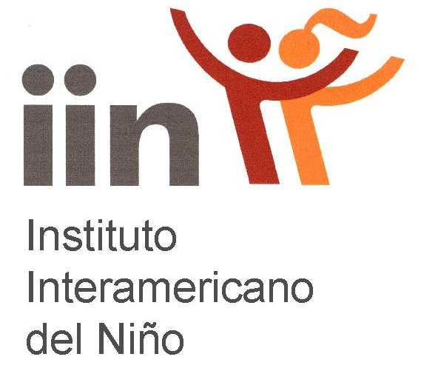
Inter-American
Children’s
Institute

DG Nº 476/04
Montevideo, August 31, 2004

Mr. Eduardo Acevedo Díaz
Alternate Representative of the Argentine Republic to the OAS
Washington, D.C.

Dear Mr. Acevedo Díaz,

I am writing to inform you that we have carefully reviewed the materials for the special meeting scheduled for September 30 and October 1 in order to obtain information and make suggestions that would serve as inputs for preparation of the Inter-American Program for the Promotion and Protection of the Human Rights of Migrants, Including Migrant Workers and Their Families.

The IIN Legal Program has taken due note of the importance of this topic to the inter-American system, and for that reason we have entrusted its Coordinator, Mr. Piero Solari, with technical coordination of efforts to follow up on this mater.

I am sorry to inform you that, for budgetary reasons exclusively, we will not be able to attend the scheduled meeting in Washington, D.C.

Nonetheless, we are fully prepared to cooperate with you and to help in meeting the objectives set for the meeting. Consequently, please be assured that you may count on the Inter-American Children's Institute in consolidating the goals that may emerge from the meeting.

Sincerely yours,

Alejandro Bonasso

Director General

Attachments:
cc: Ambassador Luigi Einaudi, Assistant Secretary General
Ms. Carmen de la Pava, Committee Secretary (General Committee, CISC)

CHILDREN’S RIGHTS AND MIGRATION

According to the bibliography I have reviewed, this topic has several facets:

1. Destabilization of families:

Increasingly, poverty or the absence of opportunities is obliging one or both parents to emigrate to look for work or new opportunities. Family stability is affected by the absence of persons in a parental role, economic insecurity resulting from job-related migration, and even the breakdown of families (essentially owing to the establishment of new families).

2. Discrimination and xenophobia in access to jobs:

Migrant families are often passed over and discriminated against for several reasons: (a) xenophobia (racial discrimination); (b) socioeconomic discrimination (migrants often take jobs away from locals because they work for less); (c) cultural discrimination; and (d) discrimination based on their legal status (absence of the legal documentation required by migrants).

3. At-risk situations:

Families and children are often placed at social risk as a result of such serious problems as trafficking in persons, sexual exploitation of children, and the worst forms of child labor. The precarious social and economic standing of migrants and their lack of cultural adaptation to their new environments exacerbates the tenuous situation of families and children.

4. Lack of information:

This is evident in three problems: (a) lack of information concerning migration opportunities and disadvantages; (b) lack of information about families that have already migrated; and (c) lack of information regarding the actual dimensions of the problem.

Migration is a problem with a national and an international impact.

Article 22 of the Convention on the Rights of the Child is very clear concerning the rights of a child, whether unaccompanied or accompanied by his or her parents, to obtain refugee status. The obligation of the states parties to cooperate in tracing his or her parents is also recognized as a right. Article 27.4 guarantees the right of the child to recovery of maintenance when one of his or her parents lives in another state.

According to reports from the region that I have reviewed, everything seems to indicate that the policies, programs, and projects in this area are focused on:

1. The establishment of protective networks (national, regional, and local) to prevent and respond to emerging at-risk situations.

2. The constitution of international networks expressed in the form of binding agreements and conventions between states with migration corridors (for example, Colombia-Venezuela and Mexico-U.S.)

3. The establishment of public policy arrangements (state-civil society) whereby social control is monitored by specialized NGOs.

4. Organization of public awareness campaigns (discouragement of undocumented emigration because of the high risks involved, trafficking in persons, and prostitution, among other problems).

5. Implementation of national programs to naturalize migrants (good examples are the United States with its citizenship lotteries, and Spain, which is in the process of easing up on its legal restrictions).

Lastly, we should consider that the strategy today is aimed at public policy design that encourages a culture of protection of human rights and respect for migrants and their families.

Piero Solari Zerpa
PROJUR Coordinator

Bibliography:

Destabilization of the Family: Children affected by migration. International Plan. James Gibson. 2000.

Migraciones, vulnerabilidad y políticas públicas. Impacto sobre los niños, sus familias y sus derechos. (Migration, Vulnerability, and Public Policy. Impact on Children, Their Families and Their Rights) CELADE. Juan Miguel Petit. 2003

Primer Seminario Regional Latinoamericano sobre las Migraciones y sus efectos en el niño, la mujer y la familia. (First Regional Latin American Seminar on Migration and Its Effects on Children, Women and the Family.) Columna internacional. (International Column). 1980.

La infancia migrante explotada: mercantilización y utilización política. (Exploited Migrant Children: Commercial and political use). César Manzanos Bilbao. 2002
input.doc

Young Children in Complex Emergencies. Kirk Felsman

