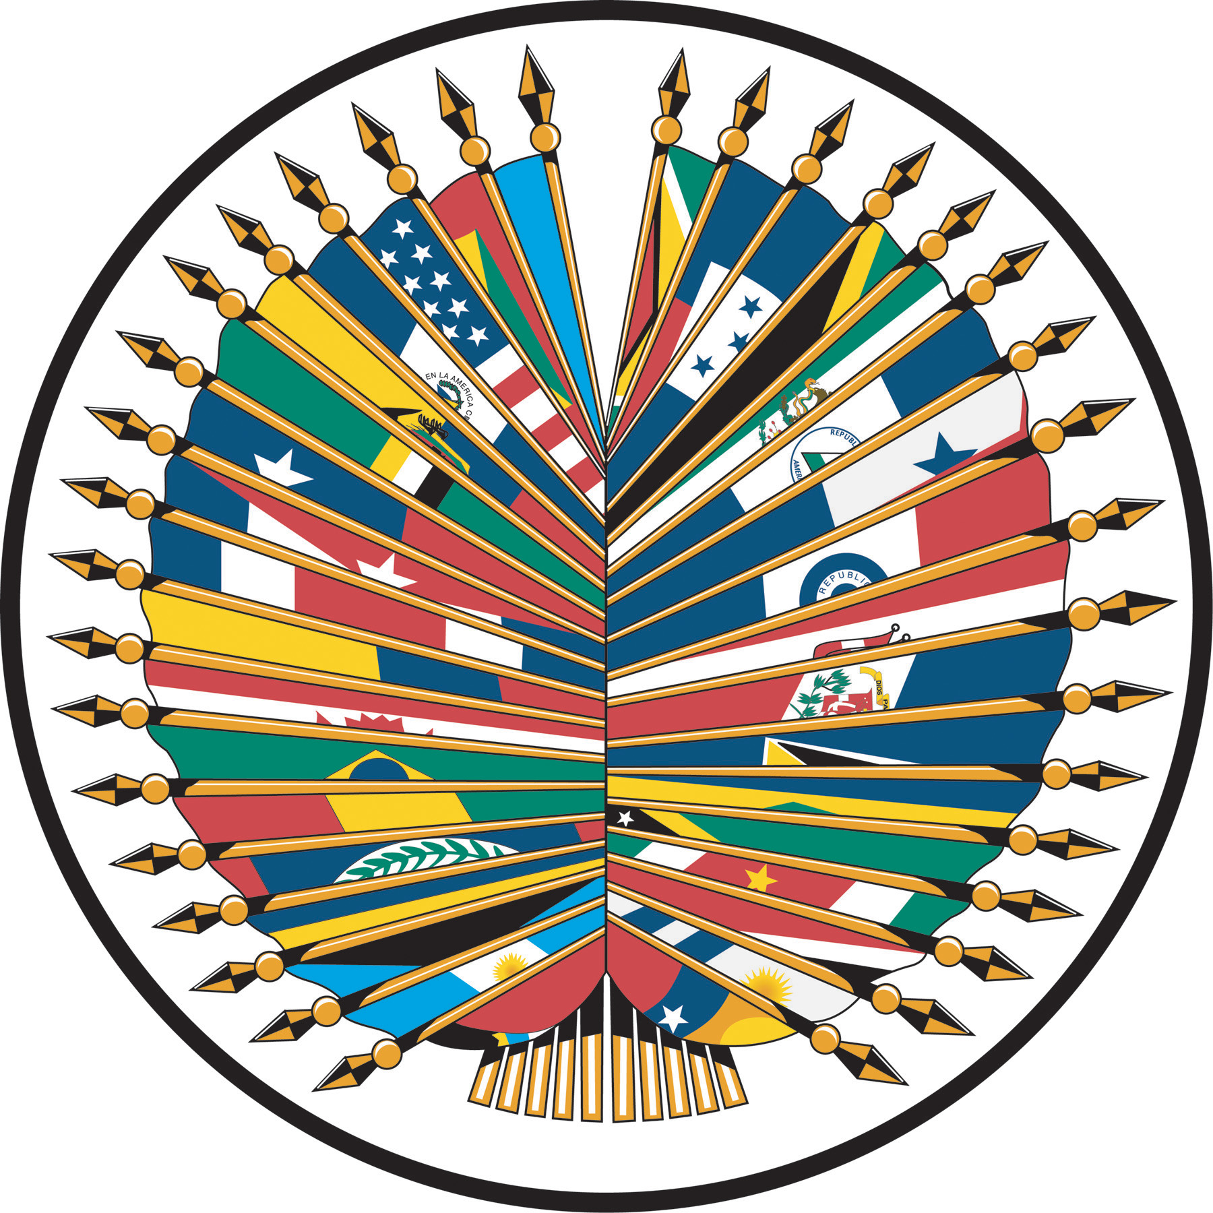

Inaugural Ceremony
Inter-American Peace Forum
Tuesday September 23, 2008
Hall of the Americas
Organization of American States
Washington, D.C.

10:00 – 10:30 a.m. Welcoming Remarks by OAS Secretary General
José Miguel Insulza

10:30 – 12:30 p.m Remarks by Nobel Peace Laureate
Oscar Arias Sánchez

12:30 – 2:30 p.m. Lunch at the Art Museum of the Americas

First Seminar of the Inter-American Peace Forum

3:00 – 3:15 p.m. Remarks by OAS Assistant Secretary General
Albert Ramdin

3:15 – 3:45 p.m. Panel No. 1
“Types and Potential of Conflicts”

Presentation: Marrack Goulding

3:45 – 4:15 a.m. Commentators:
- Ivelaw Griffith, Provost, Senior Vice President, York College
- Ambassador Álvaro Tirado Majía, Former President of the Inter-American Commission of Human Rights
- Ana Maria Romero de Campero, Executive Director of Fundación Unir Bolivia

Moderator: Victor Rico, Director, Department of Democratic and
Special Missions

4:15 – 4:45 p.m. Panel No. 2
“What is Peace in the Americas in the XXI Century? Towards a New Hemispheric Peace Agenda.”

Presentation: Dante Caputo, Secretary for Political Affairs, OAS

4:45 – 5:15 p.m. Commentators:
- Ambassador Aristides Royo, Permanent representative of Panama to the OAS
- Carrie Menkel Meadow, Jr. Professor of Dispute Resolution and Civil Procedure, Georgetown Law A.B.
- Rosario Green, Chairman, Senate Foreign Relations Committee

Moderator: Alexandre Addor-Neto, Secretary for Multidimensional Security

5:15 – 5:30 p.m. Closing

5:30 – 6:00 p.m. Children’s Chorus

6:00 – 7:30 p.m. Reception Tropical Patio

