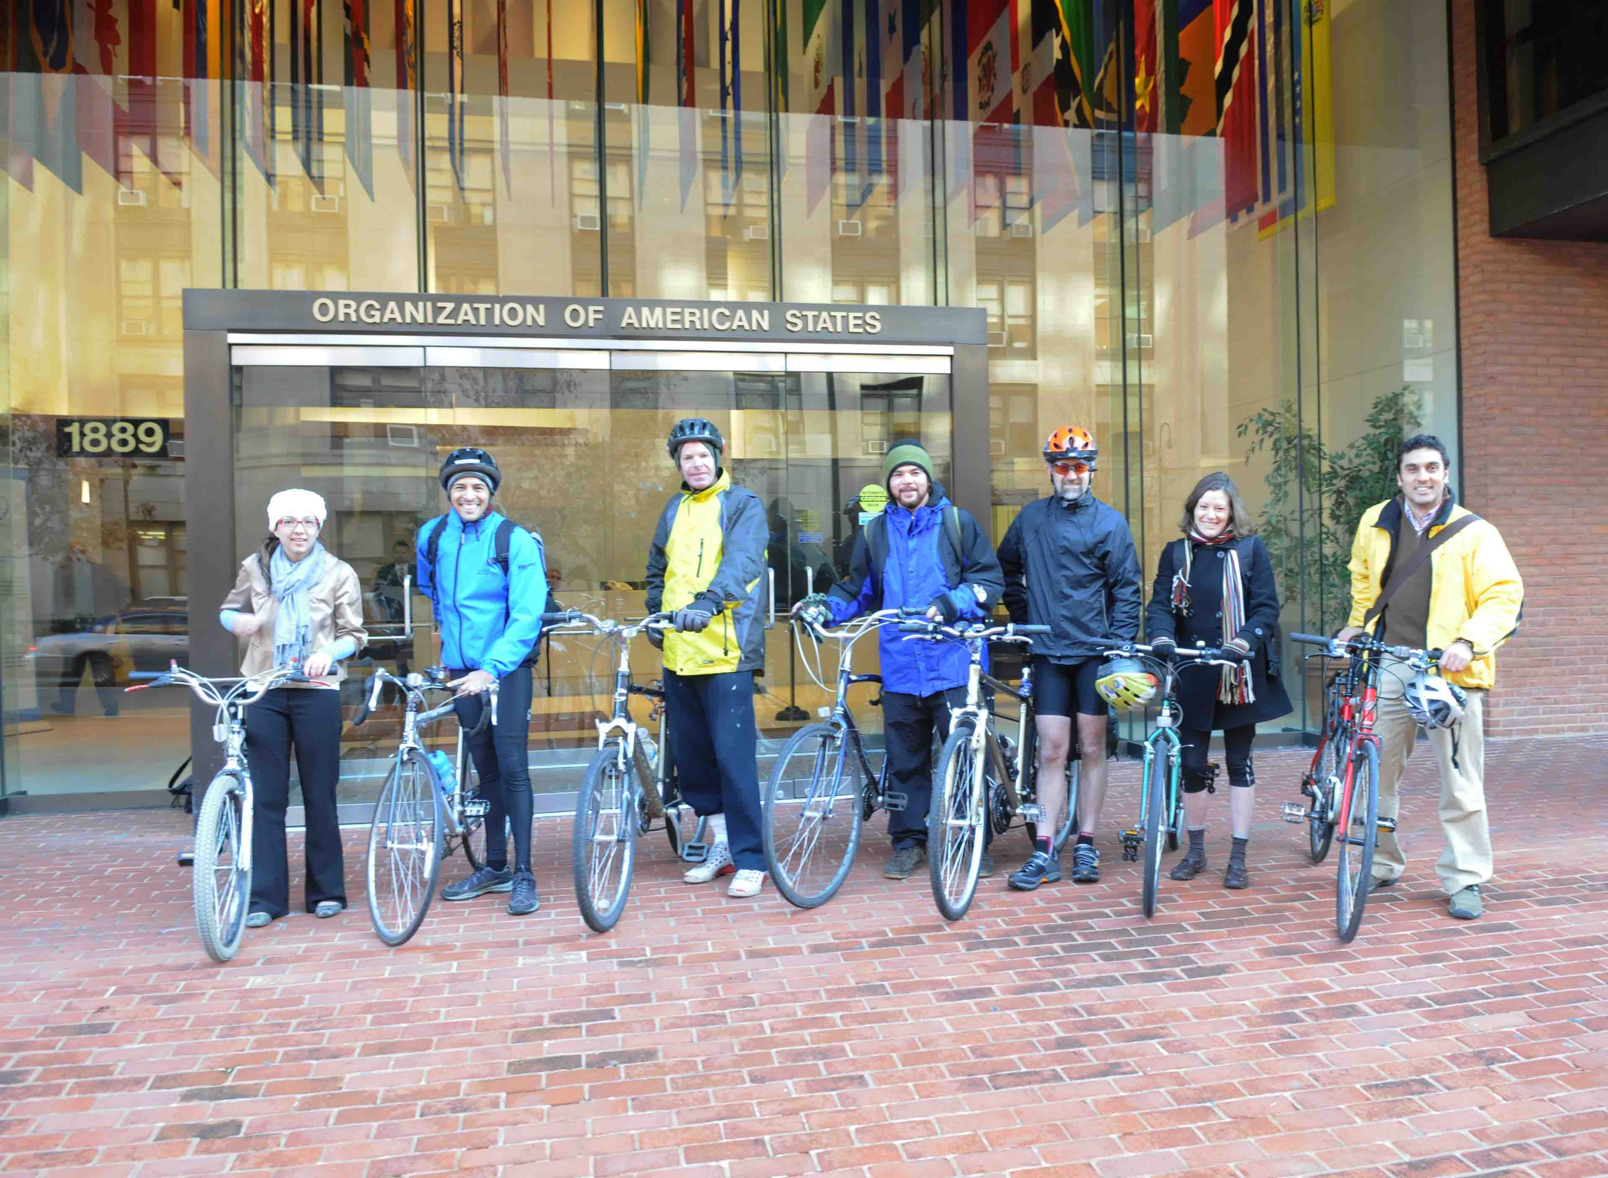

Picture – From left to right: Francia Rábago, Francisco Burgos, Richard Hubert, Mauricio Solano, Pablo González, Lisl Brunner y Alejandro Aristizabal

