REPORT No. 224/22
PETITION 1665 -18
REPORT ON INADMISSIBILITY

BIENVENIDO RODRÍGUEZ
UNITED STATES OF AMERICA
OEA/Ser.L/V/II
Doc. 227
18 August 2022
Original: English

Approved electronically by the Commission on August 18, 2022.

Cite as: IACHR, Report No. 224/22, Petition 1665-18. Inadmissibility. Bienvenido Rodríguez. United States of America. August 18, 2022.

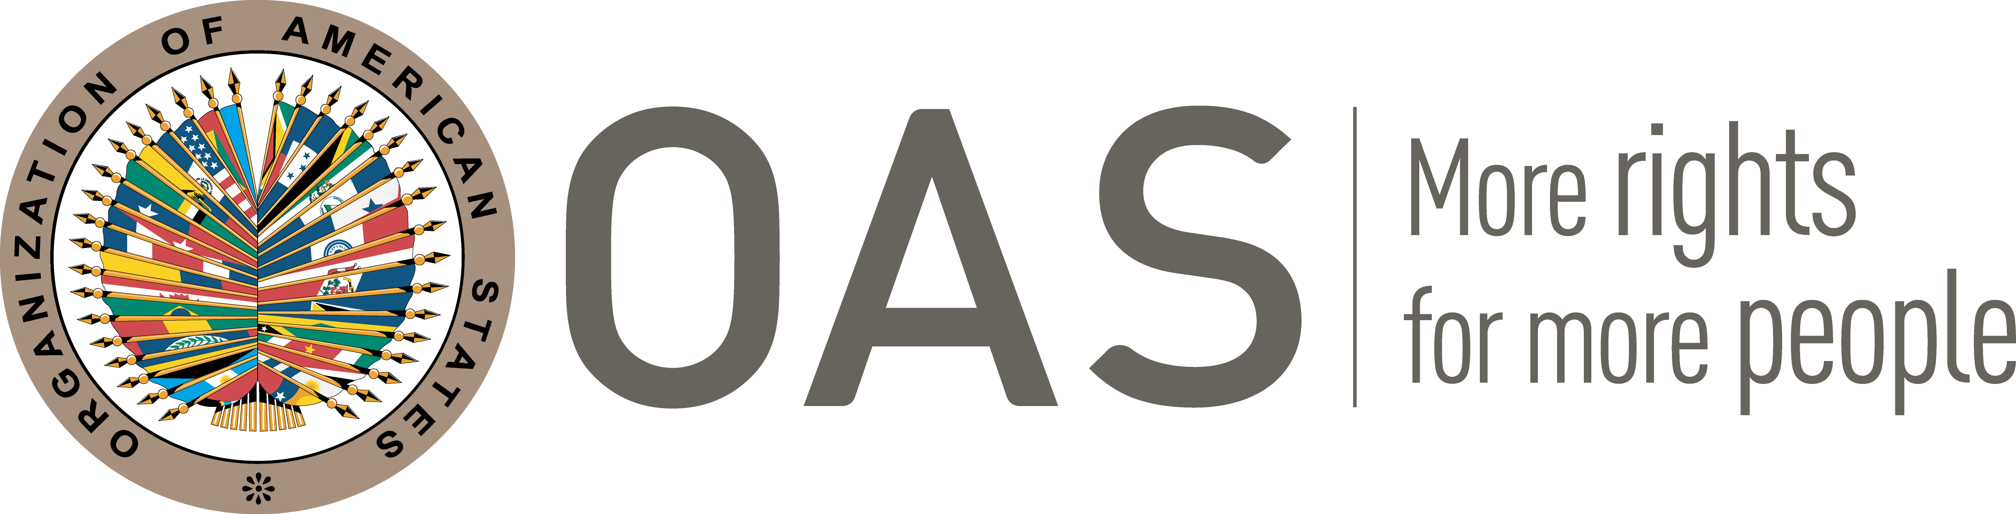
www.iachr.org

I. INFORMATION ABOUT THE PETITION
Petitioner: | Bienvenido Rodríguez
Alleged victim: | Bienvenido Rodríguez
Respondent State: | United States of America
Rights invoked: | No specific provisions invoked
II. PROCEEDINGS BEFORE THE IACHR
Filing of the petition: | May 3, 2018
Notification of the petition to the State: | May 26, 2020
State’s first response: | Sept 18 2020
III. COMPETENCE
Competence Ratione personae: | Yes
Competence Ratione loci: | Yes
Competence Ratione temporis: | Yes
Competence Ratione materiae: | Yes, American Declaration (ratification of the OAS Charter on June 19, 1951)
IV. DUPLICATION OF PROCEDURES AND INTERNATIONAL RES JUDICATA, COLORABLE CLAIM, EXHAUSTION OF DOMESTIC REMEDIES AND TIMELINESS OF THE PETITION
Duplication of procedures and International res judicata: | No
Rights declared admissible | None
Exhaustion of domestic remedies or applicability of an exception to the rule: | Not applicable
Timeliness of the petition: | Not applicable
V. ALLEGED FACTS
- This petition relates primarily to a complaint by Bienvenido Rodríguez (the petitioner and alleged victim) that the State systematically prevented him from exercising his right to practice his religion Yoruba Santeria, while he was an inmate of the Pennsylvania Department of Corrections (“PDOC”). In this regard, the petitioner claims that he was prevented from conducting or participating in certain religious ceremonies and rituals such as the Fiesta del Día de Los Tres Reyes Magos.
- According to the petitioner, his grievance led to the filing of a suit in November 2016 against PDOC before the United States District Court for the Western District of Pennsylvania (“the District Court”). Based on the record, it appears that the District Court referred the matter to mediation. This mediation was conducted and completed in April 2017 (with the participation of the petitioner and his counsel). The mediation resulted in a resolution/settlement of the suit. The precise language of the written version of the resolution/settlement was subsequently negotiated by the parties with the assistance of the District Court. This process was completed in May 2018, when the parties executed the written resolution/settlement following which the suit was dismissed by the Court with the consent of the parties in July 2018. However, the petitioner has complained that there was a delay in implementing the resolution/settlement (between the completion of the mediation and the execution of the resolution/settlement).
- The State submits that the petition is inadmissible. In this regard, the State submits that the petitioner successfully settled his complaint before the domestic courts after submitting his petition to the Commission. In this regard, the State contends that: (a) this supervening information (the settlement of the complaint) renders the petition inadmissible pursuant to Article 34 (a) of the Commission’s Rules of Procedure; (b) the Commission has repeatedly found that, where a petitioner's claims have been addressed at the domestic level, the Commission does not consider prima facie that such claims constitute a potential violation of a right.
- Further, the State contends that to the extent that the Commission considers that the petitioner has stated a prima facie claim that has not been sufficiently resolved at the domestic level, the Petitioner failed to exhaust domestic remedies as required by Article 20(c) of the Statutes of the Commission and Article 31 of the Commission’s Rules of Procedure. In this respect, the State notes that the petitioner submitted a petition while still pursing domestic remedies and, as part of the settlement of his claim, the petitioner voluntarily stipulated to dismissal of his claim at the district court level, meaning he did not exhaust those remedies by pursuing his claim to the highest level of appeal.
VI. ANALYSIS OF EXHAUSTION OF DOMESTIC REMEDIES AND COLORABLE CLAIM
- Article 31 (1) of the Commission’s Rules of Procedure provides that for a petition to be admissible the Commission shall verify whether the remedies of the domestic legal system have been pursued and exhausted in accordance with the generally recognized principles of international law. This requirement ensures the State the opportunity to hear the alleged violation of a protected right and, if applicable, settle the issue before it is brought before an international body settle human rights complaints within its own system of justice before being addressed by an international body.
- Based on the documents and information provided, it appears that the petitioner’s complaint was litigated before the domestic authorities between November 2017 and May 2018 resulting in a settlement/resolution of the petitioner’s complaint. In this regard the information available shows that the petitioner agreed to terminate the litigation because of the settlement/resolution. While the petitioner does complain of delay in the implementation of the settlement/resolution, the record indicates that this was a result of ongoing negotiations on the precise language of the settlement/resolution (between 2017 and 2018). The petitioner appears to have been part of these negotiations together with his counsel. Ultimately, it appears that the petitioner’s complaint was redressed domestically, and, in the circumstances, the Commission considers that issue of exhaustion of domestic remedies has now been rendered moot. Alternatively, the Commission considers that the petitioner has provided no other information upon which the Commission might (a) determine whether he was dissatisfied with the settlement/resolution; and (b) verify whether he pursued or exhausted any other available remedies to redress any such dissatisfaction.
- Based on the foregoing, the Commission further concludes that the petition fails to state facts that tend to establish a violation of any rights enshrined in the American Declaration, and is accordingly, inadmissible pursuant to Article 34 (a) of the Commission’s Rules of Procedure.
VII. DECISION
- To find the instant petition inadmissible; and
- To notify the parties of this decision; and to publish this decision and include it in its Annual Report to the General Assembly of the Organization of American States.

Approved by the Inter-American Commission on Human Rights on the 18th day of the month of August, 2022. (Signed:) Julissa Mantilla Falcón, President; Margarette May Macaulay, Second Vice President; Joel Hernández, and Roberta Clarke, Commissioners.

Hereinafter “the United States”, “the US”, or “the State”.
The observations submitted by each party were duly transmitted to the opposing party.
In this regard, the State cites IACHR, Report No. 1-19. Petition 325-07. Inadmissibility. Carlos Luciano Martins. Argentina. January 3, 2019, para. 17; and IACHR, Report No. 189/18. Petition 359-07. Inadmissibility. Vicente Rodolfo Walde Jauregui. Peru. December 26, 2018, para.20.

