# CHAPTER VI

# INSTITUTIONAL DEVELOPMENT AND ADMINISTRATIVE AFFAIRS (“DIAA”)

## IACHR Structure and Staff

1. The Inter-American Commission on Human Rights approved an organizational structure for the Executive Secretariat at the 153rd regular session. Even though the Executive Secretariat has been implementing this structure at the operational level, it has yet to be formally incorporated into the organizational structure of the OAS General Secretariat. On September 20, 2016, through memorandum OSG/489/16, Secretary General Almagro requested that, because efforts to complete the draft of a new Four-Year Strategic Plan of the Executive Secretariat were still ongoing and this could result in “further adjustments to the job of the Executive Secretariat,” the structure should be considered once this Plan has been completed and approved. He concluded “that a new draft Executive Order should be submitted at the appropriate time to the Office of the Secretary General for his consideration.” A detailed explanation of the approval process of the Strategic Plan is provided hereunder in Section D.1.
2. In 2016, the competitive process was reopened to fill previously frozen positions and one position that became vacant during the year due to a retirement, specifically two P04-level human rights specialist and three G05-level administrative assistant positions. At the same time, the IACHR/ES transitioned from the term of the outgoing former Executive Secretary Emilio Alvarez Icaza to the term of the incoming current Executive Secretary Paulo Abrao. The competitive application process was conducted by the Senior Management of the DIAA.
3. The table below shows the number of employees and consultants by source of funding as of October 31, 2016.

|  |  |  |  |
| --- | --- | --- | --- |
| **Category** | **Regular Fund** | **Specific Funds** | **Total** |
| Executive Secretariat | 1 | 0 | **1** |
| Assistant Executive Secretariat | 1 | 0 | **1** |
| Special Rapporteur | 0 | 1 | **1** |
| [Professionals](mailto:Otr@s%20profesionales) | 19 | 19 | **38** |
| Administrative Staff | 9 | 3 | **12** |
| **Subtotal Staff** | **30** | **23** | **53** |
| IACHR Performance Contracts | 0 | 15 | **15** |
| Associate Staff | 0 | 1 | **1** |
| **Total** | **30** | **39** | **69** |

1. Specifically, in 2016, the IACHR/ES was organized as follows:

* Office of the Executive Secretary, which serves the members of the Commission and conducts the strategic management of the Commission. It also includes the Press Office.
* Office of the Assistant Executive Secretary, which provides additional support to the members of the Commission, and manages the legal side. It includes the Protection Group and the Documents Office.
* Office of the Special Rapporteur for Freedom of Expression, whose mandate it is to promote freedom of expression by writing annual reports, engaging in outreach and dissemination, issuing advisories, conducting studies of laws and practices, that are inconsistent with international standards in this field, and supporting the drafting of reports in contentious matters and precautionary measures relating to this topic.
* Department of Petitions and Cases (“DPC”), whose purpose it is to assist the IACHR in its duty to receive, examine and process individual petitions alleging human rights violations. It is made up of the following sections:
  + Procedural Backlog Group;
  + Registry Section;
  + Petitions Section;
  + Cases Section, divided into two Groups: Merits and Court; and
  + Friendly Settlement and Follow-Up Section.
* Department of Geographic Monitoring (“DMG”), which ensures that the IACHR is continually following up on human rights situations throughout the States of the hemisphere by sub-region or country. It includes the Geographic Monitoring Section.
* Department of Thematic Monitoring (“DMT”), which conducts thematic follow-up on the situation in the OAS member countries. It includes the Thematic Monitoring Section and supports the work of the following Rapporteurships and Units:
  + Rapporteurship on the Rights of Indigenous Peoples: It was created to serve the indigenous peoples of the Americas, who are particularly vulnerable to human rights violations, and to strengthen, promote and systematize the work of the Commission in this field.
  + Rapporteurship on the Rights of Women: It was created in 1994 with the initial mandate to determine to what extent legislation and practices of the OAS Member States ensured the rights of women and abided by the general obligations to protect equality and prevent non-discrimination, as set forth in the American Convention on Human Rights (hereinafter “American Convention”) and the American Declaration of the Rights and Duties of Man (hereinafter “American Declaration”). In creating the Rapporteurship, the Commission reaffirmed its commitment to ensure full respect for the rights of women in every OAS Member State. The Rapporteurship promotes full understanding of the need for additional measures to make sure that women are able to fully exercise their basic rights and issues recommendations to prompt states to improve compliance with priority obligations relating to equality and non-discrimination. The Rapporteurship additionally promotes the application of the mechanisms of the Inter-American human rights system to protect the rights of women, conducts specialized studies and prepares the corresponding reports, and supports the Inter-American Commission in formulating responses to petitions and to other complaints of human rights violations in the region.
  + Repporteurship on the Rights of Migrants: Its purpose is to promote respect and ensure the rights of migrants and their family members, asylum seekers, refugees, applicants and beneficiaries of supplemental protection, stateless persons, victims of trafficking in persons, internally displaced persons and other vulnerable groups in the context of human mobility.
  + Rapporteurship on the Rights of Children: It provides support in the examination and assessment of the human rights situation of children in the Americas. The Rapporteurship advises the IACHR in proceedings pertaining to individual petitions, cases and requests for precautionary and provisional measures, which address the rights of children. The Rapporteurship also conducts country visits to OAS Member States and prepares studies and publications on this topic. The Rapporteurship contributes its expertise, as well as international legal precedents and studies, to the deliberations of the Commission. It is also the point of contact for civil society organizations working in the field of children’s rights.
  + Rapporteurship on the Rights of Persons Deprived of Liberty: Its mission is to closely monitor, through any reliable source, the situation of persons subject to any form of detention or imprisonment in the Member States; conduct visits to OAS Member States in order to gather information and issue recommendations to the States; write reports for the Commission on the situation of prison conditions at a particular detention facility or in a particular country, region or sub-region, along with any recommendations that are deemed necessary for the Commission; conduct promotion and education activities in the realm of human rights; coordinate promotion efforts with non-governmental organizations or other international human rights protection institutions and take any other measure deemed necessary to protect persons deprived of liberty, as provided for under the mandate of the Inter-American Commission on Human Rights.
  + Rapporteurship on the Rights of Afro-descendants and against Racial Discrimination: Its purpose is to encourage, systematize, reinforce and consolidate the actions of the Inter-American Commission with regard to the rights of persons of African descent and against racial discrimination.
  + Rapporteurship on Human Rights Defenders: Through a variety of undertakings, the Rapporteurship closely monitors the situation of persons engaged in the defense of rights in the region, including the situation of operators of justice.
  + Rapporteurship on the Rights of Lesbian, Gay, Bisexual, Trans and Intersex (“LGBTI”) Persons: (¨LGBTI”): Its job involves monitoring the human rights situation of lesbian, gay, bisexual, trans and intersex persons throughout the region and promoting respect for their rights.
* Unit on Economic, Social and Cultural Rights (“ESCR”):**[1]** It collaborates in the examination and assessment of the human rights situation in the Americas, advises the IACHR on the processing of individual petitions and cases and requests for precautionary and provisional measures, which involve these rights, conducts visits to OAS Member States and prepares studies and publications, in particular, on international norms.
* Department of Promotion and Public Policies (“DPPP”), the purpose of which is to support the IACHR in conducting human rights promotion around the region. It is made up of three sections:
  + Section of Advisory Services to States;
  + Training and Dissemination Section; and
  + Public Policy Section
* Department of Institutional Development and Administrative Affairs (“DIAA”), which is in charge of all the Commission’s financial and operational plans and reports, human resource management and administrative logistics, coordination of all administrative personnel assigned to the regional sections and rapporteurships. Additionally, under the new structure, it includes communications strategy coordination and IACHR relations with other regional and United Nations human rights mechanisms, and other institutions, as well as technology and automated tools strategy. It is made up of the following three sections and one unit:
  + Administrative Management Support Section;
  + Fundraising and Project Administration Section;
  + Interinstitutional Relations Section; and
  + Technology and Systems Unit.

## Personnel Training

1. On July 27, 2016, the DIAA and the area of Promotion and Public Policy jointly conducted a training session for the Commissioners titled “Introduction to Cultural Diversity and Social Inclusion in the international work place,” attended by all of the Commission members and the new Executive Secretary. The lead speaker was Mrs. Zakiya Carr Johnson, Senior Advisor of the Race, Ethnicity and Social Inclusion Unit of the Bureau of Western Hemisphere Affairs of the US Department of State.

## Financial Resources and Budget Execution

### Regular Fund

1. For fiscal year 2016, the OAS General Assembly approved a budget of $5,634,300 for the IACHR, of which $4,651,800 is for personnel expenditures and $982,500, for operational expenditures. Even though this 2016 budget raised the IACHR’s budget allocation by $206,400 over the 2015 budget amount, the fact of the matter is that as the year opened, several positions were still in the process of being filled and additional vacancies were left open by departures and retirements. As depicted in the graph below, taking into account the factor of vacant positions, the net amount provided to the IACHR as of October 31, 2016 is significantly lower than the amount approved, specifically $841,000 lower.

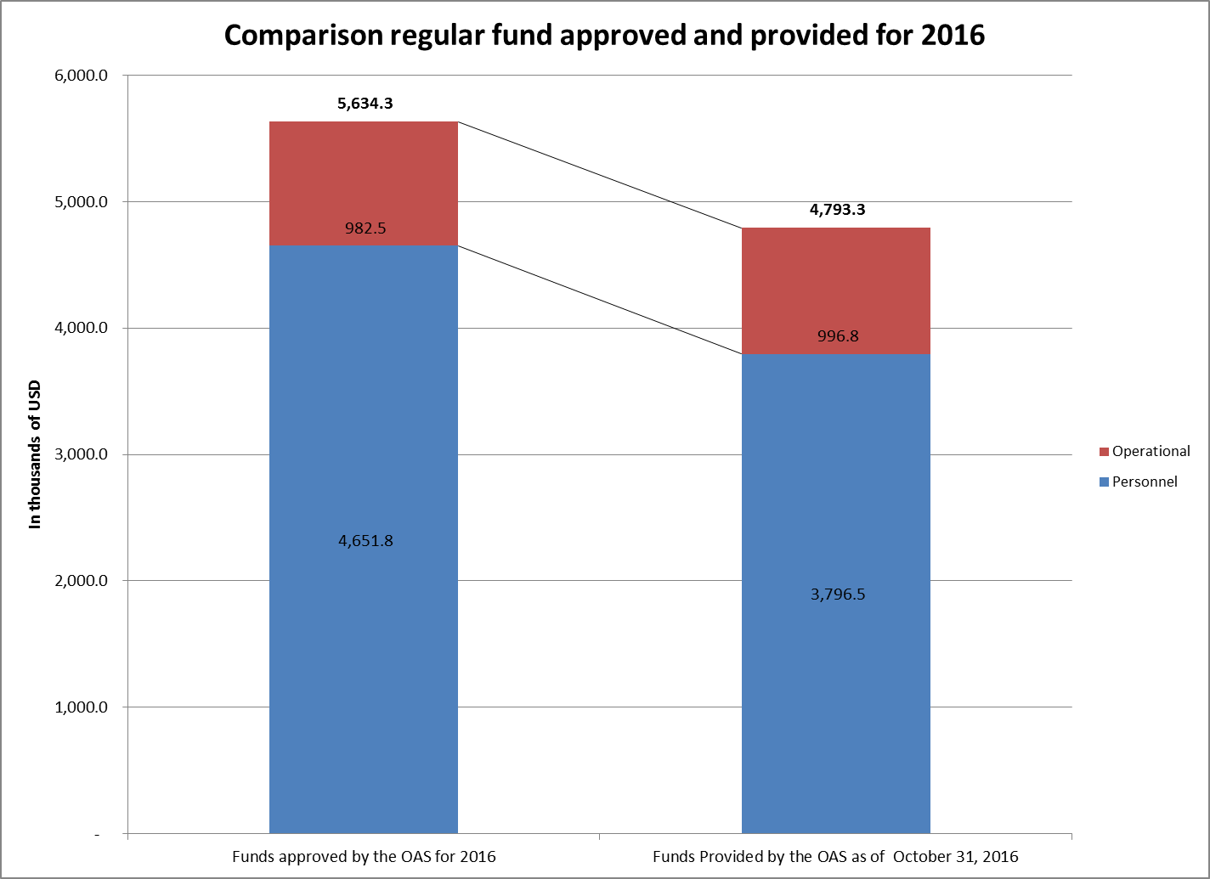

1. Regarding the two P04 level and one of the three G05 level positions, as of October 31, 2016, the processes were in the applicant selection memorandum phase.[2] As for the remaining two G05 level positions, the deadline for application was October 9 and the more than 100 applicants are being vetted to determine which ones meet eligibility criteria.
2. In looking at 2017, it is important to stress once again that despite the drastic cuts made across the board at the organization, the General Assembly agreed to not cut the budget of the Inter-American human rights protection system and negotiations are ongoing to consider a proposal to maybe double the amount of resources coming from the Regular Fund to the IACHR/ES. This proposal, introduced by the Government of Mexico, will be considered at the 47th General Assembly in June 2017.
3. With regard to execution of its regular fund allocation for 2016, as of October 31, 2016,[3] the IACHR had executed 83%, with a balance of US$810,900, against which prior obligations in the amount of US$741,000 were on the ledger.

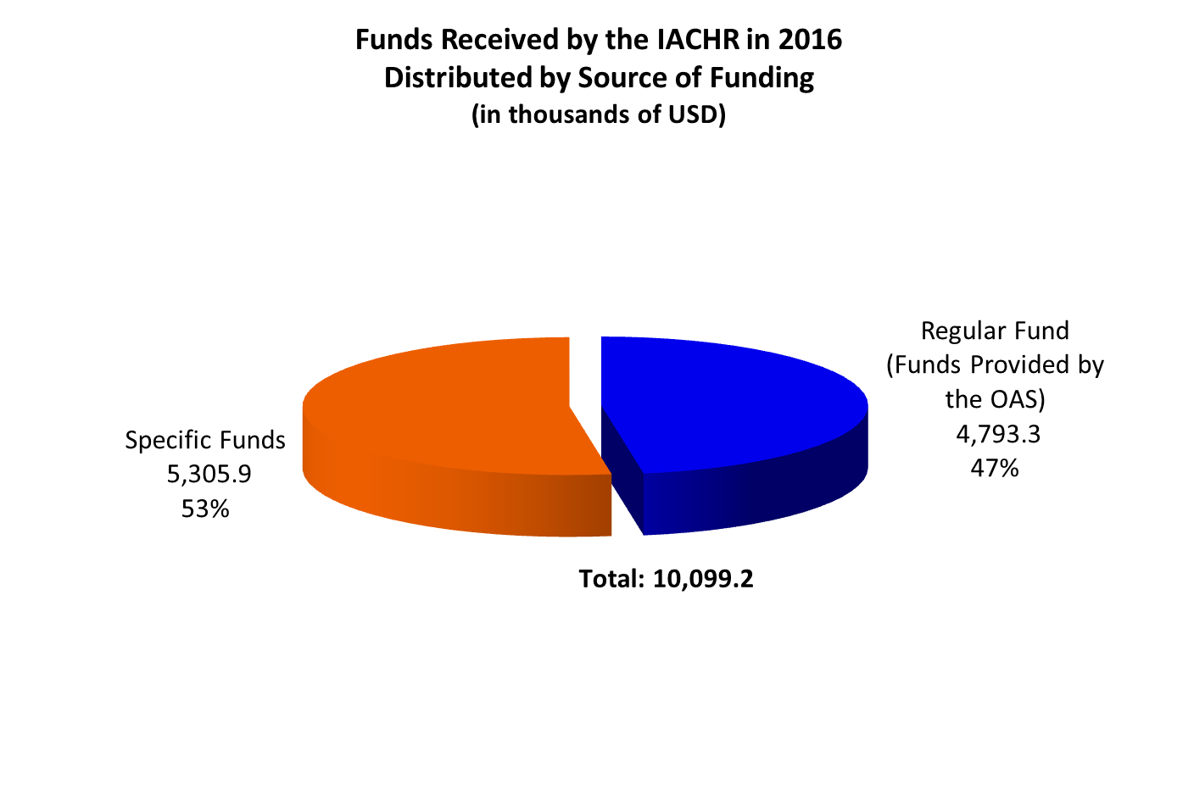

### Specific Funds

1. As of October 31, 2016, a total of US$ 5,305.900 was received from contributions by the following Member States: Antigua and Barbuda, Argentina, Chile, Colombia, Costa Rica, United States, Mexico, Panama, Peru, Uruguay; from Permanent Observers: Denmark, Spain, Sweden, Switzerland, European Union; and from non-member states and others: UNHCR, Avinna, Arcus Foundation, University of Notre Dame and Stanford University. Table No. 2 shows contributions to IACHR specific funds as of January 1 to October 31, 2016. Specific funds are donations over and above any regular contributions of Member States to the Organization, and are specifically earmarked for certain purposes, themes or projects.

**Table 2.**



1. It must be noted that even taking into account the Member States’ commitment to endow the IACHR with financial resources, the Regular Fund accounts for only around half of the annual executed budget of the Executive Secretariat.

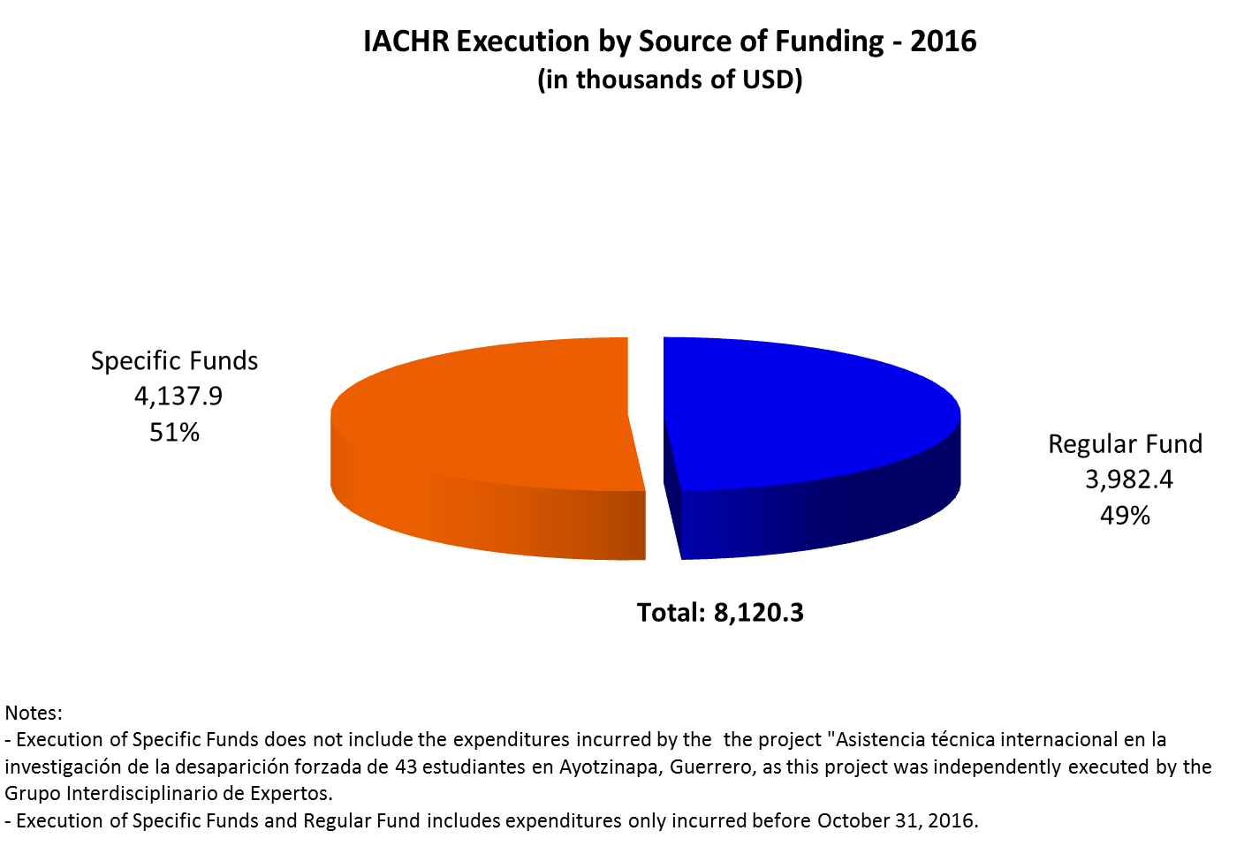

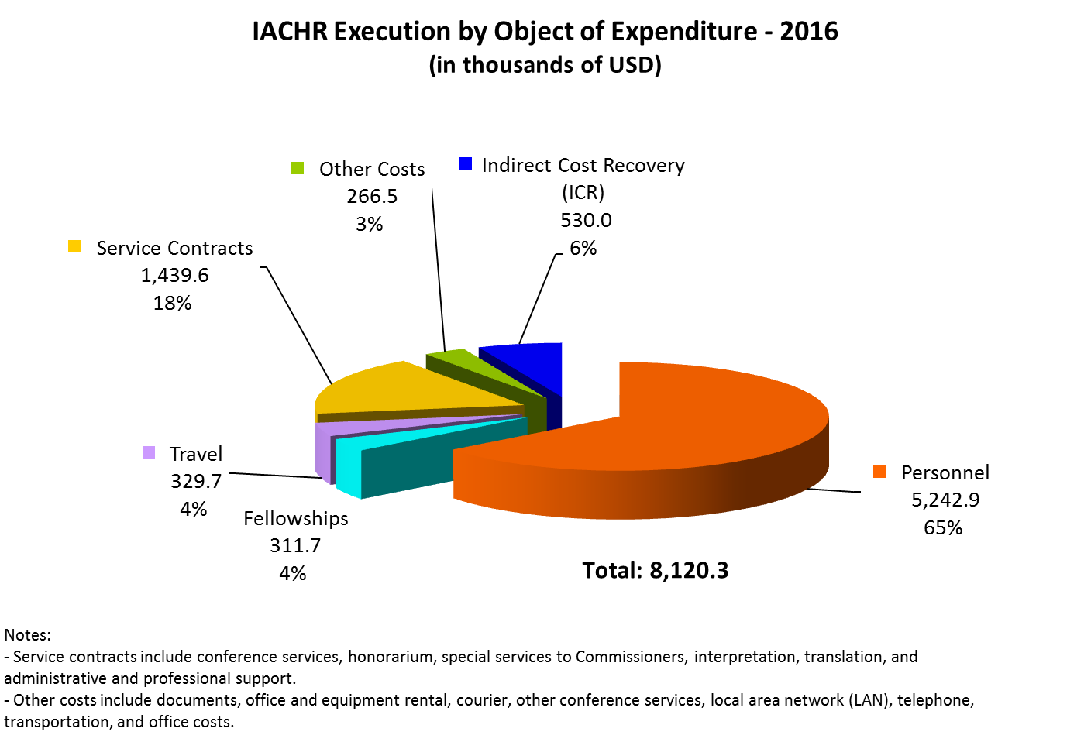

## Fundraising and Project Administration

### IACHR Strategic Planning

1. In 2016, the IACHR made progress in crafting its strategic plan for the new period. In so doing, it devised a participatory methodology consisting of three stages: a conceptual phase, a concrete proposal design and construction phase and a third discussion and approval phase.
2. The first phase involved a sending out a questionnaire to civil society and the Member States and receiving their initial input to lay the groundwork for the Plan. This consultation yielded input on effects, impacts, advancements and opportunities for improvement over the prior Strategic Plan. The consultation also made it possible to identify challenges and define the priorities and issues to be addressed by the IACHR in its new Plan. By the end of this stage, 49 responses to the questionnaire had been received. The IACHR used this input to draft a Conceptual Paper, setting forth guidelines for the discussion on the Strategic Plan. Member States provided comments and suggestions on this paper at meetings held in July of last year.
3. In the second phase, the Commission expanded the channels and mechanisms for listening and participating in order to receive concrete proposals for the design and drafting of the Strategic Plan. In December 2016, five workshops were held at the 159th and 160th IACHR regular sessions with the attendance of experts, civil society, international organizations, the IACHR Executive Secretariat team, and the Commissioners. The workshops with experts, civil society and the States will continue in January and February 2017 until the process has concluded. As of the time of completion of this report, the Commission is still working on the first draft strategic plan document to bring this phase to an end.
4. The third phase consists of a series of regional consultations, which will be held in February 2017, where it is expected that dialogue between the States and the different social and academic actors interested in strengthening the Inter-American human rights system will generate suggestions for concrete proposals about the preliminary proposal of the Strategic Plan. These consultations will yield a version approved by all stakeholders and this version will be submitted for the approval of the Commission in March 2017.

**2. General Financial Planning 2017**

1. In conjunction with the Executive Secretary, financial planning was conducted based on resource needs and up-to-date funding projections, ongoing negotiations and real contribution opportunities. The planning exercise was carried out in a comprehensive way, taking into consideration all potential funding for projects and other voluntary contributions, as an integral part of the IACHR’s annual needs budget.

**3. Project Budget Preparation**

1. In 2016, the area prepared and supported the drafting of several conceptual papers or project proposals in order to raise funding to reinforce the activities of the Rapporteurships and areas of the IACHR/ES:

* Drafted a proposal for $54,392 from Finland to strengthen human rights defender protection, which was approved for execution in the second quarter of the year.
* Drafted a request for resources from the Netherlands, based on the conceptual paper of the 2017-2020 Strategic Plan. The Kingdom of the Netherlands approved an agreement for USD$1,120,000 to support execution of the projects of the strategic plan over four years with annual disbursements of USD$280,000. The work plan of the third year is aimed at supporting the work of the rapporteurships.
* Drafted a proposal to the government of Ireland for dealing with procedural backlog, emphasizing groups subjected to discrimination in the Americas, for the amount of €50,000 Euros. The proposal was approved and the agreement signed at the end of the year.
* Adjusted the project financed by Avina/Cammina on the topic of “Migrants and their family members,” in order to add $100,000 to finance the process of planning of the Rapporteurship on Migrants in the framework of IACHR strategic planning. The Addenda to the agreement was signed and the first disbursement was received.
* Drafted a conceptual paper and subsequently drafted a complete proposal to the European Union (EU) Mexico on “Access to international justice for persons and groups living in vulnerable conditions in Mexico by providing assistance in lodging petitions before the IACHR,” for the amount of €50,000 Euros. The contract was signed.
* Drafted the conceptual paper on assistance in filing petitions and cases linked to the subject of access to justice for migrants before the UNHCR, and support for the Rapporteurship on Migrants in the amount of US$100,000. The agreement was signed at the end of the year; it was to be executed in two months; and the full amount was disbursed.
* Drafted a project proposal to raise awareness about the Inter-American human rights protection and defense system in the Northern Triangle of Central America, for the amount of $822,690, over 4.5 years, to the Pan American Development Foundation (PADF). This project is part of a larger program on *Human Rights in Democracy* funded by USAID. The proposal was approved. In keeping with internal policy, the project needs to be submitted to the OAS Project Evaluation Committee (CEP).
* Drafted a proposal for the “Promotion of economic, social, cultural and environmental rights –phase II (emphasis on the issue of human rights and corporations)” to be financed by the Spanish Fund of the OAS for the amount of €300,000 Euros.
* Drafted a proposal to support the activities of the IACHR plan over 2017 to be financed through the OAS/DEMOC Fund of the US Mission to the OAS for the amount of $2,100,000 and executed as of February 1, 2017.
* Drafted a proposal to Switzerland about human rights and corporations with a focus on security companies in the Inter-American human rights system (IAHRS). After several revisions and changes to the scope of work, it was agreed to hold a side event on the subject of human rights and corporations in the framework of the OAS Assembly in Mexico, for the amount of US$20,000.
* As a result of negotiations by President James Cavallaro with the government of Canada, drafting began of a project proposal to fight discrimination and violence against women and girls in Latin America and the Caribbean, through the IACHR protection mechanisms, for the amount of CAN$2,000,000. Canada cooperation area provided technical assistance for this purpose. The proposal remains under review and questions from the official counterparts are being answered.
* Drafted a proposal to the government of Germany to provide support to the Special Rapporteurship on Economic, Social and Cultural Rights.

1. Additionally, the area has aided in drafting and supporting proposals written by other areas of the IACHR, such as the following:
   * Reviewed and supported drafting the proposal to improve the handling of petitions at the initial review stage, coordinating with the Trust for the Americas and submitting the corresponding proposal to the National Endowment for Democracy (NED). The donor reported that this proposal was not accepted, inasmuch as it is felt that the proposed project is part of the permanent operations of the IACHR.
   * Supported the Petition Section in drafting a summary document addressed to the European Commission about a proposal regarding “Access to international justice through petitions brought before the IACHR by victims of alleged violations of human rights in the hemisphere,” for the amount of €1,5000,000 Euros, over 2018-2020. This is the first step toward submitting the complete proposal.
   * Supported the Rapporteurship on LGBTI persons in drafting a proposal to support the work of the Rapporteurship, in the amount of $250,000, which would be executed through the Trust for the Americas and funded by *Wellspring advisors*.

**4. Project Reports**

1. Over the course of 2016, seven project reports were written or coordinated by the planning and project management area and submitted to the appropriate donors:

* Supported drafting the mid-term report for Fundacion Arcus in executing the support project to the Rapporteurship on the rights of LGTBI persons.
* Coordinated and supported drafting of the second mid-term report of the preventive detention project for the Spain Fund.
* Coordinated and drafted the first mid-term report of the project on Promotion [of Rights] and Protection of Highest Risk Populations in the Americas for the European Commission.
* Coordinated and drafted the annual report for January to December 2015 of the project “Regional Human Rights Program in Central America-Proderechos,” funded by Denmark.
* Drafted the final report of Norway’s 2015 contribution supporting the IACHR in the period of December 2014-December 2015.
* Drafted annual report of activities from the United States’ 2015 contribution.
* Drafted the first narrative mid-term report and coordinated drafting of the final report for Open Society Foundation – Trust for the Americas project on strengthening the Rapporteurship on human rights defenders.

**5. Exploring new strategies and funding opportunities**

* *Crowdfunding*

1. In light of the IACHR’s financial crisis and instructions from the President of the Commission, internal consultations took place regarding the feasibility of receiving donations from private corporations and individuals and, specifically, through mass fundraising, such as crowdsourcing.
2. As a result of the consultation process, the IACHR decided to accept donations from individuals. For US-based individuals, who request an official record of tax exempt status, the Commission will follow the recommendation of the OAS Department of Legal Services to use one of the two independent non-profit entities created by the Organization, which are legally chartered as 501 (c)(3) corporations in the United States. As such, because the Inter-American Commission has previously worked with the Trust for the Americas, it has decided to do so again in this way, in addition to the fact that the Commission shares the financial/accounting system OASES/ORACLE with the OAS under a financial management agreement. For other individuals who require no record of the entity’s tax exempt status, donations will be received through the mechanisms currently available at the OAS, such as payment by check, bank transfers or payment by credit card. There are administrative costs under OAS regulations governing payments by these methods and, consequently, it is advisable for mass individual contributions to not be in such small amounts.

## Technological Advancements

1. The Individual Petition System Portal has helped to significantly increase transparency in the IACHR’s working procedures, in addition to helping the users of the IACHR to follow their matters more closely in an innovative and unique way in the region. Individuals, organizations and States have access to information on their petitions, cases and precautionary measures before the IACHR, through the use of technology and automated management tools. Transmission of communication and document exchanges, access to information on the status of the proceedings of petitions, cases and precautionary measures under examination at the Commission, has become streamlined and it is now easy, free and instantaneous to send and receive additional information in existing matters. We have received many positive comments from Member States and civil society, who have used the new system, on how it works, as well as suggestions to enhance the value even more of this automated tool which, without question, has helped to increase transparency in the work procedures of the IACHR and to make information about matters more readily available to our users.
2. As of December 31, 2016, there were a total of 4,445 registered users, 56 of which are accredited by Member States, including Argentina, Bolivia, Canada, Chile, Colombia, Costa Rica, Ecuador, El Salvador, United States, Guatemala, Guyana, Honduras, Jamaica, Mexico, Nicaragua, Paraguay, Peru, Suriname, Uruguay, Venezuela.
3. Since the Portal was implemented, 30,800 annexed documents containing additional information have automatically been processed as of today’s date. We have also received 1,708 new petitions through the Portal. Thus far, a total of 50,192 documents have been processed through this system.
4. With a view toward constant improvement of the information and management systems of the IACHR, the Technology and Systems Unit (UTS) is monitoring our technology tools on a day-by-day basis and, as we receive feedback, we find parts that can be optimized. This year, new procedures were designed, created and implemented in the PCMS to facilitate, streamline and comply with legal and administrative processes as to document flow and life cycle of active matters before the IACHR. A study was begun to create and automate electronic signatures on routine correspondence in the DMS, in different modules, in order to be able to speed up the final process of getting letters out to our users. In the Individual Petition System Portal, an automatic notification was implemented, which saves manual labor required to create, review and send confirmation of receipt to petitioners. The notification automatically goes to the petitioner’s e-mail address, once the petition is registered in our systems and the petition number and general information about processing of the petition can be identified. Subsequently, in response to feedback provided by the users of the Portal (States and petitioners), we added the number of the active case before the IACHR to the subject line of the electronic notification received by users, so they could quickly identify in their emails the case about which they are being notified.
5. UTS manages and monitors the IACHR’s information systems, telecommunication, multimedia and technological resource services and provides training and direct support to internal users and users outside of the Executive Secretariat. Uploading and feeding the document management and petitions and cases systems with the information it receives about new petitions and additional information for existing matters is a continuous task of the UTS. As of October 31, 2016, the UTS had received, classified, analyzed, processed and registered 2,245 new petitions and 30,505 documents had been manually fed into our document management system concerning additional information. A process of planning, review, adjustment and distribution has been conducted to deal with reassignment of documents and roles in the system for users in the Executive Secretariat who change duties or join a new work team. The UTS manages, in coordination with the OAS areas, the logistics of network accounts and configuration of IACHR systems for interns, fellows and Executive Secretariat staff, so that everything required is in place and available for users when they join their unit.
6. As for performance of the DMS and PCMS systems, the Department of Information Technology Services (DOITS) has reported that the IACHR systems have, over the past few years, become larger, more cumbersome and structurally more complex. This has required DOITS and UTS to respond with a significant number of Band-Aid solutions, updates and corrections to the systems, entailing a substantial investment in time and human resources in order to meet these needs. The recommendation is to improve not only the technological infrastructure to make it more solid and stable, but also to redesign our systems in keeping with the new needs of the IACHR Executive Secretariat with regard to work processes and structures. Next, we will be working on the design of a project to include enhancement and updating of the major and essential information systems of the IACHR.
7. The Technology and Systems Unit analyzed, designed, built, brought on line and generated reports of the Fellowship systems:

Rómulo Gallegos 2017

LGBTI Persons Rights

Attorneys from English-speaking Caribbean countries

Attorneys or specialists in political science from English and French-speaking countries of the Caribbean

Human Rights Defenders

International Protection and internal displacement

1. After the sessions, UTS assigned case numbers in our PCMS system to petitions for which admissibility reports were approved. In preparation for the 158th, 159th, 160th periods of sessions, UTS put the Hearing Request System on line. After the deadline had lapsed to receive hearing requests, UTS created the corresponding request reports for requests received over each period of sessions in order to pave the way for examination of the requests within the Executive Secretariat. In this way, the Executive Secretariat was provided an easy-to-use tool to manage reports and systematize information. UTS handled the logistics and coordination of technological services needed to establish and ensure success at events and meetings held both inside and outside of headquarters.
2. The Technology and Systems Unit of the IACHR generated a proposal to improve and update the digitization program, which is currently being used to turn paper documents into electronic form. UTS conducted the analysis, research and comparison of the proposed product along with drafting a document with an executive summary, as well as a list of advantages of purchasing more up-to-date and improved software for digitization of documents. UTS made the recommendation to modernize this tool, which is used on a daily basis and is essential to the function of digitization of documents and feeding our central information systems at the IACHR.
3. Statistical reports were generated by UTS in order to manage results and use them to monitor, analyze and make decisions based on the support of the different systems in place at the IACHR. Some of these reports are presented in the Executive Secretary’s report, the annual report and presentations of different areas of the Executive Secretariat.
4. UTS manages, in coordination with the areas of the OAS, the logistics for network accounts and configuration of IACHR systems for interns, fellows and new staff members, so that everything necessary for these users is in place when they arrive.
5. Regarding the project of modernization of technological equipment of the IACHR, in keeping with the OAS modernization plan, we were able to move forward in updating and replacing all of the computer hardware with the XP operating system. UTS is coordinating and closely following the plan for the installation of new hardware, so that our users have the tools and configurations they need when they receive computers and smoothly continue to perform their jobs.
6. Additionally, UTS coordinated and executed training on the different OAS systems for all users. At the training courses, attendees were also provided training and presentation materials, additional documentation on protocols and system use manuals.

1. In 2015, the Commission approved the process to create the Rapporteurship on Economic, Social and Cultural Rights and the Executive Secretariat established a special fund to receive donations from Member States for this purpose. As of the present date, two donations have been received: $8,000 from Peru and $2,000 from Uruguay. Currently, a draft project is being submitted to the Project Evaluation Committee for these purposes.
2. As of December 31, 2016, the interviewing panel’s recommendation had been submitted to the Special Subcommittee of the Selection and Promotion Committee.
3. Reports on fiscal year-end budget execution will be submitted once the OAS/GS has completed procedures to close out its books for year. This update is scheduled for release no later than the close of the first quarter of 2017 and will be published on the IACHR Web site.