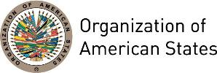

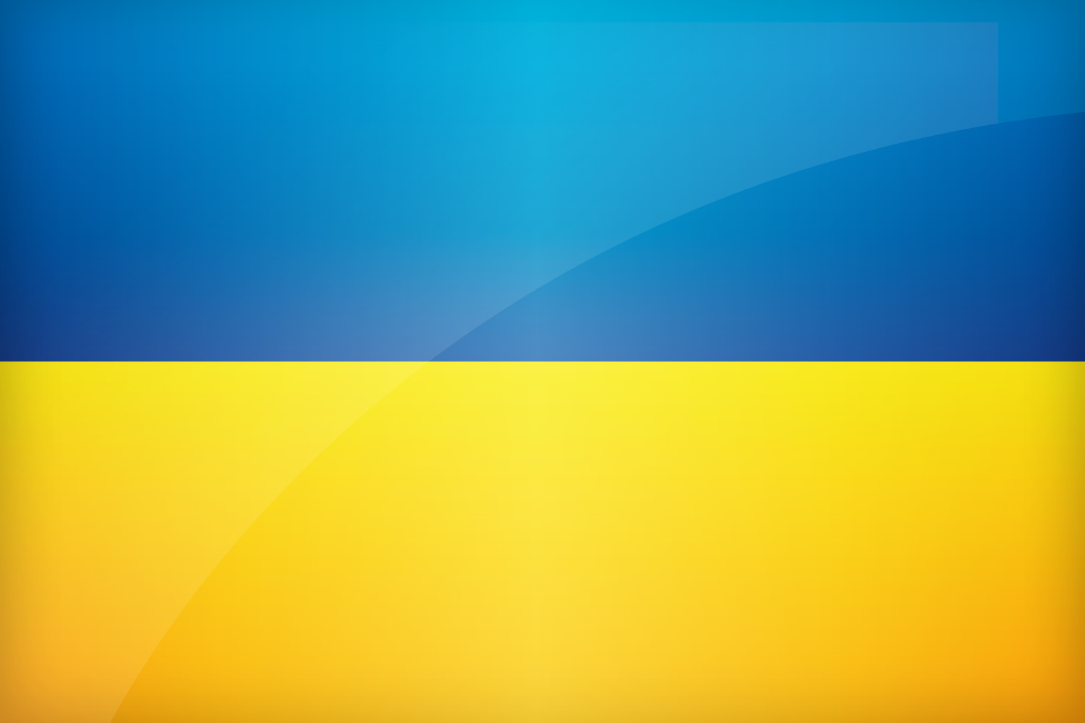
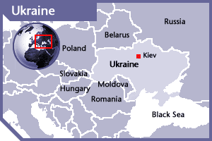

UKRAINE
PERMANENT OBSERVER

Date of Entry: February 27, 2006
National Day: August 24
Capital: Kyiv
Type of Government: Republic
Head of State: President Petro Poroshenko (June 7, 2014)
Head of Government: Prime Minister Volodymyr Groysman (April 14, 2016)
Minister of Foreign Affairs: Pavlo Klimkin (June 19, 2014)
Permanent Observer: Valeriy Chaly (August 3, 2015)

ECONOMIC INDICATORS | 2010 | 2011 | 2012 | 2013 | 2014 | 2015 | 2016
Population (in millions) | 46.01 | 45.87 | 45.7 | 45.59 | 45.43 | 45.15 | 45.00
GDP (US$ in billions) | 136.013 | 163.16 | 175.781 | 183.31 | 133.503 | 91.031 | 93.27
GDP per capita (US$) | 2,965.14 | 3,855.42 | 4,029.71 | 3,104.658 | 2,138.28 | 2124.663 | 2185.718
Source: www.tradingeconomics.com | The World Bank Group

FOREIGN RELATIONS POLICIES:
- The main priority of Ukraine's foreign policy at this time is to end the ongoing Russian aggression and fully restore Ukraine’s sovereignty and territorial integrity, including ending Russia’s illegal occupation of Crimea.
- Ukraine’s key foreign policy priorities include:
  - European integration aimed at becoming a full-fledged member of the European Union (Ukraine and the EU signed Association Agreement in 2014, which includes Deep and Comprehensive Free Trade Area);
  - Euro-Atlantic integration – deepening cooperation with NATO aimed at reaching the criteria of membership in the Alliance;
  - Developing strategic partnership with the United States of America, the European Union, other key international partners;
  - Active engagement with the United Nations (UN), particularly in light of Ukraine’s non-permanent membership in the UN Security Council in 2016-17, with the OSCE and other international organizations;
  - Effective participation in the global economy, promoting economic expansion of Ukrainian goods and services, particularly to new markets in Latin America, the Middle East, Asia, and Africa;
  - Protecting and providing assistance to Ukrainians living abroad, and working closely with the Ukrainian Diaspora.

INVOLVEMENT WITH THE AMERICAS:
- Ukraine maintains Embassies in Argentina, Brazil, Canada, Cuba, Mexico, Peru and the United States.

SOURCES:
MINISTRY OF FOREIGN AFFAIRS OF UKRAINE  http://www.mfa.gov.ua/  EMBASSY OF UKRAINE IN THE UNITED STATES OF AMERICA  http://usa.mfa.gov.ua/en  OFFICIAL WEBSITE ACTING PRESIDENT OF UKRAINE  http://www.president.gov.ua/en/ | WEB PORTAL OF UKRAINIAN GOVERNMENT  http://www.kmu.gov.ua/control/en  WORLD BANK – TRADING ECONOMICS  www.tradingeconomics.com

This page was last updated on July 6, 2017.

