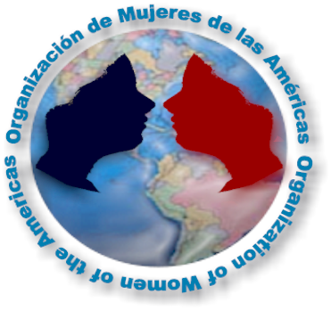

ORGANIZATION OF WOMEN OF THE AMERICAS (OWA)
VIII Food Festival of the Americas
April 30, 2006

APPLICATION FORM - VOLUNTEER LIABILITY RELEASE

Name: ________________________________________________________________________
Address: ______________________________________________________________________

E-mail:_____________________________________ Phone: _____________________________

Organization/School/University/Mission: ____________________________________________

Positions available:
❐ Check-In  Children’s Activities  General Supervision
❐ Information Desk  Entertainment  Security
❐ Event Set-up  Volunteer & Staff Support  Parking / Traffic Control
❐ Clean Up (Pre-during-Post Event)  First Aid Service  Beverage Boot
❐ Take down site  Ticket Boot

Volunteer Shift: Choose your convenience shift. If you would like to make 2 o more shift please select your preference.
❐ 7:00 am – 11:00 am (Set-up)
❐ 11:00 pm – 3:00 pm
❐ 2:00 pm – 6:00 pm
❐ 4:00 pm – To the End (Take down site)

T- Shirt: The Food Festival will be provided a T-Shirt please let us know what is your T- Shirt Size.

Small  Medium  Large  X-Large  XX-Large 

In consideration of the acceptance of my registration, I, for myself, my executors, administrators, and assigns do hereby forever release and discharge the Organization of Women of the Americas, Spanish Catholic Center, Inc, and each of their agents, employees, sponsors, affiliates, and subsidiaries from any and all claims, damages, demands, and actions in any manner arising out of my participation in any activity or event relating to the 2006 OAS Food Festival. I attest and verify that I have full knowledge of the risks involved in this activity/event and that I am physically fit and sufficiently trained to participate in it. I hereby grant to the Food Festival of the Americas Organization Committee full permission to use any and all pictures, recordings, images, or other records of this event, including my participation in it, for any legitimate purpose without compensation or remuneration to me.

______________________________________________________________ ______________________
Signature of volunteer or parent/guardian if under 18 years of age. Date

For more information contact:
Maria Celeste Fuenmayor
Food Festival Volunteer Committee Chair
Organization of Women of the Americas
Email: mfuenmayor@oas.org

Phone: (202) 458-3727 Fax: (202) 458-6854

