Project Proposal
Inter-American Biodiversity Information Network (IABIN)
Development of Value-Added Tools for Decision-Making

A. Project Name: | Internet-Based GIS Ecosystem Assessment and Reporting Tool for Conservation Decision-Making

B. Cover letter signed by the authorized representative of the firm.

C. Contact Information of the Firm
Name of Firm: | The Nature Conservancy
Name of Contact Person(s): | Dr. Steven R. Schill
Address: | The Nature Conservancy- Costa Rica Field Office Mesoamerica & Caribbean Region Science Team PO Box 230-1225 San José, Costa Rica
Country: | Costa Rica
Office Telephone: | (011) (506) 2520-8000
Cell Phone: | 1-(801)-881-7838
Fax: | (011) (506) 2520-8001
Email: | sschill@tnc.org
Website: | www.tnc.org

D. Contact Information of Associated Firm
Name of Firm: | University of Southern Mississippi
Name of Contact Person(s): | Dr. George T. Raber
Address: | Department of Geography and Geology School of Ocean and Earth Sciences 118 College Drive, #5051 Hattiesburg, MS 39406
Country: | United States
Office Telephone: | 1-(601)266-5807
Fax: | (011) (506) 2520-8001
Email: | george.raber@usm.edu
Website: | www.usm.edu/geo
E. Project Summary (English and Spanish)

This proposal is for the development of an Internet-based GIS Ecosystem Assessment and Reporting Tool for conservation decision-making. This Internet-based tool will provide a “manager’s dashboard” approach for querying current spatial information on habitat condition, socio-economic threat, and protected area status for the Mesoamerica and Caribbean region. By integrating biodiversity, socio-economic, and protected area datasets, the Ecosystem Assessment and Reporting Tool will provide a simple, but powerful interface designed to answer questions such as “Which ecosystems are least protected?” “Of these ecosystems, where and how do we need to improve management?” and “Where are the opportunities to most efficiently reduce threats to these ecosystems?” With the advent of new internet-based GIS technologies such as ArcGIS Server, exciting new possibilities exist to go beyond traditional desktop GIS functionality and open advanced analysis techniques in a dynamic and easy-to-use web interface. This project will integrate IABIN’s Ecosystem and Protected Area Thematic Network and permit conservation decision-makers to cross-query ecosystems/species with protected area information, then report back spatial and tabular format user-defined categories on the condition and vulnerability of selected ecosystems/species. This information can then be used by conservation decision-makers to develop strategies and effectively allocate resources and activities to the most appropriate places.

Esta propuesta es para el desarrollo de una Herramienta de SIG basado en Internet para la Evaluación e Informe de Ecosistemas para la toma de decisiones en conservación. Esta herramienta basada en Internet proveerá un enfoque de “tablero de control” para consultar información espacial actual sobre la condición del hábitat, amenaza socio-económica y estatus de áreas protegidas para la región de Mesoamérica y el Caribe. Al integrar conjuntos de datos sobre biodiversidad, socioeconómica y áreas protegidas, la Herramienta para la Evaluación e Informe de Ecosistemas proveerá una interfaz simple pero poderosa diseñada para responder preguntas tales como “Cuál ecosistema es el menos protegido?” “De estos ecosistemas, dónde y cómo necesitamos mejorar su manejo?” y “Dónde están las oportunidades para reducir más efectivamente las amenazas a estos ecosistemas?” Con el advenimiento de nuevas tecnologías SIG basadas en Internet tales como ArcGIS Server, nuevas y excitantes posibilidades existen para ir más allá de la funcionalidad SIG tradicional de escritorio y abrir técnicas avanzadas de análisis en una interfaz Web de fácil uso. Este proyecto integrará a las Redes Temáticas de Áreas Protegidas y Ecosistemas y permitirá a tomadores de decisión en conservación consultar en forma cruzada la información de ecosistemas/especies con información de áreas protegidas, y luego devolver, en formato espacial y tabular, categorías definidas por el usuario sobre la condición y vulnerabilidad de ecosistemas/especies seleccionados. Esta información puede entonces ser utilizada por tomadores de decisión en conservación para desarrollar estrategias y asignar recursos y actividades a los lugares más apropiados de forma efectiva.
F. Project Description

1. Project Background
The Nature Conservancy (TNC) is one of the world’s largest conservation organizations; it works in 50 US states and 30 countries and has conserved over 116 million acres of land and water. Its mission is to preserve the plants, animals and natural communities that represent the diversity of life on Earth by protecting the lands and waters they need to survive. TNC has compiled and organized vast amounts of GIS and remote sensing data throughout Latin America and has developed a variety of conservation decision-support system (DSS) tools and data dissemination web portals designed to serve the needs of the conservation community. In addition, TNC is considered a global leader in applying ecoregional assessments both in the number of ecoregions that have been assessed, and in the development of the approaches, methods and tools necessary to do so (Groves, 2003; Higgins et al, 2005; Tear et al, 2005). These ecoregional assessments involve detailed mapping of conservation features and goal setting, analysis of threats to habitats, and an inventory of protected and other managed areas. The final product is a portfolio of areas that efficiently meet conservation goals. To date, TNC has completed over 140 freshwater, marine, and terrestrial ecoregional assessments with many more currently in progress. Having worked extensively in most countries throughout Latin America, TNC has expert ecosystem, socio-economic, and protected area knowledge and GIS data and is participating consortium members for IABIN’s Ecosystem and Protected Area Thematic Networks.

The proposed project seeks to integrate IABIN’s Ecosystem and Protected Area Thematic Networks by developing an Internet-based GIS Ecosystem Assessment and Reporting Tool designed around TNC’s approach for calculating “Effective Conservation” (Higgins et al, 2007). This approach is a way of measuring progress towards a goal of having 10% of all major habitat types under effective conservation by 2015 (TNC, 2007). An ecosystem achieves effective conservation when biodiversity is expected to persist as a result of conservation actions. The framework for calculating the level of effective conservation uses three measures in combination:
- Biodiversity Status - the biological potential for a given ecosystem to persist (e.g. ecosystem size, condition, and landscape context).
- Threats Status - the degree of anticipated negative impact (i.e. socio-economic activity) to a given ecosystem (e.g. severity, scope of threat).
- Conservation Management Status - the likelihood that management activities will secure biodiversity and allow it to persist (e.g. intent, tenure, and effective management potential).

The calculation of effective conservation for ecosystems requires that biodiversity information, anticipated threat, and on-going conservation management be calculated for each ecosystem patch. Each of these measures will be calculated using several indicators which are combined to develop a final rating for each ecosystem patch. These patch level indicators can then be rolled up to compare among ecosystems. This information will be derived from TNC’s ecoregional assessments which include detailed biodiversity, threat, and conservation management information. This information will be integrated with IABIN’s Ecosystems and Protected Areas Thematic Network data. Each ecosystem patch will be assigned a rating for each of the three measures using the GIS—acceptable or not acceptable. When combined, users will be able to use the Internet-based tool to map and visualize all categories of ecosystem condition (biodiversity, threat, and conservation management status) and generate reports to determine what types of strategies may move each ecosystem patch toward an acceptable level of effective conservation. Only when all three measures are within acceptable levels, then biodiversity is reasonably expected to persist (Figure 1) and effective conservation is achieved. This simple approach provides critical insight into the current status of each ecosystem patch, identifies the restoration, threat and protection improvements that are needed, and can be used to communicate the results of complex data analyses to a broad range of partners, stakeholders and policy makers.

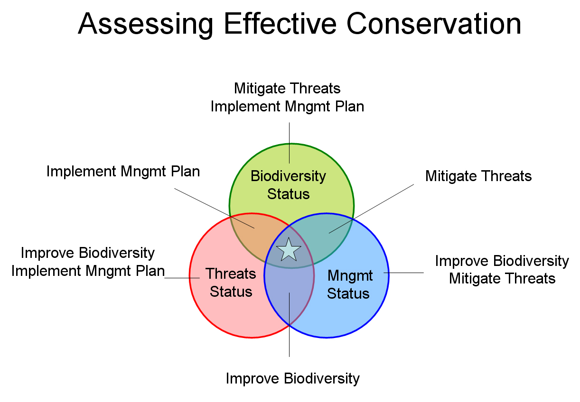
= Effective Conservation
Figure 1. Effective conservation of an ecosystem is achieved when acceptable levels are reached for all three measures: biodiversity, threat, and conservation management status. Knowing the status of each measure for each ecosystem will help decision-makers to know when and where to prioritize and guide effective conservation actions (Higgins et al, 2007).
2. Project Rationale
What is the project’s value to IABIN?
This project is of significant value to IABIN since the proposed work specifically responds to several IABIN objectives—namely providing: a) access to scientifically credible biodiversity status information in the Americas; b) developing tools necessary to draw knowledge from that wealth of resources, which in turn will support sound decision-making concerning the conservation of biodiversity; and c) a mechanism to exchange information relevant to conservation and sustainable use of biological diversity. As both public and private sectors are routinely required to make decisions in an atmosphere of uncertainty and limited resources, this tool will help prioritize the conservation landscape and maximize resources. Decision-makers require up-to-date information on the viability of an ecosystem, the level of socio-economic threat to that ecosystem, and the actual protected area management that is being implemented on the ground. This information can be used to help policy and environmental managers set conservation priorities, respond to critical needs in an effective manner, and distribute limited resources efficiently.

This development of an Internet-Based GIS Ecosystem Assessment and Reporting Tool will provide conservation decision-makers direction on determining the most appropriate places to do conservation work and what actions are needed to improve biodiversity conservation for each ecosystem by explicitly addressing the following questions:
- Where is biodiversity reasonably secure and expected to persist?
- What are the gaps in biodiversity protection and threat abatement?
- Where are there opportunities to expand and enhance biodiversity protection?
- What progress are we making as a result of conservation actions, and what biodiversity has been lost?

Why is it important that this project be implemented?
There is a need to promote greater coordination among Western Hemisphere countries in the collection, sharing, and use of biodiversity information relevant to decision-making and education. The development of an Internet-based GIS Ecosystem Assessment and Reporting Tool will integrate ecosystem, socio-economic, and protected area data and provide an interactive and user-friendly approach to identify conservation gaps and prioritize conservation action. The proposed tool will be built using new Internet-based technology that are linked to existing GIS datasets, designed with flexibility, scalability and diversification in mind. TNC has been working with IABIN on building geospatial datasets and tools for several years and understands the technology components required to implement this value-added tool. This tool will integrate existing TNC ecoregional data with IABIN’s Ecosystems and Protected Area Thematic Networks datasets, maximizing the utility of these data by providing users with advanced query functions and visualization techniques. Users will be able to visualize the current status of each ecosystem patch by combining three categories: biodiversity status, threat status, and conservation management status. In summary, this tool will answer many questions including the following:
- What is the current protection status of each ecosystem?
- How close are we to meeting conservation goals, what percentage has been achieved?
- If I need additional hectares to reach my goal, where are the most suitable areas to implement a protection strategy?

What important issue or need in the region is being addressed?
Prioritization of conservation activities is imperative. A major need of the conservation community is a method to assess the extent of biodiversity under effective conservation at multiple scales, and to provide direction on where to work and what actions may be needed to improve protection and management of biodiversity within ecosystems. The proposed tool will explicitly address this need by providing answers to questions on biodiversity status by ecosystem, identifying the gaps in that biodiversity threat abatement and protection, and finding optimal opportunities to expand and enhance biodiversity protection.

Is there any overlap with existing tools?
With support from IABIN’s DGF project, TNC recently developed a suite of GIS-based tools for assisting countries in the technically challenging process of evaluating and filling protected area gaps. The Protected Area Gap Decision- Support System (DSS) was developed as part of an ongoing process to help fill the technical void that exists in many countries. These tools are available for free download along with a detailed user manual and corresponding example data (http://www.gispatools.org). They are being used in multiple countries around the world, helping countries meet the requirements laid down in the Seventh Conference of the Parties (COP-7) Global Program of Work (PoW) on Protected Areas. While these tools were originally designed to work as stand-alone applications, new versions are currently being developed to operate as server-based tools via a central server. This way, users will be able to operate the tools via remote access in a web browser or other thin client, taking advantage of the faster processing speed of the server, and not needing expensive GIS software installed locally on their machines. The proposed GIS Ecosystem Assessment and Reporting Tool will complement these tools as a series of server-based applications capable of accessing distributed GIS databases using advanced Internet-based GIS software. Users will be able to use the model results from these tools to gain a better understanding of key overlap areas between biodiversity, threat, and conservation management status criteria for each ecosystem, resulting in more effective and efficient conservation decision-making.

How could this be made useful to the IABIN community?
With the recent development of Internet-based GIS software such as Environmental Systems Research Institute’s (ESRI) ArcGIS Server, there exists exciting possibilities to develop server-based tools that provide advanced modeling and reporting functions. Such tools can be developed so they are accessed via the Internet, executed on a remote server, and output results viewed or downloaded locally. TNC has recently invested over $1 million in developing a robust Conservation Information System (CIS) that provides the infrastructure and software needed to develop these tools (TNC, 2007). This system provides an ideal setting to integrate IABIN’s Protected Areas and Ecosystem Thematic Networks, and develop an easy-to-use internet-based GIS tool for assessing the condition, threat, and conservation management status of ecosystems.

TNC is currently implementing ArcGIS Server technology in nine different data nodes that have been set up throughout the world. TNC has invested in ESRI’s GIS technology for many years and uses Arc Spatial Data Engine (SDE) at each data node, providing powerful enterprise data management tools for storing and maintaining thousands of geographic datasets. ArcSDE utilizes the power of enterprise relational database management systems (RDBMS) to organize and serve spatial datasets to desktop and web users. Once the external data nodes are in place, they can be connected to the IABIN network permitting external audiences to access data and GIS capabilities. Because this functionality is server-based, it can readily be accessed by users who do not have desktop GIS software installed locally and even by those that have no training in GIS. This framework provides an ideal infrastructure to design, develop, and serve the proposed tools to the greater conservation community. As with all ArcGIS Server tools, the user will have the choice of executing the tool using ESRI’s ArcGIS Desktop software or downloading and installing ESRI’s freely distributed global three-dimensional client, ArcGIS Explorer. Visualization of model output in will also be available using standard internet browsers or in 3-D using Google Earth for viewing network-served KML files.

How will this work fill existing gaps?
The integration of natural and social science data and information is increasingly recognized as vital to scientific research and societal decision-making related to a wide range of pressing environmental and biodiversity issues (IABIN, 2004). A primary gap has been the lack of integration with ecosystem, socio-economic, and protected area GIS databases. Consequently, there is a need to design and build custom GIS-based tools that will allow conservation decision-makers to:
- Ask questions about an ecosystem’s biodiversity, threat, and conservation management status in an integrated manner
- Visualize and analyze model output based on the initial queries
- Integrate model output to develop scenarios (options and consequences) for decision-makers.
In addition, there is a lack of Internet-based GIS tools for conservation decision-makers. Since the proposed tool will be built using ArcGIS Server, users will be able to query large distributed GIS databases, execute advanced GIS functions, and view model results via an internet browser or other thin clients. Since all model processing is executed on the server, the use of local resources is minimized. This tool will also be user friendly so that non-GIS users can utilize the power of GIS without extensive training.

3. Project Goals and Objectives
When making decisions regarding implementation of conservation strategies or prioritization of resources to certain areas, understanding the current biodiversity status, threat level, and conservation management status of each ecosystem is critical. Conservation decision-makers are continually seeking more dynamic methods for addressing questions such as
- Where is biodiversity reasonably secure and expected to persist within each ecosystem?
- Where are the gaps in effective management of these ecosystems?
- Where are there opportunities to expand and enhance biodiversity protection?
These questions require not only solid base data, but advanced GIS processing and reporting functions in order to calculate, map, and report conditions back to the user.

The primary goals and objectives of this project include the design, build-out, and testing of a user-friendly tool that can be accessed via the Internet and will enable conservation decision-makers to:
- Query, visualize, and report the effective conservation status of each ecosystem. This will involve the integration of ecosystem, socio-economic and protected area GIS databases and be made available to both the public and private sectors using ArcGIS Server.
- Use model results to identify and have the information needed to prioritize geographic areas in order to achieve conservation goals at multiple scales. With often limited resources, conservation decision-makers need to know the value of proposed actions before opportunities for protection or treatment arise. This tool will provide conservation decision-makers a better understanding of the obstacles that they will face in working to achieve conservation goals across a landscape before conservation activities begin.

What will this tool provide?
The proposed tool will provide end users with the data and necessary analysis tools to evaluate each ecosystem and gain valuable insight into what is needed to achieve effective conservation--protected, viable and without significant threat. These goals are measurable since the tool will provide GIS model output and concrete reports on the condition and effective conservation status of all ecosystems. This information will assist decision-makers in setting priorities for guiding conservation actions. This project is relevant to IABIN’s objectives because it will create value-added tools that enhance the decision-making process, integrating ecosystem, socio-economic (threat), and protected area information in a way not previously achieved. The development of this decision-support tool will promote an efficient use of the resources and demonstrate how the integration of information is useful to decision-makers in the public and private sectors and at local, national, sub-regional and regional levels.

With a clear understanding of the spatial patterns of biodiversity, threats and conservation management being implemented on the ground, the conservation landscape can be confidently navigated to success. The desired situation is to have a complete understanding of where conservation and existing human activities are complimentary. With this information, conservation activities can be efficiently targeted toward unmet goals and are more likely to succeed. The GIS Ecosystem Assessment and Reporting Tool will facilitate the identification of the areas that hold the most significant biodiversity with the highest integrity and least threats. Conservation decision-makers will be able to not only identify areas for protection as they do now, but also to prioritize their activities with willing stakeholders. Because each of these data components is defined by geography, it is possible to create a GIS tool that can model the conservation landscape and provide clear conservation priorities.

4. Project Activities and Methodologies
With the ecosystem and protected area databases that are currently being developed through IABIN’s Thematic Networks, there exists tremendous opportunities to leverage these databases with TNC’s ecoregional assessment databases and build value-added tools that can answer conservation-related questions using new Internet-based GIS technology. The GIS Ecosystem Assessment and Reporting Tool will be based on a model that integrates biodiversity, threat, and conservation management status and then provides the results of their interaction in easily digestible maps and reports. These maps and reports can be generated dynamically from the tool and as a result, provide a current prioritization of activities for a given area at any time.

In summary, key project activities will include:
- Design of supporting data model - Design of a data model that integrates TNC’s ecoregional assessment products with the ecosystem and protected area standard format databases into a suitable and efficient framework for internet-based GIS analysis and reporting. The data model will identify how key indicators are combined and produce the desired output products and reports. GIS methods that will be used in the tool will drive the design of the data model.
- Implementation and testing of data model – Ensure that the adopted data model is compatible with proposed GIS methods and produces desired output based on the new integrated ecosystem, socio-economic, and protected areas database. Several terrestrial, freshwater, and marine ecoregions throughout Mesoamerica and the Caribbean will be chosen to prototype and test the tool.
- Hardware setup and loading of supporting database - Consolidation of database onto a robust server with high-speed internet connection with access to IABIN’s existing distributed databases. The database loading and test site will be at TNC’s partner site located at the University of Southern Mississippi’s Department of Geography and Geology.
- Design of model tool and output products - Design of an ArcGIS Server-based tool and method for creating output products that is compatible with approved data model. The tool will be designed primarily for use by non-GIS people who will have little to no GIS technology training and will allow users to build complex spatial queries based on the data model. Execution of the geoprocessing services will occur on the remote server, where the data is located. An email will notify the user once geoprocessing is complete and model output and reports are ready for download. Users will have the option of visualizing model results using an Internet browser, Google Earth, or ArcGIS Explorer, a free viewer which offers direct connection to geodatabases, to open source Web Map Services (WMS).
- Implementation and testing of tool - Implementation and testing of the tool will be conducted using centralized and distributed databases within a variety of clients (e.g. Internet browser, Google Earth, ArcGIS Explorer).
- Delivery of final report and tool with accompanying user manual – A final report will be written and delivered with the implementation of the tool and accompanying user manual. All documents will be translated into English and Spanish.

The data model will be designed so that each of the effective conservation indicators (e.g. biodiversity, threat, and conservation management status) will receive an acceptable (1) or unacceptable (0) score. Based on the combination of these indicators, an effective conservation class will be assigned for each ecosystem patch. Each patch will be assigned one of seven possible classes (Table 1). The assignment of this score will be based on the intersection of one or more of these indicators with the ecosystem classes. Figure 2 shows a hypothetical example of what the proposed graphic user interface might look like. This design may be modified based on user needs, input, and testing.

Table 1. Simple data model showing how the different combinations (acceptable= 0 and unacceptable= 0) of effective conservation indicators (e.g. biodiversity, threat, and management status) result in the assignment of a class and proposed ecosystem conservation action.
Biodiversity  Status | Threat  Status | Conservation Management  Status | Effective Management  Class | Proposed Ecosystem  Conservation Action
1 | 1 | 1 | 1 | Maintain Effective Conservation
0 | 1 | 1 | 2 | Improve Biodiversity
1 | 0 | 1 | 3 | Abate Threats
1 | 1 | 0 | 4 | Implement Better Management
0 | 0 | 1 | 5 | Improve Biodiversity and Abate Threats
1 | 0 | 0 | 6 | Abate Threats and Implement Better Management
0 | 1 | 0 | 7 | Improve Biodiversity and Implement Better Management

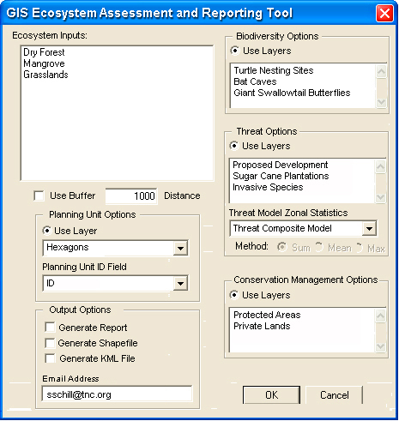
Figure 2. Hypothetical design of the graphic user interface for the GIS Ecosystem Assessment and Reporting Tool. Additional dialog boxes will be added to enable users to specify the attribute fields to be used for each of the indicator options.

Figure 3 shows a hypothetical example of spatial data output showing the proposed conservation action classes calculated for a single ecosystem. Conservation decision-makers can use this information to determine how much of each ecosystem patch is effectively conserved and set priorities and implement corresponding action plans to fill gaps. Users will be able execute the tool as a “task” in ArcGIS Explorer and view/query model output. In addition to the custom functions that will be designed, users will have access to many standard GIS functions that are already part of ArcGIS Explorer software (Table 2).

Table 2. Available GIS functions that come programmed within ArcGIS Explorer.
Select and Zoom to a Project Area | Display Project Layers and Tables | Toggle Display of Layers
Display Layer Thematically | Change Layer Symbology | Zoom to the Extents of a Layer
Zoom In, Zoom Out, Zoom to Rectangle, Zoom Extents, Pan | Identify Attributes of a Feature | View Attribute Table of a Layer
Select Features By Location | Select Features By Attributes | Zoom to Selected Features
Buffer Feature | View WMS Datasets

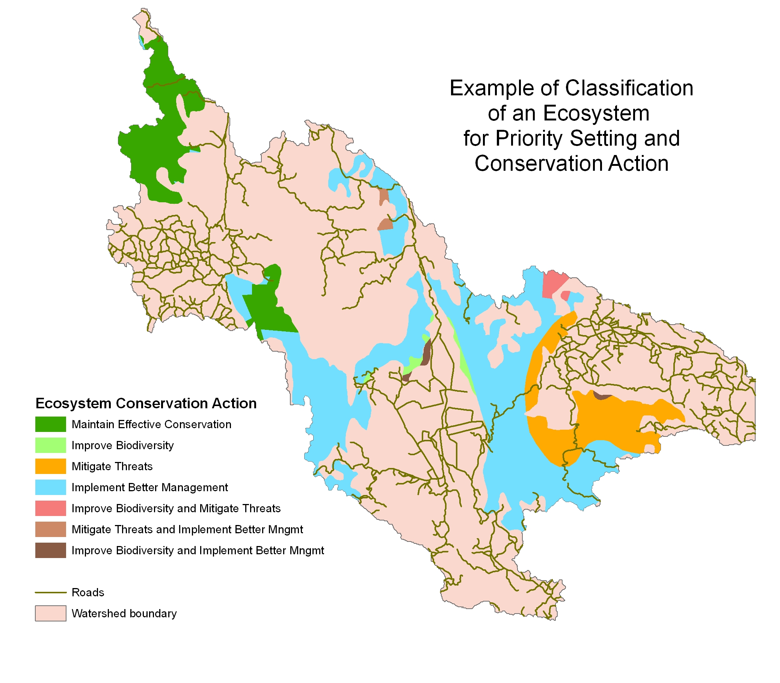
Figure 3. A hypothetical example of spatial model output for a watershed showing the classification of ecosystem conservation action classes based on the combination of biodiversity, threat, and conservation management status indicators. The dark green polygons show areas that have achieved effective conservation. This information can be used by conservation decision-makers to determine how much of the ecosystem is effectively conserved and set priorities and corresponding action plans to fill gaps.

The customized functions will produce a variety of area calculations and report generations from simple to complex, based on the request of the user. For example, if a user wants to calculate the current protected status of a particular forest ecosystem patch, the user chooses the forest ecosystem and conservation management layer, selecting the corresponding fields of interest (e.g. protected area management attributes). As additional options, users will be able to enter a buffer distance to be used as part of the analysis or summarize model results in planning units such as hexagons or watersheds. Upon execution, the layers are intersected and new output files and tables calculated and made available for use. The user is then able to visually assess the condition of protected status for the forest ecosystem patch and examine the cross-tabular reports with corresponding hectare totals. A more complex analysis is the intersection of an ecosystem patch with all three indicators. This tool will provide the framework to calculate a variety of useful summary statistics which will facilitate a more effective implementation of conservation strategies. Users will also be able to download the reports, GIS and KML files, and export internet-served maps to JPG format on a local drive.

5. Time Frame and Work Plan
The proposed tool will take one year (12 months) to design, develop, and deliver final products. Each of the five project tasks are shown in Figure 4 with corresponding timeline for completion. It is anticipated that the data model will take four months to complete and integrate into the spatial database. Over the following six months, the hardware set up and loading of the database will occur at the same time as the design and build out of the tool. The last two months will be spent implementing and testing (debugging) the tool on a variety of networks using different clients.

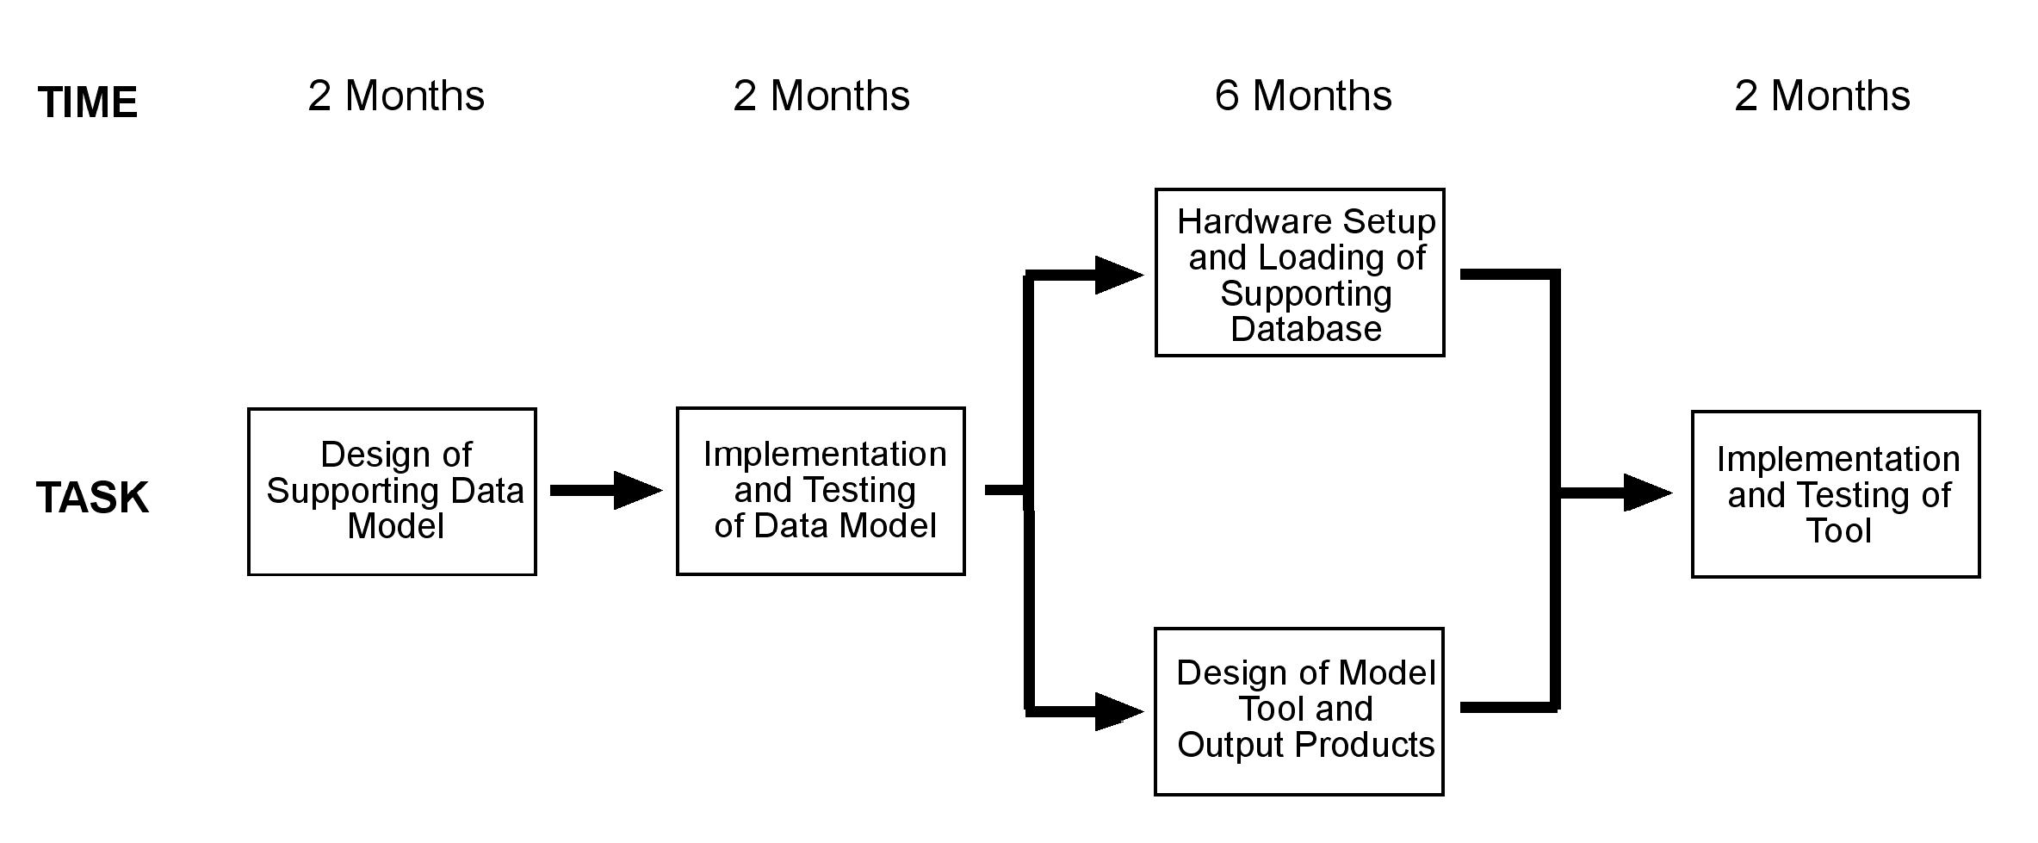
Figure 4. Work flow diagram showing major tasks for the design and implementation of the GIS Ecosystem Assessment and Reporting Tool and corresponding timeline.

Dr. Steve Schill will coordinate the project, working closely with two TNC science teams from the Mesoamerica and Caribbean (San José, Costa Rica) and Rocky Mountain (Boulder, CO) regions. Dr. Schill will lead the team in identifying key needs, then designing and developing the tool, working closely with Dr. George Raber from the University of Southern Mississippi. Dr. Raber has been working with TNC for several years and has played a key role in the development of the Protected Area Tools and many other ArcGIS Server applications and tools currently in use by TNC. William Ulate is the Conservation Information System Manger for Mesoamerica and the Caribbean and will oversee the development and integration of the ArcSDE database. The test site for the database and tool deployment will be from a server based at the Department of Geography and Geology at the University of Southern Mississippi. TNC has designed and tested previous ArcGIS Server applications here which benefit from the broad-band internet connection and fast server processing capacity that are available. Members of the application design team will include ecologist Terri Schulz from Boulder, CO and Dr. Maarten Kappelle from San José, Costa Rica. Supporting GIS experts will be Kei Sochi from Boulder, CO and Marco Castro from San José, Costa Rica.

Dr. Steve Schill will oversee all work activities and ensure that the schedule is met and that each product is delivered on time. He will submit the required progress reports in a timely manner and make regular contact to inform status updates or difficulties with the lead IABIN Secretariat or project coordinator. Performance will be evaluated by frequent review and testing of the tool as requested by IABIN.

Products developed will be submitted according to work plan and made freely available through the IABIN web site. Final products will include:
- Prototype ArcSDE databases for several ecoregions throughout the Mesoamerica and Caribbean region integrated with IABIN’s Ecosystem and Protected Area databases.
- Internet-based GIS tool with functionality as explained and accompanying user manual (translated into both English and Spanish)
- Final Report (translated into both English and Spanish)

With additional funds following the conclusion of the project, TNC is able to offer training in the use of the tool at strategic locations throughout Latin America. The Mesoamerica & Caribbean Science team holds capacity building workshops on a regular basis in several countries and could use the extensive knowledge networks that are already in place to advertise the tool to a broad audience.

6. Team Composition and Task Assignment

Name | Firm | Area of Expertise | Position | Task
Dr. Steve Schill | TNC | Conservation GIS Scientist | Project Coordinator | Project Coordination
Dr. George Raber | USM | GIS Programming | Lead Programmer | Lead Programmer
Terri Schulz | TNC | Ecologist | Application Designer | Application Design
Dr. Maarten Kappelle | TNC | Ecologist | Application Designer | Application Design
William Ulate | TNC | Database Expert | Database Manager | Database configuration and support
Kei Sochi | TNC | GIS Expert | GIS Analyst | GIS Support
Marco Castro | TNC | GIS Expert | GIS Analyst | GIS Support

7. CVs of Proposed Staff
Steven R. Schill, Project Coordinator
Dr. Steven R. Schill has over fifteen years of working in the geospatial data industry and is currently Senior Geospatial Scientist for The Nature Conservancy’s Mesoamerica & Caribbean Region. In that role, he coordinates all mapping, training, and GIS tool development for conservation partners across fifteen countries in Latin America. Previous work positions include five years as Project Manager for NASA’s Affiliated Research Center and Director of Geospatial Data Services for Geometrics, Inc. Dr. Schill received his Ph.D. in Geography from the University of South Carolina and specializes in remote sensing and conservation GIS.

George Raber, Lead Programmer
Dr. George Raber is currently a full time faculty member in the Department of Geography and Geology at the University of Southern Mississippi. A position he has held for the past 5 years. He has served as the primary software engineer for a number of geospatial applications with the Nature Conservancy. These efforts include the GIS-based Protected Area Tools referenced above, the Mesoamerica and Caribbean Region ArcGIS server implementation, and the Climate Calculator (an online tool for retrieving multi-temporal geospatial climate data). Dr. Raber also has an active research teaching and publication record and received his Ph.D. in Geography from the University of South Carolina (2003), specializing in spatial analysis.

Terri Schulz, Application Design
Terri Schulz has over fifteen years of conservation monitoring and measures of success experience with The Nature Conservancy. She is currently Director of Landscape Science and Management for The Nature Conservancy of Colorado. In this role, she is responsible for implementing conservation action planning and site-based measures of conservation success throughout Colorado, delivering site-based measures tools, training and development of “best practices” to Conservancy staff and partner NGOs and government agencies. Terri is a member of Colorado statewide measures team and responsible for designing conservation management status indicators and methodology and for developing strategy effectiveness measures for TNC’s Great Plains Initiative.

Maarten Kappelle, Application Design
Maarten Kappelle received his Ph.D. in Tropical Ecology in 1995 from the University of Amsterdam. Since 2005 he has been responsible for directing The Nature Conservancy’s Regional Science Program in the Mesoamerica and the Caribbean Region. Dr. Kappelle has conducted research in Latin America for over twenty years and is well known for his extensive experience in plant community ecology and landscape ecology of tropical forests and grasslands. He has published eight books and over 100 articles in journal papers, edited books, magazines and newsletters. Dr. Kappelle serves on a variety of steering committees including the World Conservation Union’s (IUCN) Commission on Ecosystem Management, IABIN’s Executive Committee, and on The Nature Conservancy's Science Leadership Team.

William Ulate, Database Design
Mr. Ulate is the Regional Conservation Information System (CIS) Manager for The Nature Conservancy’s Mesoamerica & Caribbean Region, based in San José Costa Rica. He is currently a member of various technical bioinformatics groups such as GBIF’s Science Committee and the Biodiversity Information Standards. Previously, he worked at INBio (Instituto Nacional de Biodiversidad in Costa Rica) developing a biodiversity information management system (the ATTA project) with a database of more than 3 million specimens and their related eco-geographic and taxonomic information. As Coordinator of INBio’s Informatics Developments Unit, William developed and integrated biodiversity information systems, databases, and web mapping applications. In 2005, he was Technical Coordinator for IABIN Species and Specimens Thematic Network and a member of the Technical Group of I3N. He graduated from Computer Science and Informatics at the Universidad de Costa Rica in 1990.

Kei Sochi, GIS Support
Ms. Sochi oversees the geographic information systems group and provides spatial analyses and cartographic support at the Colorado field office of The Nature Conservancy. She earned her A.B. from Princeton University and a M.A. in Sociology/Demography from the University of Pennsylvania. Previous to arriving at her current position, Ms. Sochi worked as a biostatistician for the University of Pennsylvania Medical School as well as a GIS specialist and data manager for the Nevada field office and the Western Regional Office of The Nature Conservancy. As the GIS manager in the Boulder office of The Nature Conservancy, Ms. Sochi has provided GIS support for conservation planning and analysis at the regional, state and local levels in addition to delivering cartographic products for the various conservation and protection activities undertaken by the chapter.

Marco Castro, GIS Support
Mr. Castro is a GIS specialist for The Nature Conservancy’s Mesoamerica and Caribbean Region. He has sixteen years of experience working with GIS and Data Management. He has a BSc. in Geography from the University of Costa Rica with postgraduate studies in Tourism (CEPEIGE, Quito Ecuador), Conservation Planning and Strategies (Monterrey Institute of Technology of Mexico) and Geographical Information Systems (University of San Francisco, Quito, Ecuador). He has worked as a GIS Manager for nine years at Costa Rica’s Instituto Nacional de Biodiversidad (INBio). At the INBio, he also supported the design and implementation of the GIS module within the framework of its Biodiversity Management Information System (BIMS) and integrated, internet-based, interactive ATTA System. Marco worked for three years as the GIS and Database Administrator at the OTS (Organization of Tropical Studies)-administered La Selva Biological Station in the Atlantic lowland rain forest zone of Costa Rica.

8. Staffing Schedule
The principal staff for the project will be Steve Schill and George Raber who will lead the design and development of the tool for twelve consecutive months. Application designers Terri Schulz and Maarten Kappelle will be involved in the initial data model and tool design and assist with the final implementation of testing. William Ulate will be involved at all stages of the data model development, database integration, and loading/testing of the database on the server. Kei Sochi and Marco Castro will provide GIS support on an as-needed basis. Part-time secretarial support will also be needed for administering the grant and helping with the translation of documents.
No. | Name of Staff | Staff Input |  |  |  |  |  |  |  |  |  |  |  |  | Total Staff-Month Input
No. | Name of Staff | 1 | 2 | 3 | 4 | 5 | 6 | 7 | 8 | 9 | 10 | 11 | 12 | n | Home | Total
1 | Steve Schill |  |  |  |  |  |  |  |  |  |  |  |  | 12 |  | 12
2 | George Raber |  |  |  |  |  |  |  |  |  |  |  |  | 12 |  | 12
3 | Terri Schulz |  |  |  |  |  |  |  |  |  |  |  |  | 3 |  | 3
4 | Maarten Kappelle |  |  |  |  |  |  |  |  |  |  |  |  | 3 |  | 3
5 | William Ulate |  |  |  |  |  |  |  |  |  |  |  |  | 8 |  | 8
6 | Kei Sochi |  |  |  |  |  |  |  |  |  |  |  |  | 3 |  | 3
7 | Marco Castro |  |  |  |  |  |  |  |  |  |  |  |  | 3 |  | 3
8 | Secretarial |  |  |  |  |  |  |  |  |  |  |  |  | 3 |  | 3
 |  |  |  |  |  |  |  |  |  |  |  | Subtotal |  |  |  | 44

9. Work Schedule
No. | Activity | Months
No. | Activity | 1 | 2 | 3 | 4 | 5 | 6 | 7 | 8 | 9 | 10 | 11 | 12
 | Delivery of Detailed Work Plan
 | Design of Supporting Data Model
 | First Progress Report
 | Implementation and Testing of Data Model
 | Second Progress Report
 | Hardware setup and Loading of Supporting Database
 | Design of Model Tool and Output Products
 | Beta Version of the Value-Added Tool and User Manual
 | Demonstration Events
 | Implementation and Testing of Tool
 | Third Progress Report
 | Two Demonstration Events
 | Delivery of Final Report and Tool with User Manual

10. Relevant Literature
Groves, C. R. 2003. Drafting a Conservation Blueprint: a Practitioner's Guide to Regional Planning for Biodiversity. Washington, D.C. Island Press.

Higgins, J., R. Unnasch, and C. Supples. 2007. Ecoregional Status Measures Version 1.0: Framework and Technical Guidance to Estimate Effective Conservation. The Nature Conservancy, Arlington, VA.

Higgins, J., M. Bryer, M. Lammert and T. FitzHugh. 2005. A Freshwater
Classification Approach for Biodiversity Conservation Planning. Conservation Biology 19(2) 432-445.

Inter-American Biodiversity Information Network (IABIN). 2004. The IABIN Development Grant Facility Project Implementation Plan: Year 1. City of Knowledge, Panama.

Tear, T.H., P. Kareiva, P. Angermeier, P. Comer, B. Czech, R. Kautz, L. Landon, D. Mehlman, K. Murphy, M. Ruckleshaus, J. M. Scott, and G. Wilhere. 2005. How much is enough? The recurrent problem of setting measurable objectives in conservation. BioScience 55:835-849.

TNC. 2007. Conservation Data & Information Systems Overview, Conservation Science, Conservation Strategies Division, The Nature Conservancy, Arlington, VA.

TNC. 2007. Conservation by Design: A Strategic Framework for Mission Success, The Nature Conservancy, Arlington, VA

G. Summary of Costs

Category | IABIN Funds
ITEM | IABIN Funds
Personnel
Project Coordinator | $20,000
Lead Programmer | $20,000
Application Designers | $ 8,000
GIS Support | $ 8,000
Secretarial Support | $ 4,000
Subtotal | $60,000
Travel
International | $10,000
Subtotal | $10,000
Software and Hardware
Servers and Network Infrastructure | $ 5,000
Subtotal | $5,000
Grand Total | $75,000

Co-Financing Category | Year 1 Co-Financing Amount |  | Total Co-Financing
ITEM | TNC | USM | Total Co-Financing
Personnel
Ecosystem/Biodiversity Experts | $15,000.00 | $0.00 | $15,000.00
GIS and remote sensing experts | $20,000.00 | $10,000.00 | $30,000.00
System and network administrators | $3,000.00 | $0.00 | $3,000.00
Programmers | $0.00 | $10,000.00 | $10,000.00
Secretarial Support | $2,000.00 | $1,000.00 | $3,000.00
Subtotal | $40,000.00 | $21,000.00 | $61,000.00
Travel
International | $6,000.00 | $3,000.00 | $9,000.00
Subtotal | $6,000.00 | $3,000.00 | $9,000.00
Software and Hardware
Servers and Network Infrastructure | $35,000.00 | $5,000.00 | $40,000.00
Software | $25,000.00 | $0.00 | $25,000.00
Dedicated Line (T1-T3) | $15,000.00 | $0.00 | $15,000.00
Subtotal | $75,000.00 | $5,000.00 | $80,000.00
Grand Total | $120,000.00 | $29,000.00 | $150,000.00

