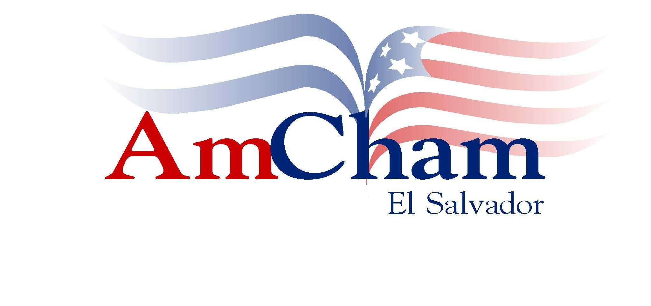

THE OCCUPATIONAL SAFETY AND HEALTH ( OSH)
HEMISPHERIC LEADERSHIP MEETING
IN PREPARATION FOR THE 2005 WORLD SAFETY AND HEALTH CONGRESS
Washington, D. C. September 24th.

DAVID R. HUEZO , PRESIDENT
AMERICAN CHAMBER OF COMMERCE OF EL SALVADOR

"INCORPORATING OCCUPATIONAL SAFETY AND HEALTH INTO CORPORATE SOCIAL RESPONSIBILITY"

"LET´S ADD AND MULTIPLY"

I

A. For years in the business world it has been said ( and it is probably still being said in most parts of our planet):

“People are your most important asset “.

Then about three years ago, Jim Collins came along and in his book Good to Great told us:

“People are not your most important asset, the right people are”

B. Threats and opportunities.

Individuals, groups, societies, as well as countries come together and join forces under either: a common threat or a common opportunity.

For the ones sitting at this table and those we represent, a common business threat , especially in terms of job losses ( ….and let us not forget that one of the most fundamental rights of any individual is to hold a job.. and that the relevance of OSH is because someone has a job!) is Asia , and more specifically continental China. In light of this, the common opportunity is for us to join forces and work towards common goals and objectives, within which is the more effective advancement of OSH in the hemisphere.

That which occupies us today, and in particular the topic "Integrating Occupational Health and Safety into Corporate Social Responsibility" makes us focus on the “third” of the nine areas [ 1) mission /vision ; 2) ethical values; 3) Place of Work; 4) human rights; 5) environment; 6) marketing; 7) community; 8) public policies; and 9) governance] in which, according to our definition, a company reflects good corporate /business social responsibility : "The place of work" , which of course includes and covers occupational health and safety.

C. Let me thus propose to you this afternoon a modified statement, (based on Jim Collins´ quoted above) which I believe is a better reflection of our focus (and opportunity today):

“It is the right people, working in the right environment, under the right conditions, that are the most important asset"

II

Current global and regional conditions as well as trends, are such, that there is a particularly favourable alignment and coincidence of interests that provide all interested and relevant players, a unique opportunity to form a "working partnership” to join forces and efforts in order to multiply and speed up results on the advancement of occupational health and safety" .

Specifically: to work towards achieving a much more effective and faster adoption compliance of OSH practices through:
A) Coordinated strategies & efforts
B) Complementing / joining resources.

III

Based on what justification, you might ask?

A. Governmental entities / agencies

- Are either non existent or incipient / in evolution, particularly in terms of pertinent legislation.

- Non existence /or limited nature of "incentives" to the employers/business sector. Rather a punitive approach prevails, (which of course can at times be justified, but it should not be the only approach).
- Limited /or under funded supervising/enforcement agencies/entities.

- But above all, the need to join official and private efforts is justified, given the nature of the task and effort involved; the former are of such a daunting scale and the availibity of resources so limited, that by necessity only a very limited segment of the universe in question is effectively reached and helped under the current approach.

Let me exemplify this, as not to belabour the point.

The USA, the richest nation in the planet, with 30 years of track record of working on the topic, given the level of resources it dedicates to OSH can only inspect about 2% of all the working places it “should” per year. Put in another way: with the $450 million dollars that USA dedicates every fiscal year to OSHA , it would take more than 160 years to cover all the work places that require inspection.

This begs the question: Then what situation is to be expected in other less powerful or developing countries?

B. Now from the business side:

- Globalization is forcing our companies to be more productive, competitive, to add value and differentiate.

- There is, increasing realization that CSR/BSR, (i.e." its nine good business practices" mentioned before - including under 3, OSH) are "good business" for sustained growth and development.

- Qualifying Criteria:

- Access (through trade agreements) to major world markets.
- Support for capacity building/ development ( international agencies)
- Official funding / grants ( World Bank, US-AID,etc)
- Loans / International placements ( private banks/ stock markets)
- Foreign Investment (private and institutional)

All the above are increasingly using required certification of compliance with values, principles, practices (including OSHA) of CSR/BSR as qualifying and differentiating criteria.

4) Workers themselves (specially the most talented, qualified, creative
and innovative ones ) , are selecting places to work that practice CSR/ BSR and that have it as integral parts of their culture.

- Last but not least: Consumers, when acquiring goods and services, are increasingly taking into account CRS/BSR compliance (including OSHA)

IV

A. Both CSR/BSR as well OSH (within CSR) are in process of evolution.

B. The number of companies (large local ones, Trans nationals, and /or small but progressive ones) that have so far actively embraced CSR/BSR are still a small number compared to the large universe yet to be reached; thus the need to reach many, many more, as quickly and as effectively as possible.

V

Therefore a Proposal:

“A two-pronged collaborative approach"

A. Use CSR/BSR Networks in the hemisphere, to further advance OSHA to a broader segment of the business and labour communities; fundamental here is that it be done on a “ voluntary and incentive driven fashion ( like VPP- Voluntary Protection Program in the USA -- which as you all know ,has proven to be a success story unparalleled yet).

B. Develop joint programs, private sector and government. There are good recent examples of this in Central America:

(i) USAID regional approach to OSH - pilot project
(ii) Coordinated efforts by FUNDEMAS (private sector CSR/BSR), the
Salvadorian government, BSR (USA) effort, to put CRS/BSR (which
Includes OSH) in the country’s National Agenda.

VI

In terms of a proposal as preparation for the 2005 World Safety and Health Congress:

A. Select 1-3 countries and/or a region (could be Central America) and perform a comparative analysis of the effectiveness in OSH coverage/ compliance under two different scenarios:

1. STATUS QUO/ (“business as usual “government and its agencies continue going at it alone).

2. Collaborative effort between the governments/ agencies and private sector through CSR/ BSR associations’ network; the later participation, being based exclusively under a "voluntary, incentive driven, recognition program" like the VPP.

B. Estimating/ measuring:

- Incremental number of companies covered
- Reduction of Implementation time required
- Costs involved
- Reduction of incidents
- Increase competitiveness of companies / countries in the world markets, by the “ branding” of good CSR/BSR practices [ including work place ]
- Increase the attraction of FDI.

C. This proposal requires work and research by interdisciplinary teams, thus, the need for a joint task force that could be structured as follows:

- OSH Official Agencies/ Government.
- USA AID
- “Forum” ( CRS/ BSR alliance in Latin America which includes private sector associations like FUNDEMAS in El Salvador, dedicated to promoting CSR / BSR; Forum currently includes associations in : USA, Canada, Mexico, Guatemala, El Salvador, Peru, Brazil, Chile, Uruguay, Argentina y Panama)

VII

Delivery at 2005 WSC:

1. Introduction / Rationale for the research initiative.
2. Report principal findings
3. Present Conclusions and Recommendations
4. Interaction amongst panellists

5. Feedback from participants / public

VIII
Visual Aids:

- 1-2 pages summary to be distributed among participants
- Power Point Presentation

IX.

On closing, a reminder:

“If you keep doing what you have been doing, you will keep getting the same results"

X.
Thank you for your attention and look forward to your comments and suggestions.

D.R. Huezo
-----------------------------------------+-------------------------------------------------

