APPENDIX III: SECTION 5.0
PHOTOGRAPHS OF TYPICAL INFRASTRUCTURE ELEMENTS
IN ST. LUCIA

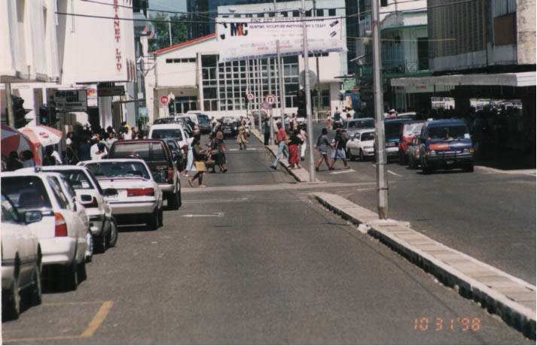

Figure A3-1. Main Street in Castries

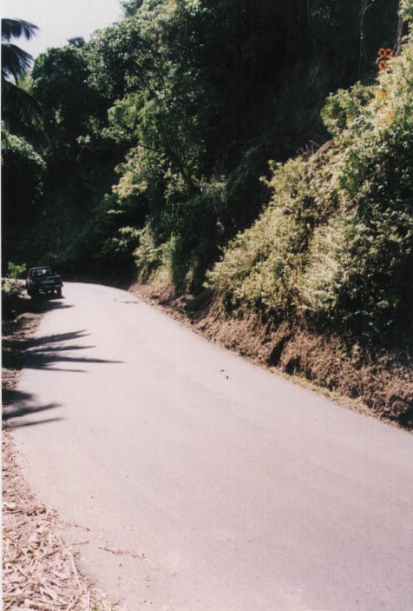

Figure A3-2. Country Road with Potential Road Side Hazard Slide

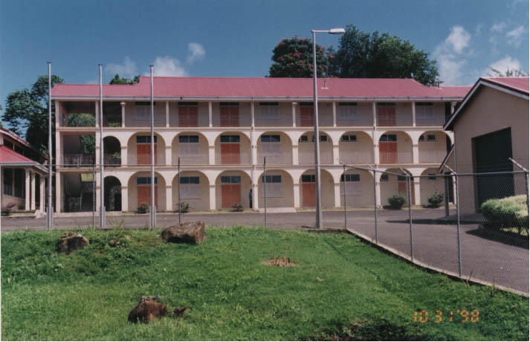

Figure A3-3. Main Building of Technical College

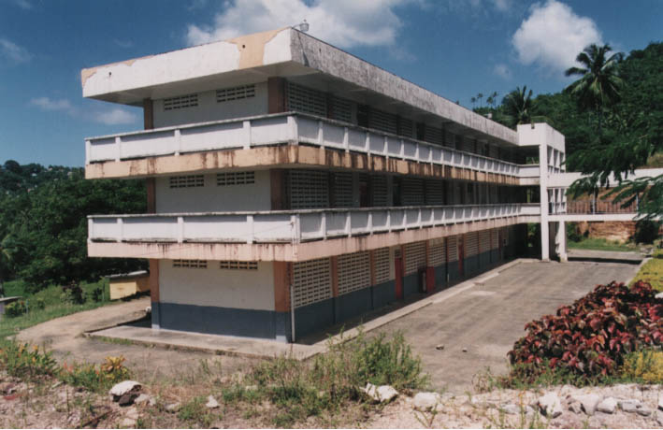

Figure A3-4. Typical Secondary School

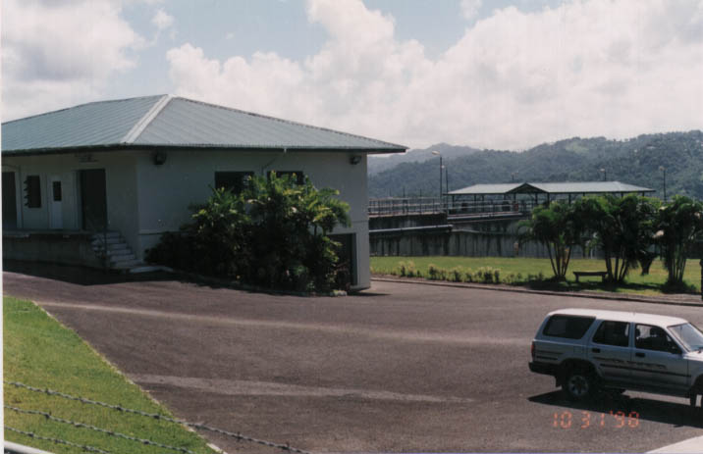

Figure A3-5. Water Treatment Plant

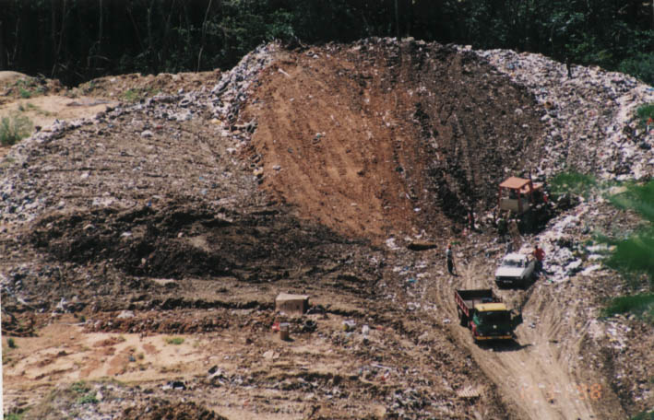

Figure A3-6. Solid Waste Management Site

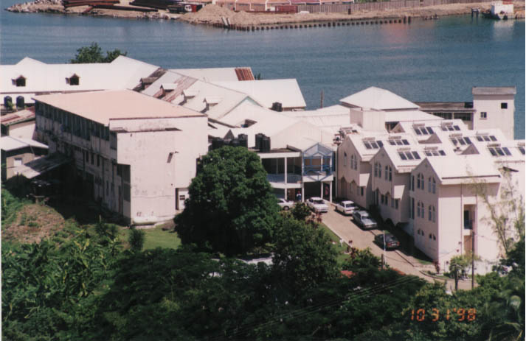

Figure A3-7. Main Hospital Complex

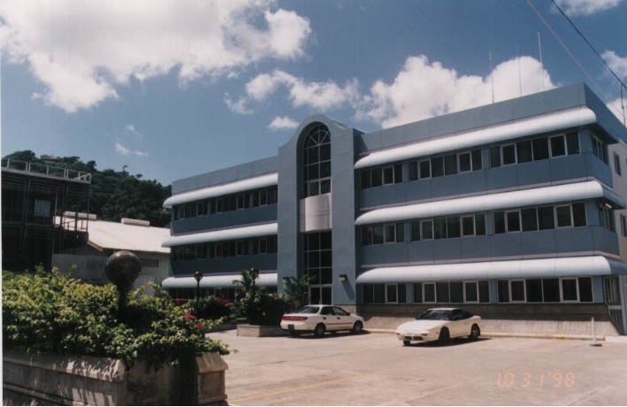

Figure A3-8. Institutional Building – SLASPA Castries

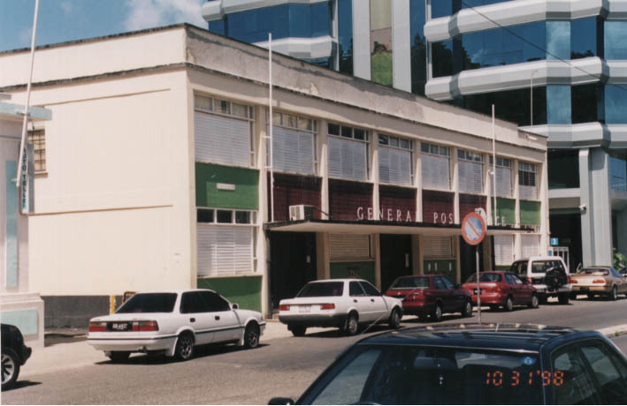

Figure A3-9. Institutional Building – General Post Office

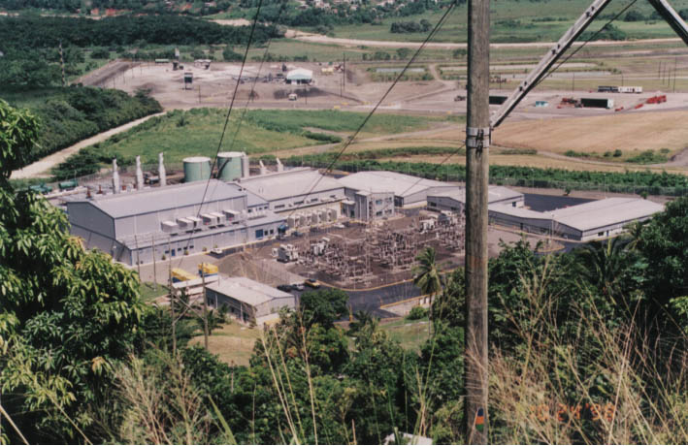

Figure A3-10. View of Main Power Station – Cul-De-Sac

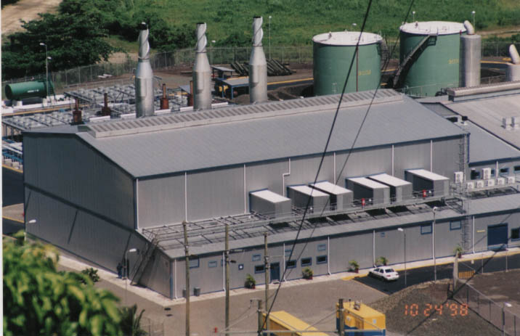

Figure A3-11. Main Building in Power Station – Cul-De-Sac

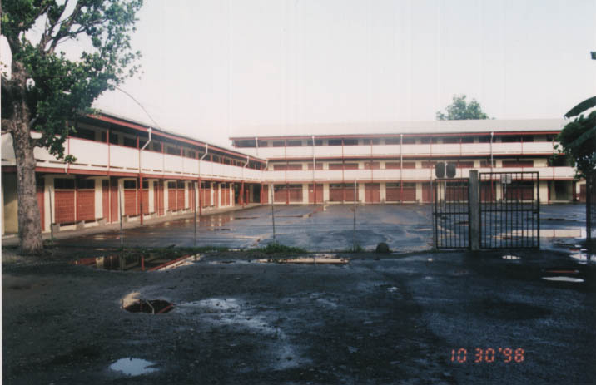

Figure A3-12. Typical Primary School

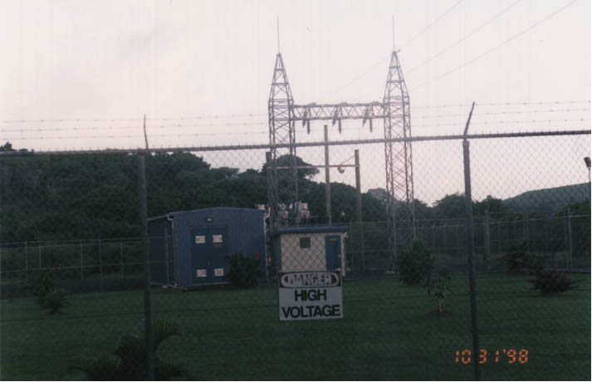

Figure A3-13. Typical Sub-station

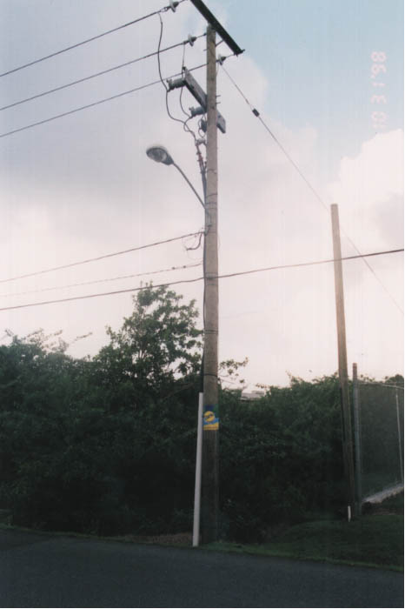

Figure A3-14. Typical Pole

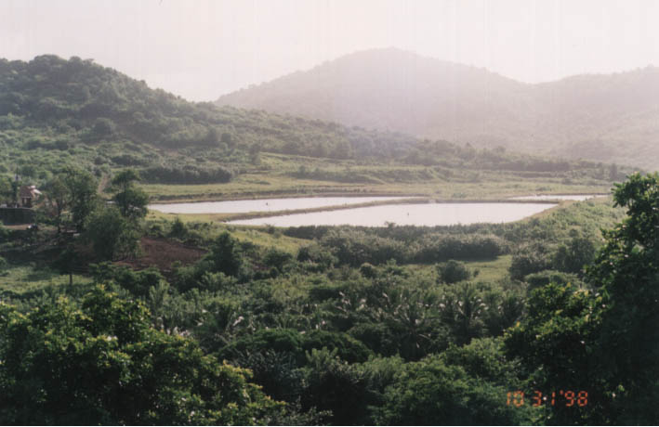

Figure A3-15. Stabilization Ponds – Sewer Plant

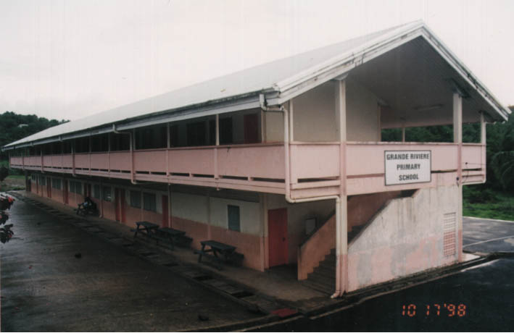

Figure A3-16. Primary School

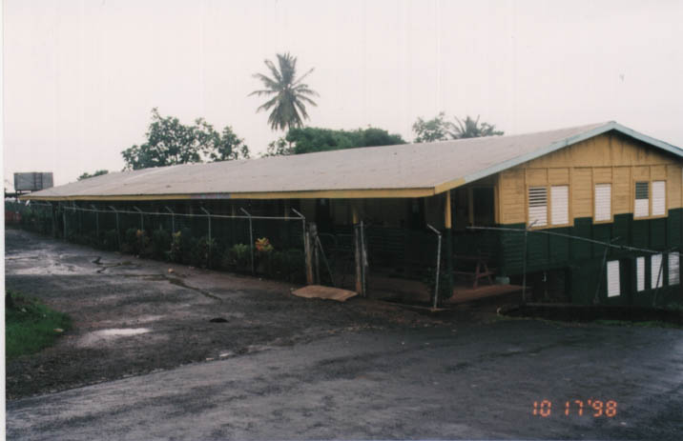

Figure A3-17. Infant School

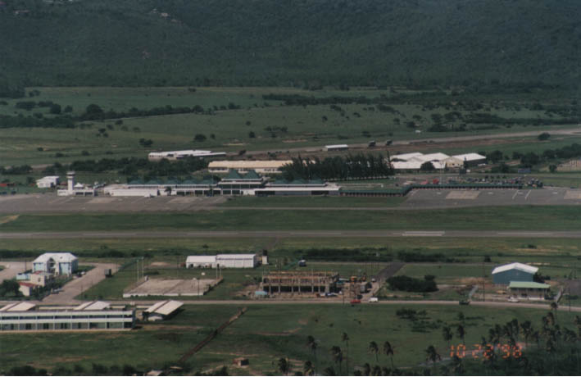

Figure A3-18. Hewanorra Airport – Terminal and Runway

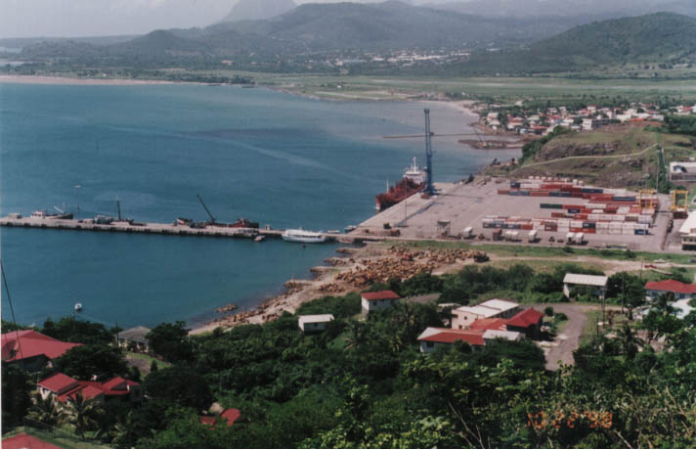

Figure A3-19. Port Vieux Fort – SLASPA

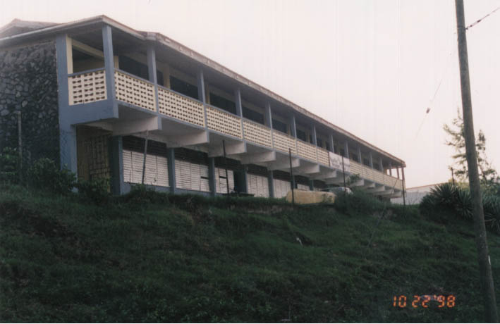

Figure A3-20. Typical Comprehensive School

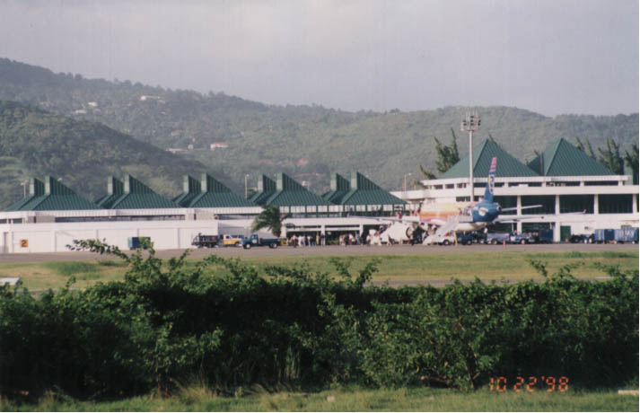

Figure A3-21. Hewanorra Airport Terminal Building

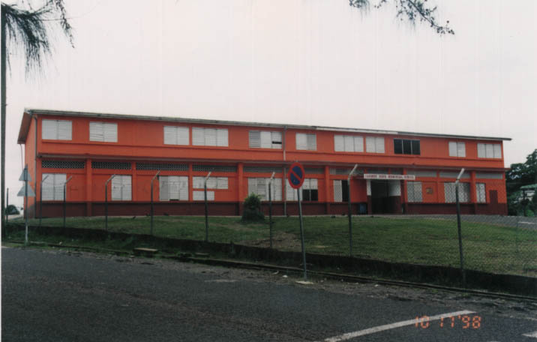

Figure A3-22. Older Block Work Primary School

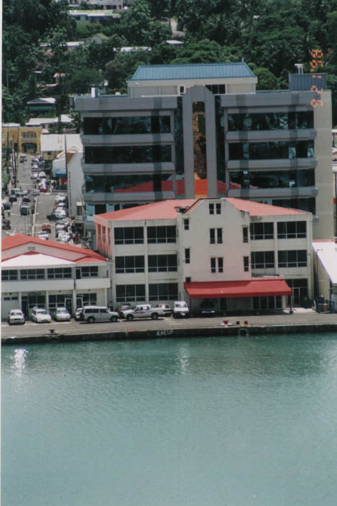

Figure A3-23. Institutional Buildings – Fisheries Complex Castries

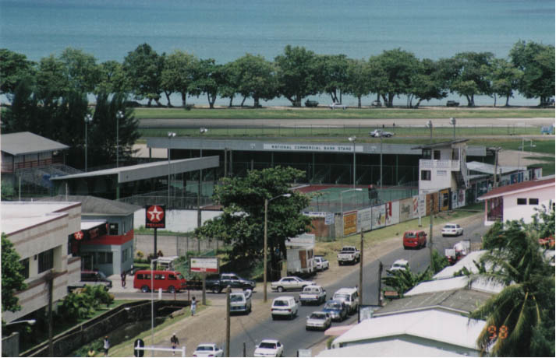

Figure A3-24. Sports Complex

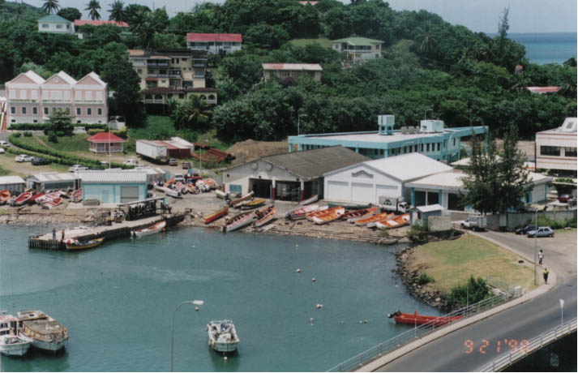

Figure A3-25. Institutional Buildings – Fisheries Complex Castries

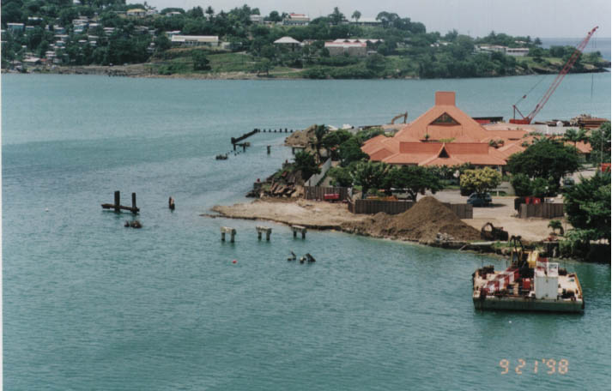

Figure A3-26. New Berths under Construction – Pointe Seraphine

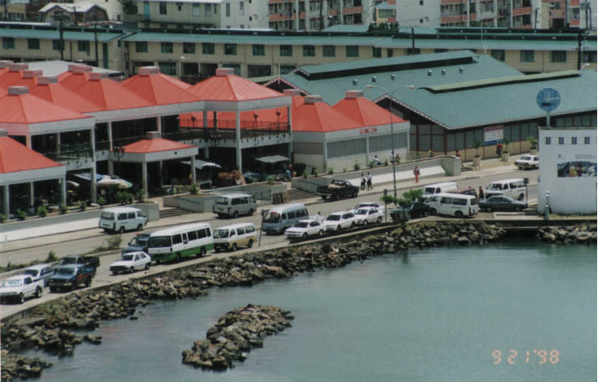

Figure A3-27. Castries Market Complex

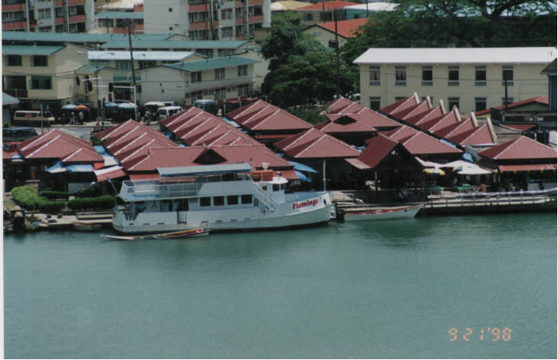

Figure A3-28. Castries Vendors Arcade

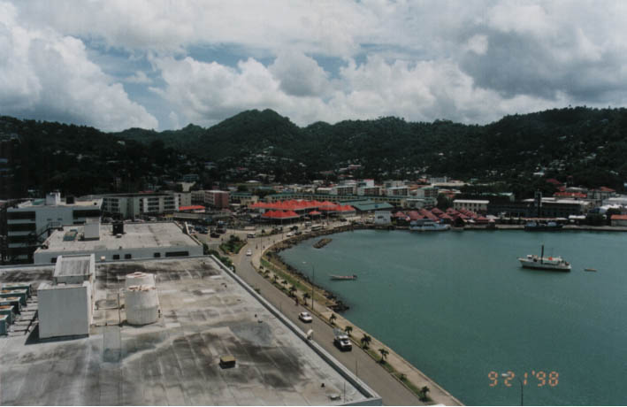

Figure A3-29. Main Street into Castries from the North

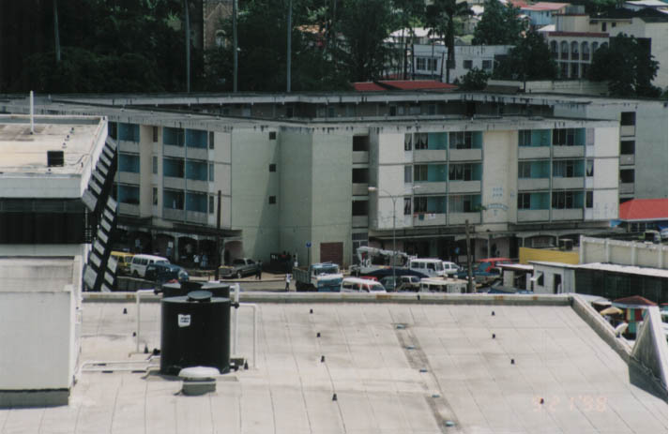

Figure A3-30. Typical High Rise Housing

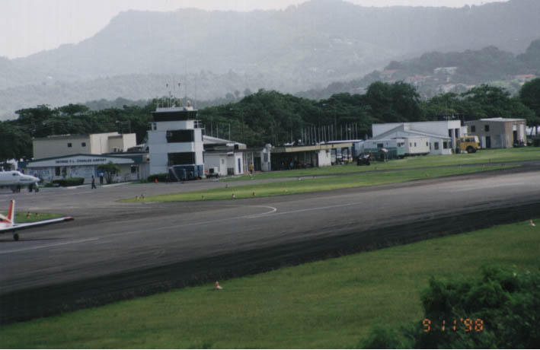

Figure A3-31. George F.L. Charles Airport – Terminal and Runway

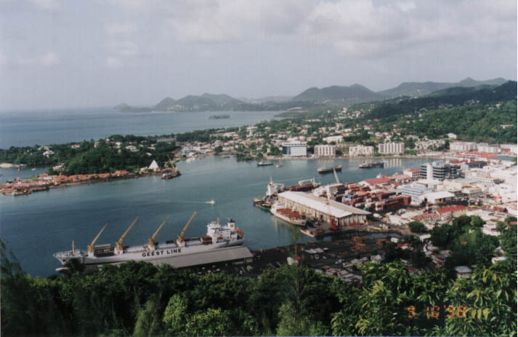

Figure A3-32. Port Castries from the Morne

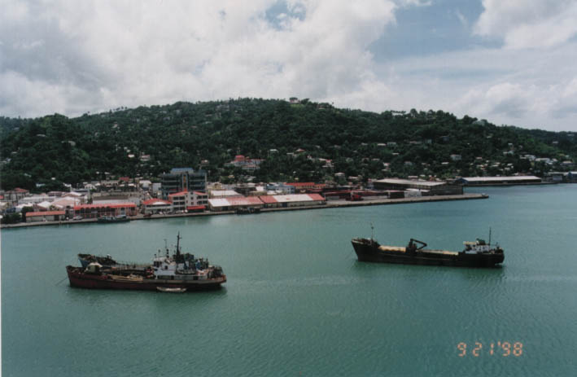

Figure A3-33. Port Castries from Pointe Seraphine

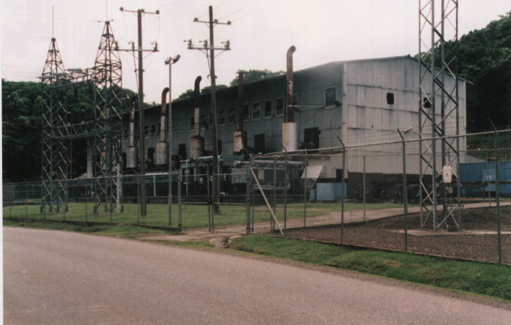

Figure A3-34. Old Power Station Used as a Sub-Station

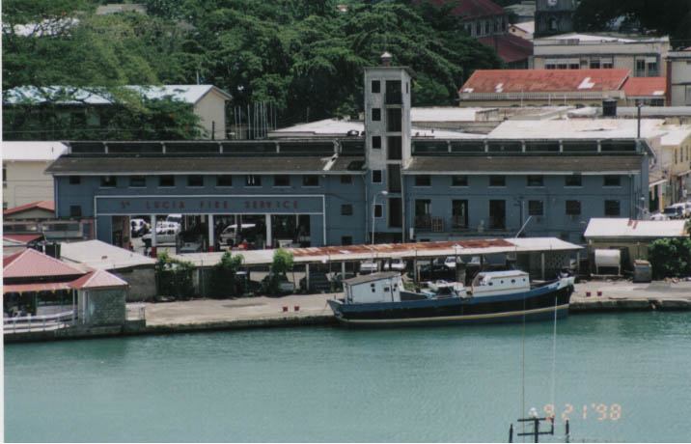

Figure A3-35. Typical Institutional Buildings – Fire Post

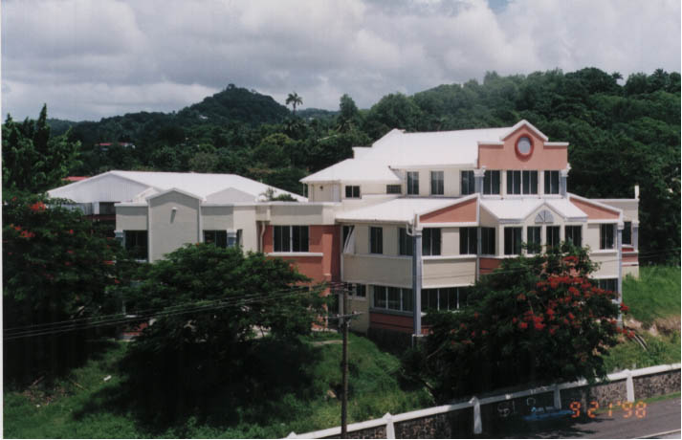

Figure A3-36. Typical Institutional Buildings – Ministry of Culture

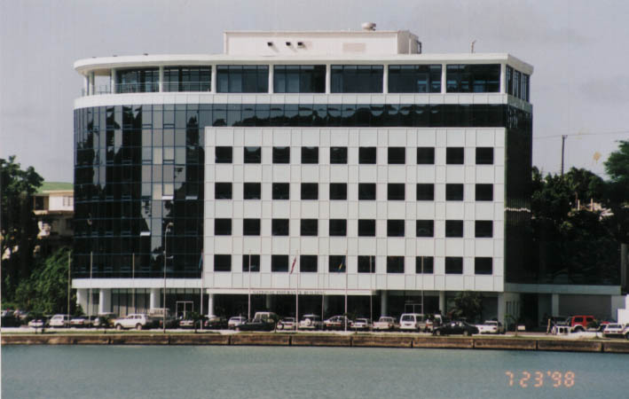

Figure A3-37. Typical Institutional Buildings – National Insurance

