REPORT No. 227/20
PETITION 922-11
REPORT ON INADMISSIBILITY

EX - WORKERS OF THE NATIONAL COPPER CORPORATION
CHILE

OEA/Ser.L/V/II
Doc. 242
6 September 2020
Original: Spanish

Approved electronically by the Commission on September 6, 2020.

Cite as: IACHR, Report No. 227/20, Petition 922-11. Inadmissibility. Ex-workers of the National Copper Corporation. Chile. September 6, 2020.

www.iachr.org
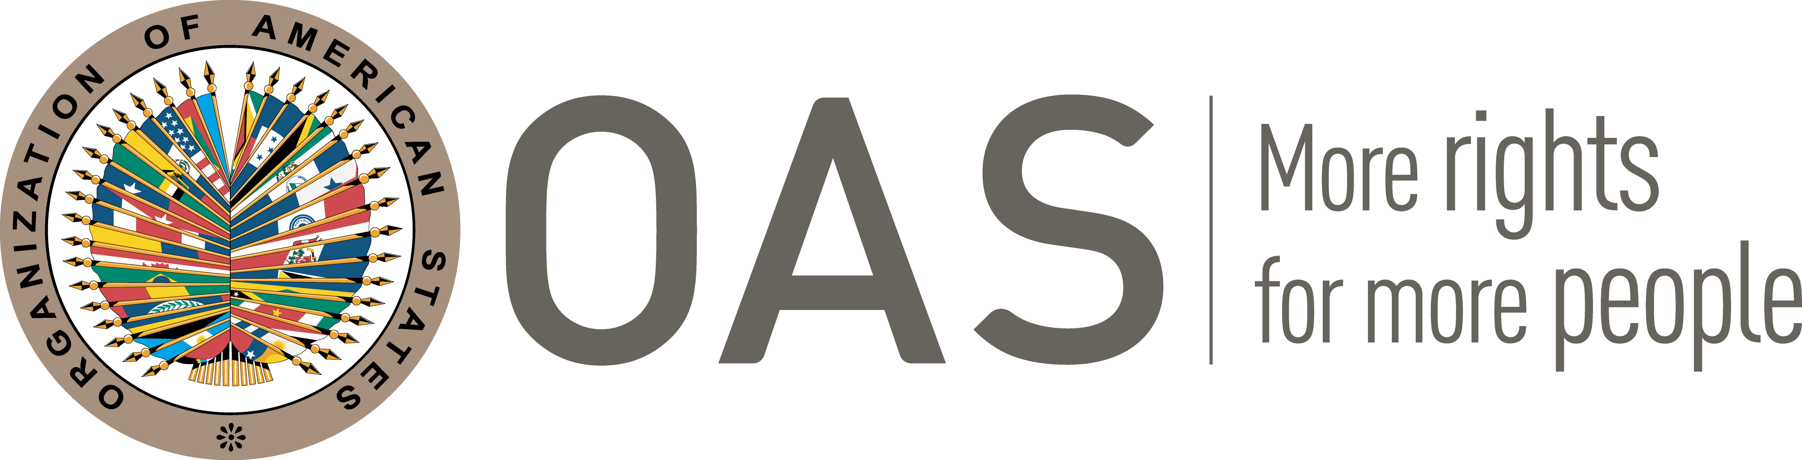

I. INFORMATION ABOUT THE PETITION
Petitioner: | Johana Cristina Rivera Tijerina
Alleged victim: | Arístides Zúñiga Zepeda and others
Respondent State: | Chile
Rights invoked: | Articles 8 (fair trial), 25 (judicial protection) and 26 (economic, social and cultural rights) of the American Convention on Human Rights, in relation to its article 1.1 (obligation to respect rights)
II. PROCEEDINGS BEFORE THE IACHR
Date of receipt | July 8, 2011
Additional information received during the investigative stage: | July 25, 2011
Notification of the petition to the State: | August 16, 2016
State’s first response: | November 17, 2016
Additional observations from the petitioners | July 8, 2017
III. COMPETENCE
Competence Ratione personae: | Yes
Competence Ratione loci: | Yes
Competence Ratione temporis: | Yes
Competence Ratione materiae: | Yes, American Convention (deposit of the instrument of ratification made on August 21, 1990)
IV. DUPLICATION OF PROCEDURES AND INTERNATIONAL RES JUDICATA, COLORABLE CLAIM, EXHAUSTION OF DOMESTIC REMEDIES AND TIMELINESS OF THE PETITION
Duplication of procedures and International res judicata: | No
Rights declared admissible | None
Exhaustion of domestic remedies or applicability of an exception to the rule: | Yes
Timeliness of the petition: | Yes

V. FACTS ALLEGED
- The petitioning party denounces that the State violated the rights of 2,644 people (hereinafter, “the alleged victims” or “former workers”) by firing them from the state-owned company “Corporación Nacional del Cobre” (hereinafter “CODELCO”) for their political opinions. They maintain that such action was carried out without due judicial guarantees, generating a violation of his economic, social and cultural rights.

- Petitioners explain that between September 11, 1973 and March 11, 1990, the alleged victims were dismissed from CODELCO in a discriminatory manner because of their political opinions. It maintains that the aforementioned company is state-owned, so that its officials are public agents who, it alleges, directly commit the responsibility of the State through their actions.
- Petitioners indicate that on July 14, 2005, the representatives of the former workers filed a claim for compensation against the Executive President of CODELCO, alleging that their discriminatory dismissal caused them to have to live in precarious conditions, which represented a violation of their economic, social and cultural rights. It specifies that on July 10, 2009, the First Civil Court of Santiago declared the claim unfounded, considering that the action was prescribed, since it was filed at least fifteen years after the last dismissal. The petitioner argues that an appeal was filed against said decision, but that on August 5, 2010, the Santiago Court of Appeals confirmed the first instance ruling. Against this decision, the defense of the alleged victims filed a cassation appeal, which was rejected on January 10, 2011 by the Supreme Court of Justice, considering that there was no legal violation in the previous sentences.
- The petitioning party claims that despite the fact that the courts accepted their competence to analyze the claim for compensation, they did not issue a ruling on the merits and limited themselves to decreeing the prescription of the action. In their opinion, such action is arbitrary, since human rights obligations are imprescriptible.
- For its part, the State alleges that the alleged facts do not constitute violations of the human rights of the alleged victims. It maintains that the petitioning party does not present a coherent or detailed account of the events in order to demonstrate an infringement of rights. In this regard, the State alleges that the alleged victims had at their disposal all the existing procedural tools in the law, without there having been any affectation of any judicial guarantee. In this sense, it alleges that a violation of due process has not been established, but that the former workers would only be dissatisfied with the meaning of the decisions. For this reason, it requests that the petition be declared inadmissible based on Article 47 (b) of the American Convention, since it considers that the petitioner's request is that the Commission act as a court of appeal, in contradiction to its complementary nature.
VI. ANALYSIS OF EXHAUSTION OF DOMESTIC REMEDIES AND TIMELINESS OF THE PETITION
- Based on the information provided by the parties, the Commission concludes that the remedies of the national jurisdiction were exhausted with the last resolution issued in the compensation process, on January 10, 2011 by the Supreme Court of Justice, therefore that the requirement established in Article 46.1.a) of the American Convention is met. In addition, the petition was presented on July 8, 2011, therefore, within the six-month period established in Article 46.1.b) of that same treaty.
VII. ANALYSIS OF CHARACTERIZATION OF THE ALLEGED FACTS
- The petitioning party claims that the alleged victims were arbitrarily denied compensation for having been dismissed from CODELCO in an allegedly discriminatory manner, due to their political opinion. For its part, the State maintains that no information has been presented that proves a violation of human rights and that the tribes validly established that the compensation action had prescribed.
- In this regard, the Commission highlights that the petitioning party only questions that its claim for compensation against CODELCO was rejected based on a statute of limitations, without explaining the reasons why it took at least fifteen years to initiate such judicial action. In this regard, the petitioning party has not presented information that justifies or explains such delay in taking action before the local courts, so the IACHR does not have elements to determine whether the application of the aforementioned limitation clause in the present case affected the rights of the alleged victims. Nor does the petitioning party raise arguments or provide elements that allow observing at this stage, possible violations of judicial guarantees or the right to judicial protection, due to the actions of the domestic courts.
- Therefore, based on the allegations and information presented by the parties, the Commission concludes that the petition does not comply with the requirement established in Article 47.b of the American Convention, since the information provided by the petitioning party, do not reveal prima facie facts that could constitute possible violations of the Convention.
VIII. DECISION
- To declare this petition inadmissible; and
- To notify the parties of this decision; to publish this decision and include it in its Annual Report to the General Assembly of the Organization of American States.

Approved by the Inter-American Commission on Human Rights on the 6th day of the month of September, 2020. (Signed): Joel Hernández, President; Flávia Piovesan, Second Vice-President; Esmeralda E. Arosemena Bernal de Troitiño, and Stuardo Ralón Orellana, Commissioners.

The petition is filed in favor of 2,644 former workers of the National Copper Corporation, who are duly individualized in the petition.
In accordance with the provisions of Article 17.2.a of the Commission's Regulations, Commissioner Antonia Urrejola Noguera, a Chilean national, did not participate in the debate or in the decision of this matter..
Hereinafter "the American Convention" or "the Convention."
The observations submitted by each party were duly transmitted to the opposing party.

