
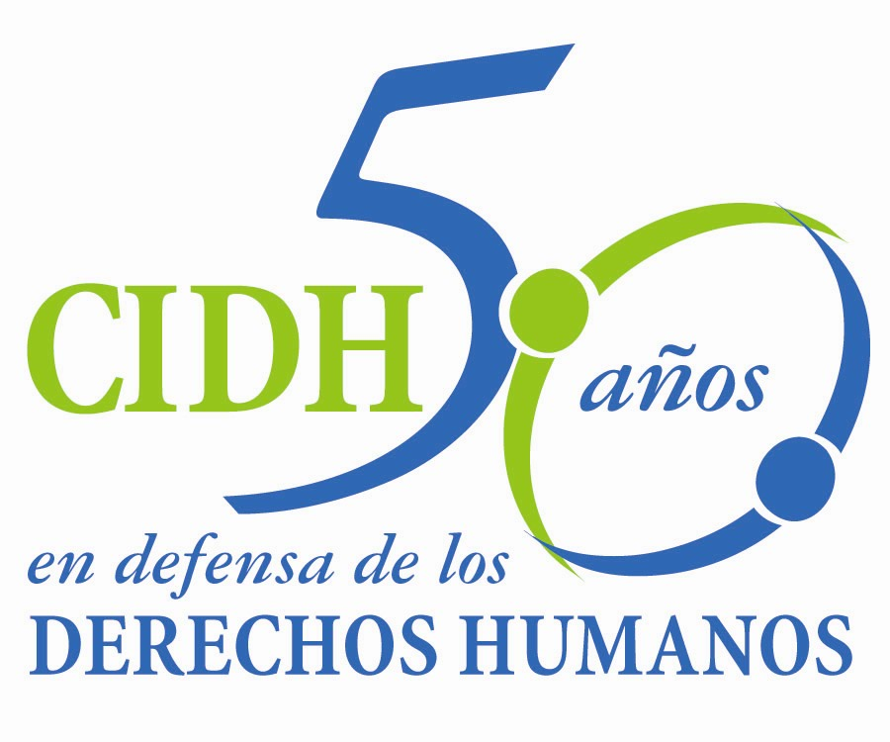
INTER - AMERICAN COMMISSION ON HUMAN RIGHTS
COMISION INTERAMERICANA DE DERECHOS HUMANOS
COMISSÃO INTERAMERICANA DE DIREITOS HUMANOS
COMMISSION INTERAMÉRICAINE DES DROITS DE L'HOMME

ORGANIZACIÓN DE LOS ESTADOS AMERICANOS
WASHINGTON, D.C. 2 0 0 0 6 EEUU

February 21, 2013

Ref.: Case No. 12.548
Garífuna Community of “Triunfo de la Cruz” and its members
Honduras

Mr. Secretary:

I have the honor to address you on behalf of the Inter-American Commission on Human Rights to submit to the jurisdiction of the Inter-American Court of Human Rights Case No. 12.548 concerning the Republic of Honduras (hereinafter “the State,” “the Honduran State,” or “Honduras”), involving a series of violations of the American Convention on Human Rights (hereinafter “the American Convention” or “the Convention”) to the detriment of the Garífuna Community of Triunfo de la Cruz and its members.

This community is a distinct ethnic group whose members share social, cultural, and economic characteristics, particularly their special relationship with the land that they have historically occupied and their collective concept of ancestral property. The Garífuna Community of Triunfo de la Cruz and its members have won recognition in Honduras as an indigenous people, and that was not disputed in the case before the IACHR. The violations in the present case include various elements of the right to property of the Garífuna Community of Triunfo de la Cruz and its members, their right to participate in matters that concern them, and their rights to a fair trial and judicial protection.

Señor
Pablo Saavedra Alessandri, Secretario
Corte Interamericana de Derechos Humanos
Apartado 6906-1000
San José, Costa Rica

Anexos

The Garífuna Community of Triunfo de la Cruz does not have proper and culturally appropriate title to its ancestral territory. Specifically, the Commission found that recognition of part of the ancestral territory was delayed and so far the Community has not received a single title to all the territory based on historic occupation customary use by the Community. In addition, the IACHR found that this situation has prevented them from continuing their traditional lifestyle.

The Community has not enjoyed peaceful occupation and tenancy of its ancestral lands because of: (i) the lack of delimitation and timely demarcation of the titled lands, (ii) the lack of legal certitude in the titles granted, (iii) restrictions on access to zones of the ancestral territory because of the establishment of protected areas, and (iv) failure to protect their territory effectively from occupation and damage by third parties, and guarantee that it be exclusively indigenous. Failure to comply with these obligations has kept the Community in a state of permanent turmoil because of the action of private persons and public authorities.

Moreover, expansion of the urban area by authorities and the sale of community lands has infringed on the ancestral territory. This situation reflects failure to comply with the legal obligations assumed by the State, especially regarding the Community’s known territorial claims, which exacerbates the conflict, apprehension, and legal incertitude. Furthermore, expansion of the urban area resulted in harassment, threats, and even the assassination and arrest of male and female leaders and community authorities.

The case also has to do with the lack of prior, free, and informed consultation of the Triunfo de la Cruz Community and its members concerning the adoption of decisions affecting the territory they have occupied historically. These decisions include the execution of tourism projects and megaprojects, the creation of a protected area in part of their ancestral territory, and sales of communal lands.

Finally, the Commission concluded that the Garífuna Community of Triunfo de la Cruz and its members has not had a remedy that takes into account its unique features, its economic and social characteristics, its customary law, its values, and its customs and usage in the context of procedures related to collective property. The Commission deemed that the victims have not had effective access to justice in the context of complaints related to the sale of ancestral lands; acts of threats, aggression, harassment, and persecution suffered by community authorities; and the situation of ongoing violence and insecurity caused by third parties in their territory.

The State ratified the American Convention on Human Rights on September 8, 1977, and accepted the Court’s jurisdiction on September 9, 1981.

The Commission has designated Commissioner Tracy Robinson and Executive Secretary Emilio Álvarez Icaza L. as its delegates. Elizabeth Abi-Mershed, Assistant Executive Secretary, and Silvia Serrano Guzmán and Isabel Madariaga, attorneys of the Executive Secretariat of the IACHR, will be legal advisers.

In accordance with Article 35 of the Inter-American Court’s Rules of Procedure, the Commission attaches a copy of Report 76/12 prepared per Article 50 of the Convention, and a copy of the Inter-American Commission’s entire case file (Appendix I) and the appendixes used in preparation of Report 76/12 (Appendixes). That Report on the Merits was transmitted to the State of Honduras in a communication of November 21, 2012, giving it a period of two months to report on compliance with the recommendations. The State of Honduras requested an extension of the period in accordance with Article 51 of the American Convention, which was granted until February 14, 2013. To date, the Honduran State has not submitted its report on compliance with the recommendations.

The Commission therefore submits the instant case to the jurisdiction of the Inter-American Court in order to obtain justice for the victims in view of the lack of information on the Honduran State’s compliance with the recommendations.

The Inter-American Commission submits to the Court’s jurisdiction all of the facts and human rights violations described in the Report on the Merits 76/12. Although the facts established by the Inter-American Commission include some that occurred before Honduras accepted the Court’s jurisdiction, they are included by way of context to explain subsequent facts and violations. The Commission requests that the Court conclude and declare that:

- The State of Honduras violated the right to property established in Article 21 of the American Convention on Human Rights, in conjunction with Articles 1.1 and 2 thereof, to the detriment of the Garífuna Community of Triunfo de la Cruz and its members, for not having provided effective access to a collective property title to its ancestral territory; and for having refrained from delimiting, demarcating, and protecting it effectively.

- The State of Honduras violated Article 21 of the American Convention, in conjunction with Article 1.1 thereof to the detriment of the Garífuna Community of Triunfo de la Cruz and its members by having taken decisions regarding measures that affected its territory, without satisfying the requirements established under inter-American law, such as conducting expropriation proceedings; not threatening the subsistence of indigenous communities; conducting prior, free, and informed consultations, as well as social and environmental impact assessments; and guaranteeing the participation of the indigenous in the benefits resulting from the concessions granted.

- The State of Honduras violated Articles 8 and 25 of the American Convention in connection with Articles 1.1 and 2 thereof, to the detriment of the Garífuna Community of Triunfo de la Cruz and its members, due to failure to provide an appropriate and effective procedure for the recognition, titling, demarcation, and delimitation of the territory claimed by the alleged victims, that would make it possible to guarantee peaceable possession and recovery of its ancestral land.

- The State of Honduras violated Articles 8 and 25 of the American Convention in connection with Articles 1.1 and 2 thereof, to the detriment of the Garífuna Community of Triunfo de la Cruz and its members due to failure to conduct a serious, effective and prompt investigation intended to ascertain the truth and determine responsibilities with respect to the complaints filed by Community members and leaders.

Therefore, the Commission requests the Court to order to the State of Honduras to:

- Adopt as soon as possible the measures needed to give effect to the right to communal property and possession of the Garífuna Community of Triunfo de la Cruz and its members with respect to its ancestral territory; and, in particular, the legislative, administrative, or other measures needed for the appropriate delimitation, demarcation, and titling of its lands, in accordance with its customary law, values, habits, and customs and to guarantee to members of the Community the development and continuity of its cosmovision in such a way that they can continue their traditional lifestyle, in keeping with their distinct cultural identity, social structure, economic system, customs, beliefs, and traditions.

- Establish, with the participation of indigenous peoples, legislative or other measures needed to give effect to the right to prior, free, informed, and good faith consultation, in accordance with international human rights standards.

- Adopt an affective and simple recourse that protects the right of the indigenous peoples of Honduras to claim and gain access to their traditional territories and that protects those territories against actions by the State or third parties that violate their right to property.

- Investigate and punish those responsible for the threats, harassments, acts of violence and intimidation, and damage done to the property of members of the Community of Triunfo de la Cruz and especially its leaders and authorities.

- Make reparation, both individual and collective, for the consequences of the violation of the aforementioned rights.

- Adopt any measures needed to avoid similar acts occurring in the future, in line with its duty to prevent and guarantee fundamental rights recognized in the American Convention.

In addition to the need to obtain justice for the victims, the IACHR believes that this case incorporates questions of the inter-American public order of human rights.

Specifically, the Commission notes that several of the violations in this case occurred because of the lack of a legal framework to permit full recognition of the ancestral property of the Garífuna Community of Triunfo de la Cruz and its members, as a collective, with the particular characteristics of its relationship with the land and the territory and traditional use of them. The lack of a proper legal framework also prevented granting a proper and culturally adequate title, and caused problems in access to justice, owing to the lack of a procedure for obtaining recognition of the terms. This case will allow the Inter-American Court to establish the parameters that should be considered when creating legislation regarding the territory claims of indigenous and tribal peoples, so that such laws can achieve their objectives and meet international standards in this area. This development will have an impact on the inter-American public order of human rights.

This case also involves one of many kinds of violations over a long period of time that to date continue blocking a complete and proper recognition of the ancestral property and the effective possession and use of the lands and territories that belong to them. This variety and multiplicity of violations were perpetrated by State agents and private parties, whose attribution of responsibility calls for special analysis of the scope of State obligations for the official recognition and demarcation and effective protection of ancestral property when there are threats from private parties with or without official support. The sequence of violations in this case has had an impact on the Community as a collective and its leaders and members as individuals, who in the framework of the grievances have experienced violations of other rights, such as the right to life, humane treatment, political participation, and freedom of association. All of these elements make the instant case especially important because they involve the determination of the scope of the States’ obligations to respect and guarantee human rights in the face of various types of threats to the indigenous peoples’ rights.

Since these questions have significant impact on the inter-American public order of human rights, in accordance with Article 35.1.f of the Inter-American Court’s Rules of Procedure the Commission offers expert testimony:

  - An expert witness whose name will be provided shortly, who will testify on the minimum parameters to be taken into account when designing and implementing a legal framework to permit full and culturally appropriate recognition of the ancestral property of indigenous peoples, including the idiosyncrasies deriving from their collective nature and their cosmovision of the land and natural resources, and land titling and demarcation. In addition, the expert will testify on State obligations vis-à-vis acts of private parties that threaten the possession and peaceful use of lands and territories of indigenous and tribal peoples, in components of prevention as well as investigation. The expert will analyze the effects or consequences on the indigenous peoples of the lack of protection by the States of their ancestral territories.

The currícula vitarum of the proposed expert witnesses will be included in the appendixes to the Report on the Merits 76/12.

The Commission puts at the Court’s disposal the following identification of the persons who have acted as petitioners throughout the processing and their contact information:

Organización Fraternal Negra Hondureña
Xxxxxxxxxxxxxxxxxxx
Xxxxxxxxxxxxxxxxxxx
Xxxxxxxxxxxxxxxxxxxxx

Original signed

Elizabeth Abi-Mershed
Deputy Executive Secretary

