**CHAPTER VI  
INSTITUTIONAL DEVELOPMENT AND ADMINISTRATIVE AFFAIRS**

1. **Structure and Personnel of the IACHR**
2. The current structure of the IACHR had its onset in 2008, at which point the Executive Secretariat created the Regional Sections, and the Registry, Court, Protection, and Friendly Settlement Groups, in addition to the Rapporteurships. Then, in accordance with the guidelines set forth in the 2011-2015 Strategic Plan, the Administrative and Financial Section evolved into the Department of Institutional Development and Administrative Affairs (“DIAA”).
3. During most of 2014, the management of the IACHR worked in consultation with the Commission to design a new structure that will better address the challenges being faced, in particular that of procedural backlog. The result was an approval by the Commission during its 153rd Period of Sessions of the proposed new structure of the Executive Secretariat. The Executive Secretariat is now in the process of fulfilling the required administrative processes to implement this structural change, which includes issuance by the Secretary General of an amendment to Executive Order 08-01 on the structure of the OAS.
4. There were eight competitions opened in 2014. As a result of the new policy suggested by DIAA to the Department of Human Resources that makes the selection process more efficient, we were able to welcome three new staff members from outside the IACHR, and regularize or promote 9 existing staff members with these eight competitions.
5. The following chart shows the total number of staff and consultants by source of financing as of December 9, 2014:



1. Specifically, in 2014 the IACHR was divided as follows[1]:

* Office of the Executive Secretary and Assistant Executive Secretary, through which service is provided to the Commissioners, and all strategic management of the Commission is administered. It also includes the Press Office, the Technology and Systems Unit, and the Documents Office.
* The Department of Institutional Development and Administrative Affairs which is in charge of all financial and operative planning and reporting, human resource management, and administrative logistics for the Commission, as well as oversight of the coordination of all administrative personnel assigned to the regional sections and Rapporteurships.
* Special Groups Section
  + Registry: This Section is tasked with receiving, evaluating, and processing all incoming petitions, determining whether based on *prima facie* analysis, the petitions state facts that could tend to establish a violation of the rights protected by the inter-American human rights instruments, whether domestic remedies have been exhausted, and whether the requirements necessary to file the petition have been satisfied. The Registry Section has oversight of a group of approximately 20-25 interns per session.
  + Court Group: In charge of the providing management of the cases presented before the Inter-American Court of Human Rights.
  + Protection Group: Is responsible for the evaluation of all new requests for precautionary measures and their follow up. Additionally, the Protection Group prepares evaluations, under the emergency mechanism of Article XIV of the Inter-American Convention on Forced Disappearance of Persons, and evaluates those matters that can be raised to the Inter-American Court of Human Rights through of a request for provisional measures. The Protection Group deals with an annual correspondence flow of more than 2000 communications and receives an increasing number of approximately 400 new requests for precautionary measures per year.
  + Friendly Settlement Group: Provides technical support to the IACHR related to the application of alternative dispute resolution mechanisms, and initially the gathering of best practices.
* Rapporteurships and Thematic Units

The IACHR Rapporteurships are governed by strict guidelines established in its Rules of Procedure and in practices established by the plenary of the Commission, which approves those offices' reports and work plans and evaluates execution of their mandates. Because they are offices specializing in specific subject matters, the IACHR Rules of Procedure detail the procedure by which they are established and how the thematic, country, or special Rapporteurs are elected.

1. There are currently nine Rapporteurships and one thematic unit. These are:
   * Rapporteurship on the Rights of Indigenous Peoples: created to devote attention to the indigenous peoples of the Americas, who are particularly vulnerable to human rights violations, and to strengthen, promote, and systematize the Commission's own work in this area.
   * Rapporteurship on the Rights of Women: created in 1994 with an initial mandate to review to which degree the legislation and practice from OAS Member States related to the guarantee of the rights of women, and complied with the general obligations of equality and non-discrimination established in the American Convention on Human Rights (hereinafter “American Convention”), and the American Declaration of the Rights and Duties of Man (hereinafter “American Declaration”). By creating the Rapporteurship, the Commission renewed its commitment to guarantee the full respect of women’s rights in each of the OAS Member States. The Rapporteurship contributes to a thorough understanding of the need for additional measures to guarantee women’s full exercise of their basic rights, and issues recommendations to promote that States improve their compliance with their priority obligations related to equality, and non-discrimination. Additionally, the Rapporteurship promotes the application of the mechanisms of the inter-American system of human rights to protect the rights of women; undertakes specialized studies and prepares related reports; and supports the inter-American Commission in offering a response to petitions, and other reports of human rights violations in the region.
   * Rapporteurship on the Rights of Migrants: seeks to promote the respect and guarantee of the rights of migrants and their families, asylum seekers, refugees, complementary protection seekers and beneficiaries, stateless persons, victims of human trafficking, internally displaced persons and other vulnerable groups in the context of human mobility.
   * Special Rapporteurship for Freedom of Expression: The mandate of the Rapporteurship is to promote freedom of expression by preparing annual reports, conducting dissemination activities, issuing alerts, studying norms and practices contrary to international standards in this field, support for the preparation of reports in contentious matters, as well as on precautionary measures related to this subject.
   * Rapporteurship on the Rights of the Child: cooperates with the analysis and evaluation of the situation of the human rights of children in the Americas. The Rapporteurship provides advice to the IACHR in the proceedings of individual petitions, cases and requests of precautionary and provisional measures which address the rights of the child. Likewise, the Rapporteurship undertakes on site visits in the OAS Member States and prepares studies and publications related to the rights of children. The Rapporteurship shares its expert knowledge and brings international jurisprudence and studies to the Commission’s discussions. The Rapporteurship is also the contact for civil society organizations that work with children’s rights and with children’s organizations.
   * Rapporteurship on the Rights of Persons Deprived of Liberty: Its mission is to remain informed, via any reliable information source, about the situation of persons subject to any form of detention or prison in the Member States; conduct visits to OAS Member States for the purpose of compiling information and make recommendations to the States; prepare reports for the Commission on the correctional situation in a particular detention center or country, or at the regional or sub-regional level, along with any recommendations deemed necessary for the Commission; conduct promotional and educational human rights activities; coordinate promotional activity with nongovernmental organizations or other international institutions for the protection of human rights; and take any other action or step deemed necessary to protect persons deprived of liberty, within the mandate of the Inter-American Commission on Human Rights.
   * Rapporteurship on the Rights of Afro-Descendants and against Racial Discrimination: Its objective is that of stimulating, systematizing, reinforcing and consolidating the action of the Inter-American Commission on the rights of people of African-descendent and racial discrimination.
   * Rapporteurship on Human Rights Defenders: Through its various tasks, the Office of the Rapporteur closely follows the situation of all persons who work to defend rights in the region, including the situation of justice operators. In 2014, it incorporated two fellowships of six and nine months respectively.
   * Rapporteurship on the Rights of Lesbian, Gay, Trans, Bisexual and Intersex Persons: To monitor the situation of human rights of lesbian, gays, transsexual, bisexual and intersex persons in the region, and to promote respect for their rights.
   * Unit on Economic, Social and Cultural Rights[2]: Cooperate with the analysis and evaluation of the situation of these rights in the Americas, provide advice to the IACHR in the proceedings of individual petitions, cases and requests of precautionary and provisional measures which address these rights, undertake working visits to the OAS Member States and prepare studies and publications, in particular international standards.

* Regional Sections: The IACHR has five regional sections which are responsible for petitions in the admissibility phase and merits cases, follow up of recommendations and of monitoring the human rights situations in the respective geographic areas, which are divided in the following manner:
  + Andina I
  + Andina II
  + Cono Sur
  + Mesoamerica (Mexico, Central America, and Spanish-speaking Caribbean)
  + EFP (USA, Canada, Brazil, and English- and French-speaking Caribbean)

1. **Financial resources and budget execution**
2. **Regular Fund**
3. For fiscal year 2014, the General Assembly approved a budget of $5,354,300 for the IACHR, of which $4,372,500 is personnel expenses, and $972,800 is set aside for operational expenses. Although this approved budget for 2014 indicated a modest increase of $63,300 over 2013, the reality is that we began the year with 7 frozen positions amounting to a freezing of approximately $67,200/month in personnel expenses. As the chart below demonstrates, when one accounts for the frozen positions, the net amount provided to the IACHR is considerably lower than the approved amount, with a difference of over $500,000.

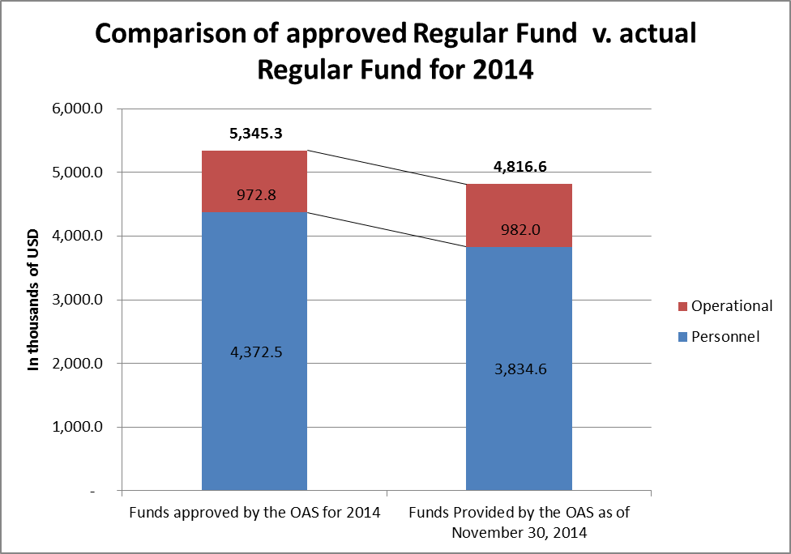

1. In May of 2014, the General Secretariat released budgetary authority to allow us to fill only four of those seven positions: two P01-level positions, one G06 level position, and one G05-level position. But as of the close of the year, only the two P01’s and the G06 had been successfully filled. We are still awaiting conclusion of the G05 competition by the General Secretariat.
2. Meanwhile, the Executive Secretariat continued to lobby for the reinstatement of the remaining positions, and in October 2014, the member states approved the 2015 budget in which they reinstated the three positions that remained frozen (two P04s and one P02). Nonetheless, a separate P03 position, that of Chief of the Administrative Management Section formerly occupied by recently retired staff member Dania Giraldo, was eliminated. The net change between the approved 2014 and 2015 budgets, taking into account Regular Fund and ICR appropriations, is of a mere 2% increase. Considering however that the net increase to the Regular Fund budget between 2014 and 2015 was only 1.5%, this represents an equitable increase to the Executive Secretariat of the IACHR.[3]
3. Regarding execution of its 2014 allotment, as of November 30, 2014[4], the IACHR had executed 91% of its allotment, with a balance in the Regular Fund of $428.3, against which were already registered obligations totaling $409.6.

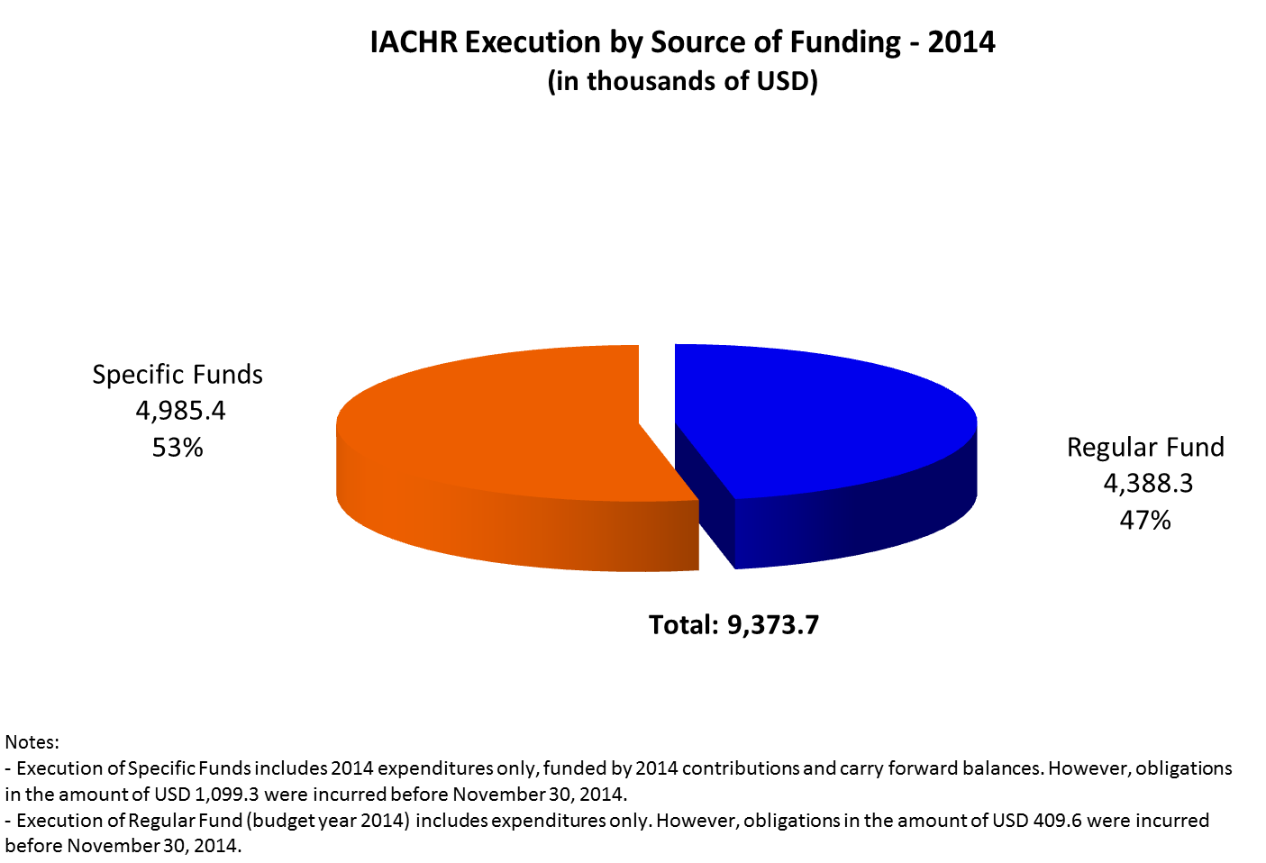

1. **Specific Funds**
2. The Inter-American Commission on Human Rights is diversifying its search for financing due to the decrease in international cooperation and the reorientation thereof towards other regions. Firstly, it seeks to receive greater contributions from the OAS member states. Secondly, to turn to new financing from foundations and/or institutions that will not compromise the independence of the IACHR. And finally, to participate in open calls, while keeping in mind that most are targeted at civil society and not at intergovernmental organizations like the OAS.
3. As of November 30, 2014, US$4,479,500.00 had been received from Argentina, Canada, Chile, Costa Rica, the United States, Mexico, Denmark, the European Union, Finland, France, Holland, Spain, Switzerland, Children’s Villages, the Arcus Foundation, the International Work Group for Indigenous Affairs (IWGIA), the United Nations High Commissioner for Refugees (UNHCR), Plan International, the University of Notre Dame, Save the Children – Sweden, and World Vision. Table No. 2 shows the contributions made to the IACHR’s specific funds between January 1, 2014 and November 30, 2014.



**3. IACHR Strategic Plan**

1. At the end of 2010, the IACHR adopted the Strategic Plan 2011-2015, with the aims of maximizing efficiency, showing the results obtained in a transparent way through the use of measurable and realistic indicators, and encouraging better coordination among donors. Likewise, with the adoption of the Strategic Plan, the Commission consolidates a strategy to mobilize resources with a program-based approach.
2. The Strategic Plan includes all of the Commission’s activities in eight programs and their corresponding action plans, laying the foundation for a new type of medium- and long-term cooperation on programs, through which potential donors can make contributions to a joint fund with a single annual report, which in turn provides them with a clear and transparent picture of the financial management of the IACHR.
3. Mid-2014, a task force was organized within the Office of the Executive Secretary in order to consider the criteria to be used in an evaluation of the Strategic Plan 2011-2015. This evaluation will not only assess the results obtained, but will also serve as a foundation for the new IACHR Strategic Plan for 2016-2020.

**4. Contributions made from January 1, 2014 until November 30, 2014[5]**

* The Government of Argentina contributed US$60,000 to the Strategic Plan. The Office of the Public Prosecutor of the Autonomous City of Buenos Aires contributed US$15,688 to the IACHR to defray the costs associated with carrying out the human rights course offered during the 149th period of sessions.
* Canada made the penultimate contribution to the project in existence since 2008, in the amount of US$304,247.
* Chile made a contribution of US$85,000 to the IACHR Strategic Plan.
* Costa Rica contributed US$5,800 to the IACHR Strategic Plan.
* Mexico made a contribution of US$500,000 to the IACHR Strategic Plan.
* The United States contributed US$123,725 to the Rapporteurship for Freedom of Expression and US$750,000 to the IACHR (2013-2014 contribution). The IACHR has still not received the United States’ 2014-2015 contribution.
* Denmark has made disbursements worth US$684,213 for its program for human rights in Central America (PRODECA). This program supports the IACHR Strategic Plan.
* The first disbursement of the European Union’s contribution, worth US$547,263, was received. The European Union is contributing €1,000,000 for the years 2014-2015, distributed as follows: €700,000 to the IACHR and €300,000 to the Inter-American Court of Human Rights. The contribution to the IACHR is focused on two Strategic Plan programs: Program IV, Rapporteurships, with resources for drawing up a provisional report on poverty and human rights, a topic that is relevant to all of the Rapporteurships and Thematic Units, and Program II, Individual Petition System. Likewise, it is expected that the final disbursement for the 2010 project financed by the European Union will be received, in the amount of US$65,103.
* Finland made the third contribution in the amount of US$388,800 to the Rapporteurship for Freedom of Expression.
* The Spanish Fund for the OAS provided US$180,000 to cover 60% of the financing of the project on Friendly Settlements. The final disbursement, in the amount of US$30,000, is expected to be received upon presentation of the project’s interim reports.
* The Government of Holland contributed a total of US$317,662, 20% of which is allocated to the Rapporteurship on the Rights of LGBTI Persons.
* The Government of Switzerland contributed US$12,788 in support of the Rapporteurship for Freedom of Expression.
* In terms of contributions from other institutions, it is worth highlighting the contribution made by the ARCUS Foundation in the amount of US$45,000 to finance a fellow to support the LGBTI Persons Unit.
* The Office of the United Nations High Commissioner for Refugees gave a contribution of US$60,000, to support diverse activities.
* The sum of US$136,000 was received from the International Work Group for Indigenous Affairs (IWGIA) for financing the third phase of the project in support of the Rapporteurship on the Rights of Indigenous Peoples.
* The organization Save the Children gave US$25,000, mainly to finance a fellow for the Rapporteurship on the Rights of the Child.
* The Rapporteurship on the Rights of the Child received US$100,000 to finance its activities from the organization Plan International.
* The sum of US$106,600 was received from the organization World Vision, to finance a financing proposal made by the Rapporteurship on the Rights of the Child with regard to national systems for the protection of children’s rights and their operation as a noteworthy institutional mechanism for the protection of children, in particular from violence.
* The organization Children’s Villages contributed US$5,000 to the Rapporteurship on the Rights of the Child.
* The IACHR also received US$12,800 from the University of Notre Dame for the partial financing of the fellowship.

**5. Proposals being prepared and negotiations in the initial stage**

* A financing proposal on pretrial detention was submitted to the Spanish Fund for the OAS, in accordance with the priorities established in the IACHR Strategic Plan.
* A proposal requesting 20,000 euros from the European Union to finance a meeting of ombudspersons, to be held in Jamaica, was submitted. This meeting will bring together ombudspersons from CARICOM and Latin America to exchange good practices with the objective of strengthening their offices in the CARICOM countries in the context of the serious public-safety challenges faced thereby.
* A proposal with regard to financing for the Rapporteurship on migrant workers was submitted for the Central America and Mexico Migration Alliance (CAMMINA).
* A financing proposal regarding girls and adolescents and their rights in the Americas was submitted to the organization Plan International.
* A letter requesting a voluntary contribution for financing for the 2014-2015 period was sent to the Government of the United States. Note that, historically, the United States has contributed one part before the end of the calendar year and a second part the following year, as its fiscal year goes from October to September.

1. The following two graphs indicate the distribution of execution by source of fund, and by Object of Expenditure.



1. It is important to note even considering the commitment by Member States to provide financial resources to the IACHR, the Regular Fund represent only 47% of the 2014 annual execution of the Executive Secretariat.

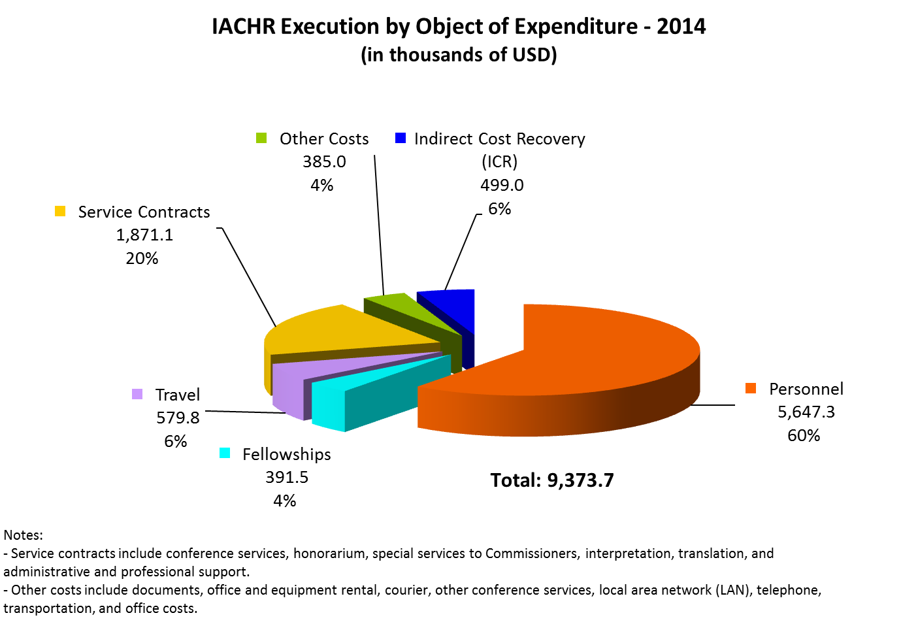

1. **Technology advances**
2. The Technology and Systems Unit (“TSU”) is responsible for managing information technology resources, projects, systems applications, and telecommunications of the IACHR. The TSU’s main functions are to promote integrity and transparency of the Commission’s processes and work with technology and automatized tools for improving management decision making, management internalization practices, streamlining manual procedures of the staff, and support for victims, petitioners and States with innovation technology.

1. In 2014, the Technology and Systems Unit (TSU) managed to consolidate several projects and in doing so meet the IACHR Executive Secretariat’s automation and process-improvement objectives by managing information technology resources, systems applications, and telecommunications services. Via the implementation of the projects undertaken by the TSU, we were able to make improvements to some of the Commission’s procedures and efforts by using automated management tools and technology including management internalization processes, the systematization of manual processes engaged in by staff, and support for victims, petitioners, and states through the use of technological innovation.
2. During this year’s regular and special sessions, the Technology and Systems Unit was responsible for coordinating, managing the logistics of, programming, monitoring, and following up on technology and telecommunications services in direct contact with the respective services areas in order to ensure that the events and meetings went smoothly as far as the technological challenges and components involved were concerned.
3. The TSU designed and implemented a couple of electronic form-based applications in order to ascertain civil society’s interest in participating in specific hearings such as thematic hearings and/or hearings requested by member states. After capturing the data digitally, we were able to provide the Executive Secretariat with user-friendly reports for assessing and selecting the organizations that participated in the hearings.
4. The Technology and Systems Unit also developed an automated and personalized system for requests to participate in the hearings held during the 152nd special session in Mexico; this was the only centralized means of making such requests. This new digital system aimed to facilitate and hasten processes for the benefit of all involved and allowed for requests to take part in one or more hearings to be submitted in any of the four official languages.
5. The Technology Unit also prepared statistical reports based on the data obtained from requests made for hearings and working meetings during the Commission’s sessions this year. The report contained the overall number of hits the system’s site received, requests that include hearings and working meetings broken down by country, type of requester, type of request, and rapporteurship, as well as statistics and graphs having to do with the requests approved. These tools both permit and facilitate decision-making by senior managers.
6. In recent years, the TSU has been working persistently on a project to develop the Individual Petition System Portal in an effort to fulfill the mandate issued by the OAS member states that calls for mechanisms allowing states, petitioners, and victims to electronically access files on petitions and cases to be enhanced. Two events were held to present the portal and demonstrate to users of the IACHR what this new system that will provide them more information on their petitions, cases, and/or precautionary measures is all about. The first event was held in Asuncion, Paraguay during the General Assembly. The second event took place at headquarters during the 153rd regular session and was attended by member states and representatives of civil society. In addition to presenting the advantages, functionalities, and improvements offered by the portal, a live demonstration was also done on how information will be accessed and displayed for those who have a case, petition, and/or precautionary measure with the IACHR and who wish to register in the system. The TSU is continuing to manage, monitor, and work on developing this system, which will set the standard for moving forward in both providing users of the IACHR with access to information and ensuring the transparency of such information.
7. The Fellowship Application System (FAS) was put into operation. After having analyzed, designed, developed, and tested the digital and automated fellowship application system, the TSU satisfactorily delivered the system so it could be implemented using a web-based platform that enables the documents and data the Executive Secretariat needs to analyze and reach decisions with respect candidates’ applications for the different fellowship programs to be managed. In addition, training was provided to Executive Secretariat staff that will be responsible for the system with regard to the processes for fellowship recipient selection. The respective documentation on managing and using the system, for both users and system administrators, was delivered as well. Lastly, implementation of the system for candidates for the 2015 Rómulo Gallegos Fellowship Program was successful. We have been able to measure impact as far as processes for collecting and processing data for the subsequent assessment and selection of fellows are concerned, and as a result have come up with processes that are now more agile and efficient. We were also able to measure and report the results of data obtained from the requests in a tangible way. Below you will find graphs containing information on the impact of implementation of the FAS as well as data on the fellowships already awarded under the system: Rómulo Gallegos 2015 and the 2015 Fellowship on International Protection and Internal Displacement

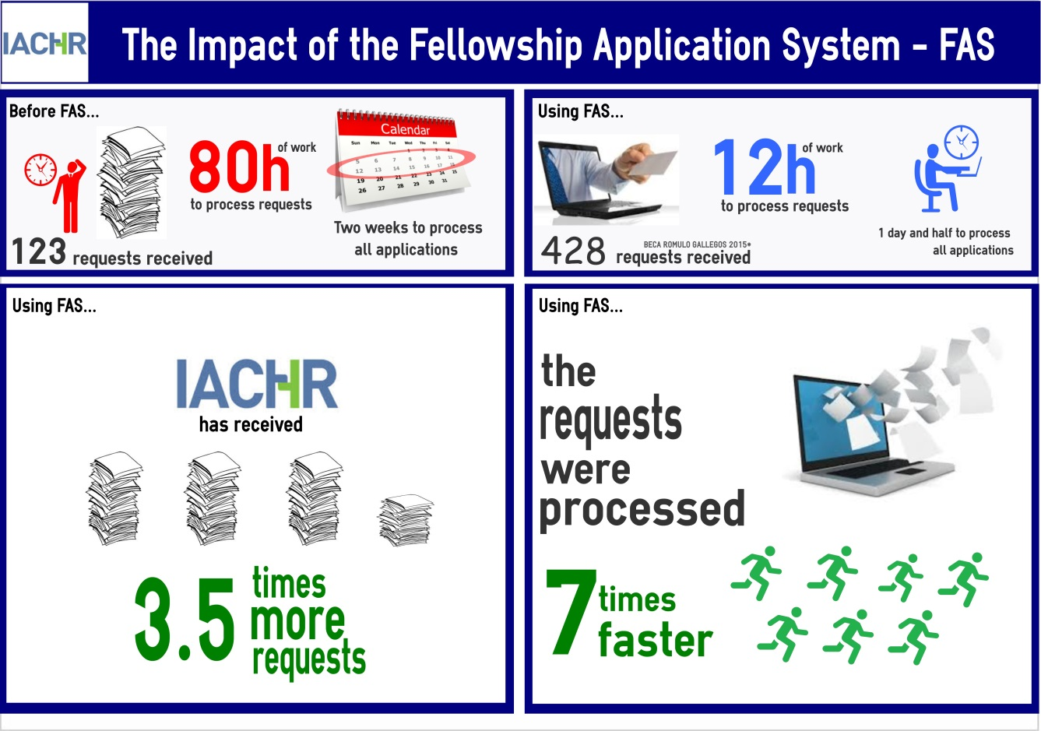

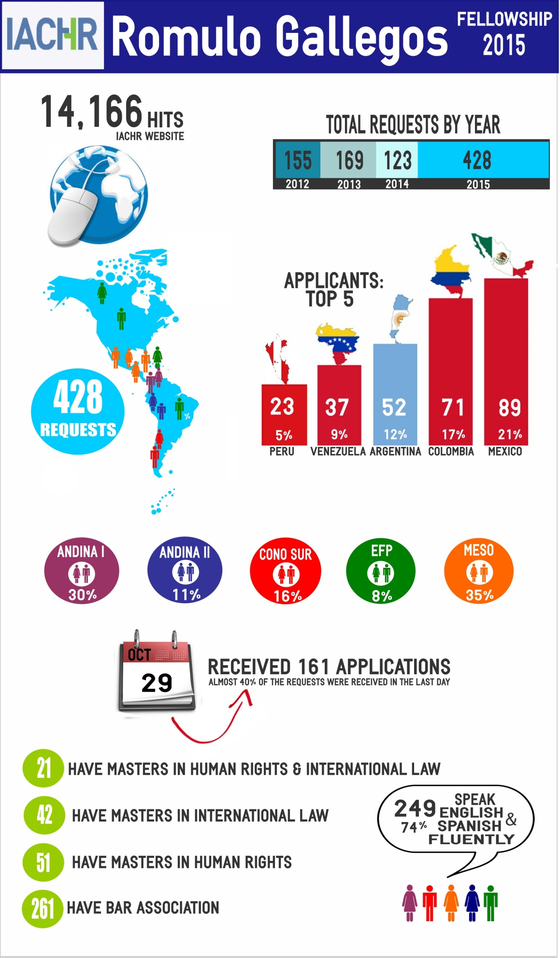

1. The TSU, in its ongoing efforts to enhance and facilitate the work of the Executive Secretariat’s staff, is moving forward with a project to modernize and replace technological, multimedia, and telecommunications equipment in the IACHR; this is one of the open-ended projects in place to meet this objective. Two multimedia rooms that include different state-of-the-art technologies were designed, coordinated, and put into place. These rooms have the capacity to project presentations and can be used for videoconferences and teleconferences; they also include smart boards and collaborative tools. This makes it possible for virtual meetings to be held between the members of the IACHR as well as with the users of the inter-American human rights system. Furthermore, we now have better quality multimedia capabilities for the presentation and discussion of our day-to-day work. As to the replacement of computer equipment, between 2013 and 2014, some 102 computers were updated, 21 used computers were reconnected, and 14 local and 1 network printers were procured..

|  |  |
| --- | --- |
| **Equipment Procured** | |
| 102 | Desktop computers |
| 107 | Desktop computer screens |
| 15 | Printers |
| 4 | Laptops |
| 43 | Software licenses |
| 2 | Smart multimedia rooms |
| 1 | IP telephone for conference calls |

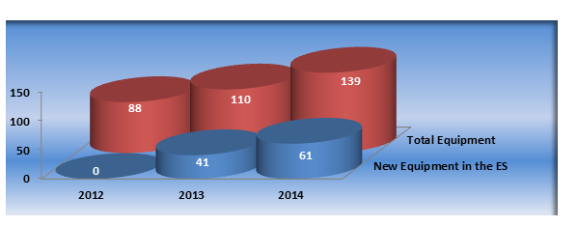

1. The TSU worked in coordination with the Universidad Federal da Paraíba on the demonstration of a human rights and technology simulator for a virtual training program on international systems for the protection and defense of human rights. A number of representatives from the Center for Legal Sciences at the Universidad Federal de Paraíba in Brazil attended. Executive Secretariat staff had the opportunity to witness the demonstration and provide feedback to them for purposes of improving the flows and processes involved in the development of this system, the implementation of which is intended to educate attorneys who are studying human rights at the Universidad Federal de Paraíba.
2. The processes and systems used and employed within the Technology and Systems Unit were documented so there would be reference manuals for internal use by the staff of the Executive Secretariat who use the systems as well as for those who manage the systems and provide support for tasks related to data entry, data maintenance and quality, data processing, and reports.
3. We held trainings within the TSU for purposes of sharing knowhow among the unit’s staff. Training was also offered to new Executive Secretariat staff, fellows, and interns on the use and operation of the DMS and PCMS systems. Those who attended the training received support documents and reference manuals on the substance of the training.
4. The Technology and Systems Unit, in its ongoing efforts to improve existing systems, took into account the feedback received from our external and internal users to enhance and update the Hearing Request System (HRS). After some adjustments, the system will allow our users to better understand what information they need to provide in their requests for hearings and/or working meetings, and will also include an assistance module that provides step-by-step directions on how to fill out the request.
5. The Technology and Systems Unit also generates statistical reports so that outcomes may be managed, [and] for monitoring, analysis, and decisions based on the information obtained thanks to the support of the different systems implemented within the IACHR. These reports appear in the Executive Secretary’s report, the annual report, and in presentations from the different areas of the Executive Secretariat.
6. From the Technology and Systems Unit, we can affirm that the IACHR is making progress in its efforts to manage data in close connection with the development of new methods for data management, process automation, and for bringing users of the inter-American human rights system in closer through the use of systematized technological platforms, and we will continue to promote such improvements in order to facilitate access to human rights-related information for those who approach the Commission.
7. Below you have the Technology and Systems Unit’s catalogue of projects::

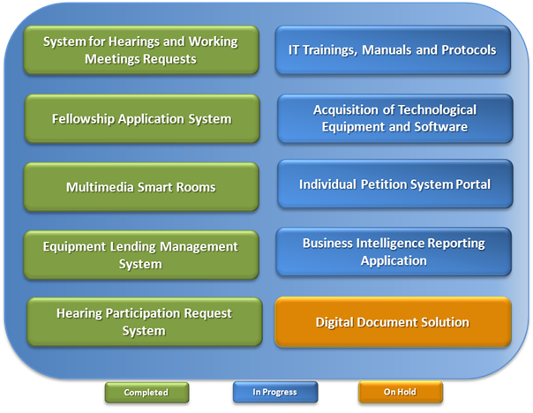

1. The new structure will be implemented in 2015.
2. The Commission approved the process to ensure the creation of the Rapporteurship for Economic, Social and Cultural Rights between December 2015 and January 2016.
3. On January 16, 2015, we received notification from the Secretary for Administration and Finance that as a result of the financial shortages at the GS/OAS, all unfilled positions (2 P04s and P02 that had been reinstated), are to remain frozen throughout 2015, in effect negating the budget approval by member states.
4. Reporting on year-end execution will be provided once the GS/OAS has concluded its financial closing procedures. We anticipate this update to be furnished by the close of the first quarter of 2015 and uploaded to the IACHR website.
5. The Government of Norway made a contribution of US$540,756.00 to the Strategic Plan in December of 2014. The Government of France contributed US$24,000 to the IACHR in December 2014.