**CHAPTER VI  
INSTITUTIONAL DEVELOPMENT AND**

**ADMINISTRATIVE AFFAIRS**

## Structure and Personnel of the IACHR

1. During its 153rd regular session, the Commission approved the new structure of the IACHR. In addition to the Offices of the Executive Secretary and Assistant Executive Secretary and the Department of Institutional Development and Administrative Affairs, which retain their prior structure, the new plan includes the reorganization of personnel under four new departments: the Department of Petitions and Cases; the Department of Geographic Monitoring; the Department of Thematic Monitoring; and the Department of Promotion and Public Policy.
2. The Office of the Executive Secretary is still in the process of taking the administrative steps required to implement this structural change, which includes the issuance by the Secretary General of an amendment to Executive Order 08-01 on the structure of the OAS. On October 29, 2015, the Executive Secretariat presented a proposal to the Office of the Secretary General for implementing the structure at no additional cost to the Organization, and thus the expectation is that it will be accepted very soon.
3. Competitive hiring processes for eight staff vacancies were announced in 2015. These include 4 previously frozen positions, for two P04-level human rights specialists and two G05-level administrative assistants. This represents a positive trend on the part of the new administration to prioritize the needs of the IACHR’s Executive Secretariat, especially given the serious financial restrictions seen throughout the Organization.
4. The following table shows the number of staff and consultants by funding source as of September 30, 2015[1]:

|  |  |  |  |  |
| --- | --- | --- | --- | --- |
| **Category** | **Regular Fund** | **Specific Funds** | **ICR (Indirect cost recovery)** | **Total** |
| Executive Secretary | 1 | 0 | 0 | **1** |
| Assistant Executive Secretary | 1 | 0 | 0 | **1** |
| Special Rapporteur | 0 | 1 | 0 | **1** |
| [Professionals](mailto:Otr@s%20profesionales) | 19 | 19 | 1 | **39** |
| Administrative Staff | 10 | 4 | 0 | **14** |
| **Subtotal Staff** | **31** | **24** | **1** | **56** |
| IACHR Performance Contracts | 0 | 15 |  | **15** |
| Associate Personnel | 0 | 4 | 0 | **4** |
| **Total** | **31** | **43** | **1** | **75** |

1. Also during 2015, the Executive Secretariat was the executing entity for the project of the Interdisciplinary Group of Independent Experts (“GIEI”), established to investigate the disappearance of 43 students in Ayotzinapa, Mexico. To this end, 5 experts were appointed and a total of 8 consultants were hired to provide logistical support.

|  |  |
| --- | --- |
| **GIEI Performance Contracts** | **Specific Funds** |
| GIEI Experts | 5 |
| GIEI Other Performance Contracts | 8 |
| **Total** | **13** |

1. Specifically, in 2015, the IACHR was divided in the following manner:

* Office of the Executive Secretary, which provides services to the Commissioners and is responsible for the strategic management of the Commission. It also includes the Press Office.
* Office of the Assistant Executive Secretary, which provides additional support to the Commissioners, and directs the legal team. It includes the Protection Group and the Documents Office.
* Office of the Special Rapporteur for Freedom of Expression, whose mandate is to promote freedom of expression through annual reports, dissemination activities, alerts, the examination of laws and practices contrary to international standards in this field; and to provide support for the preparation of reports in adversarial matters as well as on precautionary measures related to this issue.
* Department of Petitions and Cases (DPC), which assists the IACHR with the receipt, analysis, and processing of individual petitions alleging human rights violations. It is composed of the following sections:
  + Procedural Delay Group;
  + Registry Section;
  + Petitions Section;
  + Cases Section, divided into two Groups: Merits and Court; and
  + Friendly Settlements and Follow-Up Section.
* Department of Geographic Monitoring (DMG[2]), which ensures the IACHR’s constant observation of the human rights situation in all of the States of the hemisphere, from a geographic focus, by subregions or countries. It includes the Geographic Monitoring Section.
* Department of Thematic Monitoring (DMT), which provides thematic oversight of the situation of OAS Member countries. It includes the Thematic Monitoring Section, and covers the work of the following Rapporteurships and Units:
  + Rapporteurship on the Rights of Indigenous Peoples: Created to focus special attention on the indigenous peoples of the Americas, who are particularly vulnerable to human rights violations, and to strengthen, promote, and systematize the Commission's own work in this area.
  + Rapporteurship on the Rights of Women: Created in 1994 with an initial mandate to determine the extent to which the laws and practices of OAS Member States guaranteed the rights of women and complied with the general obligations of equality and non-discrimination established in the American Convention on Human Rights (hereinafter “American Convention”), and the American Declaration of the Rights and Duties of Man (hereinafter “American Declaration”). By creating the Rapporteurship, the Commission renewed its commitment to ensuring full respect for women’s rights in each of the OAS Member States. The Rapporteurship contributes to a thorough understanding of the need for additional measures to guarantee women’s full exercise of their basic rights, and issues recommendations for States to improve compliance with their priority obligations related to equality and nondiscrimination. Additionally, the Rapporteurship promotes the application of the mechanisms of the Inter-American System of Human Rights to protect the rights of women; conducts specialized studies and drafts the respective reports; and supports the Inter-American Commission in responding to petitions and to other reports of human rights violations in the region.
  + Rapporteurship on the Rights of Migrants: Seeks to promote and guarantee respect for the rights of migrants and their families, asylum seekers, refugees, seekers and beneficiaries of complementary protection, stateless persons, victims of human trafficking, internally displaced persons, and other vulnerable groups in the context of human mobility.
  + Rapporteurship on the Rights of the Child: Cooperates with the analysis and evaluation of the situation of the human rights of children in the Americas. The Rapporteurship provides advice to the IACHR in proceedings on individual petitions, cases, and requests for precautionary and provisional measures that address the rights of the child. Likewise, the Rapporteurship conducts on-site visits to OAS Member States and prepares studies and publications on children’s rights. The Rapporteurship shares its expert knowledge and brings international jurisprudence and studies to the Commission’s discussions. The Rapporteurship is also the point of contact for civil society organizations that work with children and on the issue of children’s rights.
  + Rapporteurship on the Rights of Persons Deprived of Liberty: Its mission is to remain informed, via any reliable information source, about the situation of persons subject to any form of detention or prison in the Member States; conduct visits to OAS Member States for the purpose of compiling information and making recommendations to the States; prepare reports for the Commission on the correctional situation in a particular detention center or country, or at the regional or sub-regional level, along with any recommendations deemed necessary for the Commission; conduct promotional and educational human rights activities; coordinate promotional work with nongovernmental organizations or other international institutions for the protection of human rights; and take any other action or step deemed necessary to protect persons deprived of liberty, within the mandate of the Inter-American Commission on Human Rights.
  + Rapporteurship on the Rights of Afro-Descendants and against Racial Discrimination: Its objective is to stimulate, systematize, reinforce, and consolidate the action of the Inter-American Commission with respect to the rights of people of African descendent and against racial discrimination.
  + Rapporteurship on Human Rights Defenders: Through its various tasks, the Office of the Rapporteur closely follows the situation of all persons who work to defend rights in the region, including judges, prosecutors, and public defenders.
  + Rapporteurship on the Rights of Lesbian, Gay, Trans, Bisexual and Intersex (LGBTI) Persons: Its function is to monitor the human rights situation of lesbian, gays, transsexual, bisexual, and intersex persons in the region, and to promote respect for their rights.
  + Unit on Economic, Social, and Cultural Rights (DESC)**[3]**: The Unit has a mandate to cooperate with the analysis and evaluation of the situation of these rights in the Americas, provide advice to the IACHR in proceedings on individual petitions, cases, and requests for precautionary and provisional measures which address these rights, undertake working visits to the OAS Member States, and prepare studies and publications, in particular on international standards. Likewise, one of the Unit´s principal tasks will be to enable the creation of the future Special Rapporteurship for DESC.
* Department of Promotion and Public Policy (DPPP), the purpose of which is to support the IACHR in its promotion of human rights in the region. It is comprised by three sections:
  + Advice to States Section;
  + Training and Dissemination Section; and
  + Public Policy Section
* Department of Institutional Development and Administrative Affairs (DIAA), which is in charge of all financial and operative planning and reporting, human resource management, and administrative logistics for the Commission, as well as the coordination of all administrative personnel assigned to the regional sections and Rapporteurships. In addition, under the new structure, it manages the coordination of the IACHR’s strategy for relations and communication with regional human rights mechanisms, the United Nations, and other institutions; as well as the administration of technology and automation tools.. It is composed of the following three sections and one unit:
  + Administrative Management Section;
  + Resource Mobilization and Project Management Section;
  + Inter-Institutional Relations Section; and
  + Technology and Systems Unit

## Staff Training

1. During 2015, in cooperation with the Department of Promotion and Public Policy, DIAA implemented the first phase of training and workshops for the Promotion of Gender Equality and Nondiscrimination, which involved the participation of staff of the Executive Secretariat in the OAS Task Force on Sexual and Workplace Harassment, and ongoing training sessions on workplace harassment, sexual harassment, cultural diversity, social inclusion, and gender equality. A total of three workshops were held: 1) “Introduction to Cultural Diversity and Social Inclusion in the International Workplace,” presented by Ms. Zakiya Carr Johnson, Senior Advisor to the Race, Ethnicity, and Social Inclusion Unit at the U.S. Department of State, which was attended by 60 people; 2) “Understanding and Addressing the Spectrum of Sexual Harassment in the International Workplace in the 21st Century,” presented by Carol Miaskoff, Associate Legal Counsel at the U.S. Equal Employment Opportunity Commission, in which 72 people participated; and 3 “Reporting but Not Testifying: Should Women Victims of Intimate Partner Violence be Compelled to Testify in the Criminal Justice System?” given by Dr. Tania Reneaum Panszi. The 2016 workshops are being planned, beginning with one designed for supervisors and coordinators on how to handle complaints of harassment.
2. From September to November 2015, a series of more than ten courses and orientation events was organized for the fall interns. These events consisted mainly of interactive presentations by different offices, sections, and groups of the IACHR Secretariat, as well as a round table with the Executive Secretary.
3. A seminar on the use of force was organized in conjunction with the International Committee of the Red Cross for the staff of the IACHR Secretariat. This event took place on October 29, 2015, and speakers included ICRC Armed Forces Delegate Martin Lacourt, and Javier Ortíz, Head of the Security Forces Program at ICRC.

## Financial resources and budget execution

### Regular Fund

1. For fiscal year 2015, the General Assembly approved a budget of $5,427,900 for the IACHR, of which $4,455,100 is earmarked for personnel costs and $972,800 for operational costs. Although this 2015 budget reflects a modest increase of $82,600 over the 2014 budget, the fact is that the year began with a hiring freeze on three vacant positions. Added to this is the fact that only two of the four positions previously unfrozen had been successfully filled, and therefore two competitive hiring processes had still not been concluded. As shown in the table below, when the hiring freeze is taken into account, the net amount provided to the IACHR is significantly lower than the approved amount, with a difference of $480,200.
2. As of September 2015, the Executive Secretariat has the following competitions in process: two P04s and two G05s. Accordingly, in spite of having been unfrozen during the course of the year, those positions have not yet been filled.
3. Looking ahead to 2016, the Executive Secretariat was able to reinstate the P03 position of Head of the Administrative Management Section. At a time when the General Secretariat made personnel cuts throughout the Organization—up to 25% of the staff in some departments—it is a major achievement that the Office of the Executive Secretary not only did not have its budget cut, but also that the unfreezing of the positions and the addition of a P03 position were maintained.
4. With respect to the execution of the 2015 budget allocation, as of September 30, 2015,[4] the IACHR had executed 75%, with a balance of US$1,230,630, against which obligations totaling US$1,226,200 had already been entered.

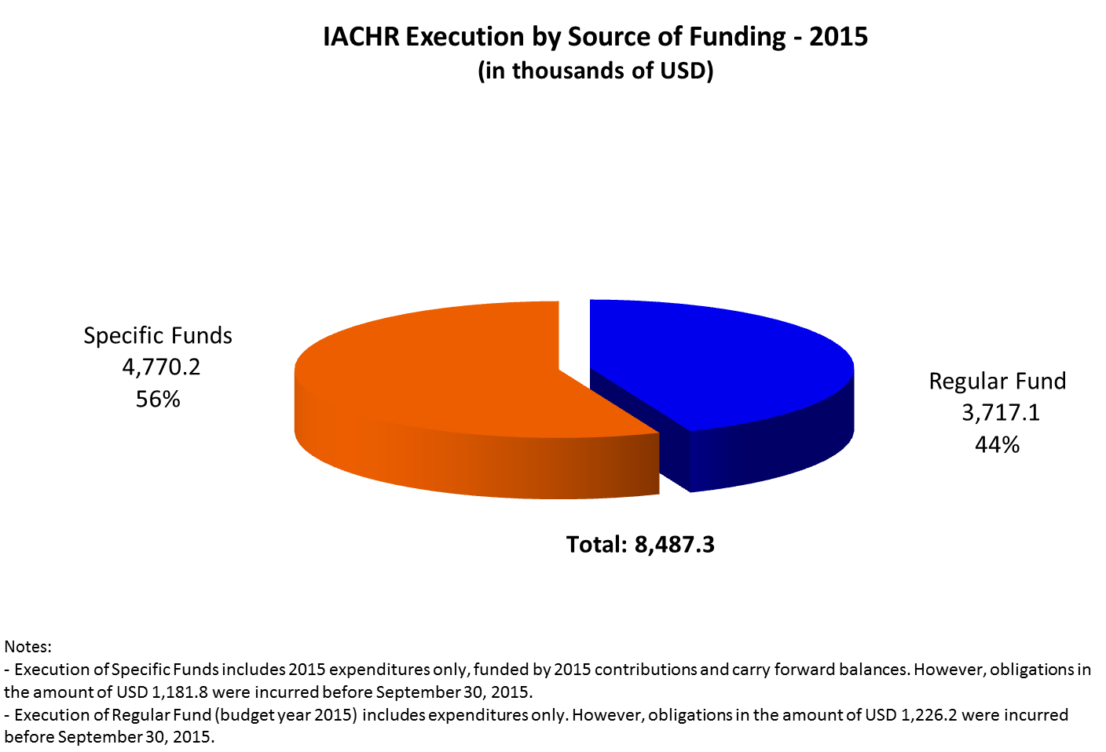

### Specific Funds

1. As of September 30, 2015, the ES/IACHR had received US$ 4,205,100 in contributions from the following Member States: Argentina, Canada, Chile, United States, Mexico, Paraguay, Peru, and Uruguay; from Permanent Observers: Denmark, Spain, France, Sweden, Switzerland, and the European Union; and from non-member States and others: AVINA, the Arcus Foundation, the International Work Group for Indigenous Affairs (IWGIA), the Office of the United Nations High Commissioner for Refugees (UNHCR), Save the Children – Sweden, the University of Notre Dame, and Stanford University. Table 2 shows the contributions made to the IACHR’s specific funds between January 1 and September 30, 2015. The Specific Funds consist of donations outside the regular contributions of OAS Member States, and which are specifically earmarked for certain purposes, issues, or projects.



1. The following graph shows the distribution of execution by Object of Expenditure. It should be noted that, even considering the commitment of the Member States to provide funding to the IACHR, the Regular Fund represents only about half of the annual execution of the Office of the Executive Secretary.

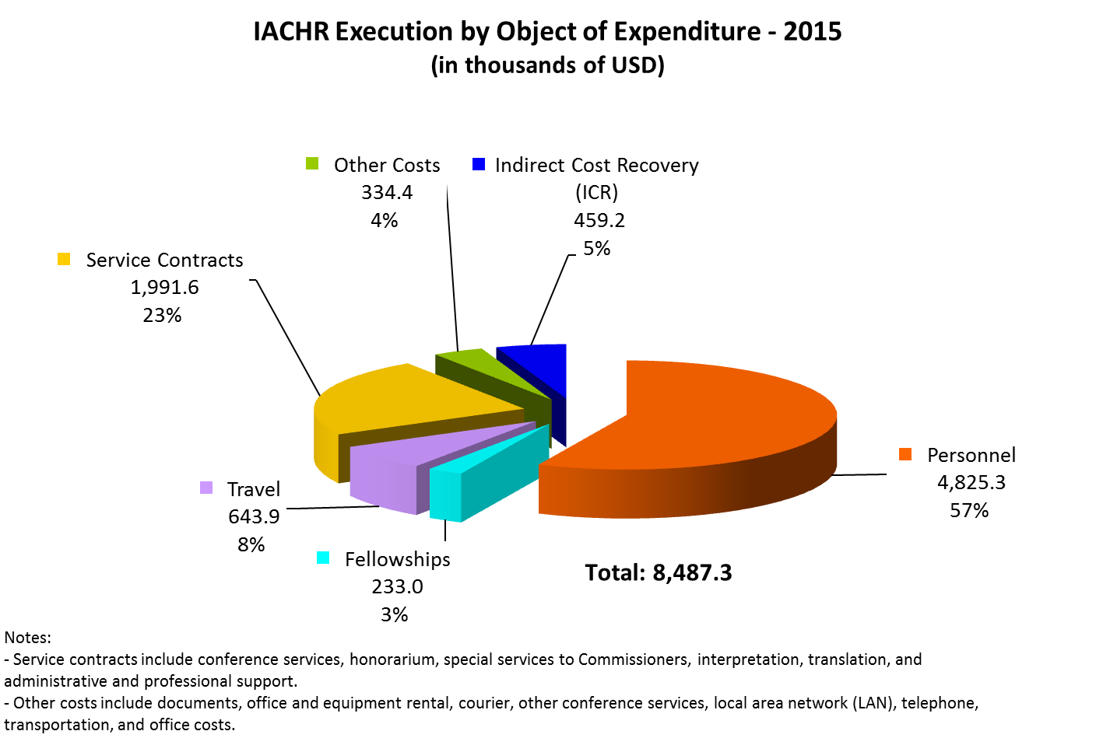

## Resource Mobilization and Project Management

1. The Resource Mobilization and Project Management Section (SMRAP) conducted an assessment to identify and overcome the challenges faced in the task of mobilizing external resources. The assessment and the plan have served as the basis for developing the activities on which the office is currently working, such as the preparation of the 2016-2020 strategic plan and the drafting of a manual of functions and procedures for project management at the IACHR. The office is also working on donor mapping, which has identified potential donors, as well as on the formulation of projects for the mobilization of resources, which will be explained below.

### Strategic Planning of the IACHR

1. The preparation of the IACHR’s 2016-2020 strategic plan began in July, with an internal process for the assessment of strengths, opportunities for improvement, and lessons learned from the 2011-2015 strategic plan (SP 2011-2015). The SMRAP outlined a work program for the preparation of the new strategic plan.
2. In order to facilitate the external evaluation of SP 2011-2015, the SMRAP has also been compiling information about the scope of the plan’s objectives based on the IACHR’s annual reports and available information. The office has also collected information relating to the impact and principal effects of the IACHR’s work over the past five years.
3. In addition, given the need for an external evaluation of SP 2011-2015, the terms of reference have been prepared and the necessary information has been gathered to perform this work. The IACHR has been exploring potential sources of funding for this evaluation.
4. During the September 8-9 workshop “Challenges in the Inter-American Human Rights System: New times, old challenges,” led by different members of civil society who took part in the IACHR strengthening period, the Inter-American Commission received valuable information on the assessment of its work and recommendations on the various pillars of the IACHR. Based on this feedback, the SMRAP prepared a questionnaire for consultation with civil society and the States, with which it hopes to receive inputs on priority issues and themes and recommendations on strategies for improving the impact of its mechanisms that it can include in SP 2016-2020.

### Assistance and Support in the Review of Different Projects

1. The SMRAP has provided support to the areas that have requested it, in the form of technical assistance and review, concept notes, and project documents. The formulation of the Pretrial Detention project was completed in the OAS Project Management System (PMS) based on the observations of the Planning and Evaluation Department. It has also continued to comply with the observations of the OAS Spanish Fund. In addition, it reviewed a draft of the agreement on the Strengthening of Human Rights and Legislative Bodies, a concept note about young people in the criminal justice system, and a concept note for the MacArthur Foundation.

### Preparation of Project Proposals

1. During 2015, twelve project proposals were drafted or coordinated by the SMRAP, detailed below, with the objective of raising funds in support of the activities of the Rapporteurships and ES/IACHR areas:

* Preparation of the project indicators and documents to assist the Rapporteurship on the Rights of LGBTI Persons, as well as the negotiation and signing of agreements. The cost is $100,000 for a two-year period.
* Proposal to the Open Society Foundation through the Trust for the Americas to assist the Rapporteurship on Human Rights Defenders, with a cost of $150,000.
* Drafting of a project proposal for Finland with an emphasis on human rights defenders and journalists, for a three-year period (Euros €600,000). The donor has not reported on the status of the proposal.
* Technical support for the preparation of a reflection document on racial discrimination in the United States and its presentation to various potential donors.
* Coordination and preparation of a proposal for the Swedish International Development Cooperation Agency (ASDI/SIDA), focusing on women who are human rights defenders, LGBTI persons, the protection of indigenous peoples, and access to justice ($385,000). Unfortunately, this proposal was turned down by the donor.
* Assistance with and finalization of a profile project on the promotion of the friendly settlement procedure to Ireland ($113,000) (No answer to date from the donor).
* Request for additional financial support to follow up on precautionary measures in Honduras, Guatemala, and Nicaragua in the context of Regional Projects in Central America – Proderechos ($34,000).
* Development of a new proposal on the thematic issue of *Migrants and their families,* addressing in particular the right to access to justice and due process for asylum seekers. This would be for a two-year period, and was presented by Avinna/Camina ($100,000).
* Development of a new proposal on the initiation of the Rapporteurship on Economic, Social, and Cultural Rights, raising funds from different donors.
* Support for the development of a proposal that would address the issue of the use of the friendly settlement mechanism. This proposal will be financed by the Spanish Fund ($203,800).
* Preparation of a proposal for an extension of Norwegian cooperation to finance the promotion and defense of human rights in Latin America ($800,000). In November 2015, Norway indicated that as a result of an internal policy change, it would not be supporting initiatives in the Americas in 2016.
* Preparation of a proposal for the promotion of rights in Central America within the framework of the Proderechos project for 2016 ($206,000).

### Project Reports

1. During 2015, eleven project reports were drafted or coordinated by the SMRAP to be presented to the respective donors:

* Annual Report of the Central America Regional Human Rights Project – Proderechos, funded by Denmark, as well as the reports for the assessment, coordination, and assistance of the review mission for this project.
* Final report on the 2014 contribution of the United States to the activities described in SP 2011-2015, carried out in 2014.
* Project report on the “Promotion of the Standards of the Inter-American Human Rights System in the Area of Pretrial Detention in the Americas, in the context of the IACHR’s Strategic Plan—program 4. (CDH 1107).” The report was requested for the evaluation and launching of the new 2015 project with AECID.
* Coordination, consolidation, and participation in the preparation of the report on the *Program of the Inter-American Commission on Human Rights and Indigenous Peoples* for the International Work Group for Indigenous Affairs (IWGIA).
* Final report on activities undertaken in relation to the outline of the Strategic Plan during the 2014-2015 period funded by the Kingdom of the Netherlands.
* Presentation of a document on the systematization of information and the supplementing of a report related to the project “Promotion and Standards of the Inter-American Human Rights System in the Area of Pretrial Detention in the Americas, in the context of the IACHR Strategic Plan—Program 4.” The report was requested for the evaluation and launching of the new 2015 project with the Spanish Fund in response to the observations of the OAS Department of Planning and Evaluation.
* Support for and coordination of the Midterm Report on the promotion of the use of friendly settlement procedures for the Spanish Fund.
* Annual Report on the Project “Assistance for the Strengthening of the Rapporteurship on the Rights of the Child -2015” funded by Save the Children.
* Annual Report on the strategic plan programs funded by the contribution from the Kingdom of Norway in 2015.
* The SMRAP has coordinated the provision of inputs and prepared the report on the project funded by the European Commission on the *Promotion and Protection of the Rights of the Most At-Risk Populations in the Americas.*

### Exploration of New Sources and Opportunities

1. In view of the IACHR’s instruction to request voluntary contributions for the development of the 2016-2020 strategic plan as well as an extraordinary contribution for the creation of the Rapporteurship on Economic, Social, and Cultural Rights, 33 letters were sent to Member States. In addition, letters of introduction and letters of interest were drafted and sent to international organizations and donors such as OXFAM UK, the International Development Research Center (IDRC) in Canada, and the Oak Foundation, as well as the governments of Korea and Japan.
2. A partnership was established with the Pan American Development Foundation (PADF) for the presentation of joint proposals to donors to which the IACHR did not have direct access. One of them was partner support for a proposal to USAID in a competitive bidding process on public policy and human rights in Mexico. Unfortunately, another organization won the bid.

## Technology Advances

1. The Technology and Systems Unit (UTS) is responsible for managing information technology resources, projects, systems applications, and telecommunications for the IACHR. The UTS main functions are to promote the integrity and transparency of the Commission’s processes and work with technology and automated tools to improve management decision-making, internalize management practices, streamline manual staff procedures, and provide support to victims, petitioners and States with innovative technology.
2. During the 155th regular session the IACHR launched the Individual Petition System Portal (IPSP or Portal) on which the UTS has been working for some time, coordinating and implementing related activities within the Office of the Executive Secretary of the IACHR, including:

* The inclusion, review, and approval of all of the texts on the Portal for each official language.

• The creation, review, validation, and dissemination of the Portal’s Terms of Use and Agreement for users interested in registering and using the Portal in the four official languages. At this time, we have received replies from 18 Member States who have submitted the information and expressed their interest in participating and using the system: Argentina, Bolivia, Brazil, Chile, Colombia, Costa Rica, El Salvador, the United States, Guatemala, Guyana, Honduras, Jamaica, Mexico, Nicaragua, Panama, Paraguay, Peru, and Uruguay.

• Testing of the Portal’s operation in a test environment, including the creation of cases with simulated information for purposes of rehearsing various potential scenarios. The respective follow-up and monitoring was conducted in order to validate the outcomes.

• Reporting to the Department of Information and Technology Services (“DOITS”) on discrepancies and problems in the features and operability of the system found during the testing, and the outcomes obtained.

1. This system sets the standard for progress in the approach and transparency of the information available to users of the IACHR with respect to their cases, in a manner that is innovative and unique in the region. There is no other system in the hemisphere with the particular features and operability that this Portal provides to those who place their trust in the IACHR.
2. Individuals, organizations, and States can access information on their petitions, cases, and precautionary measures pending before the IACHR, thus contributing to the enhanced transparency of the procedures and expediting their processing through the use of technology and automated management tools. This launch is part of the IACHR’s efforts to create mechanisms that facilitate access to information for persons who use the Inter-American Human Rights System. The design of these tools has taken account the need to safeguard the sensitive information in the possession of the IACHR.
3. The Portal not only contains efficiently structured and digitized information but also offers other benefits. For instance, it offers transparency in the IACHR’s work and proceedings through the use of technology and automated management tools, the expedited exchange of communications and documentation, access to information on the status and procedural stage of pending petitions, cases, and precautionary measures, and an easy, free, and instantaneous way to send and receive additional information on existing matters.
4. Once the Portal went online, users immediately began to register and make use of the tool. As of December 31, 2015, it had a total of 1,473 registered users, 45 of which are users accredited by Member States including: Argentina, Bolivia, Canada, Chile, Colombia, Costa Rica, Ecuador, El Salvador, Guatemala, Guyana, Honduras, Jamaica, Mexico, Nicaragua, Paraguay, Peru, Uruguay, and Venezuela. To date, 10,736 documents containing additional information have been processed through the automated system. In addition, we have received 483 new legal complaints through the Portal A total of 19,705 documents have been processed through the system thus far.
5. In order to constantly improve the systems, the UTS carried out the project to improve the performance of our document management system (DMS), which is used to control the flow of documents received from and issued to petitioners and States. The DMS was showing signs of instability in response times and performance, due to the fact that the technological platform on which the system is based needed to be updated and improved with cutting-edge elements. This project included phases for the planning, testing, monitoring, implementation, and adjustment of the changes and enhancements to the DMS. At the trial phase, in order to ensure that the proposed improvements worked properly in our actual work environment without causing adverse effects, the work flows and processes were simulated in a special, separate environment dedicated solely to testing. Experiments were conducted with users from the different modules of petitions, cases, and precautionary measures, playing out scenarios that included everything from the registration of the complaint to the electronic signature of a letter, going through all of the work flows and all of the respective sections. The results were successful, the system’s performance was stabilized, and there was a notable improvement in response times.
6. The systems[5] of the IACHR rely on the direct administration, monitoring, and support that the UTS provides to users inside and outside the Executive Secretariat. It is responsible for constantly feeding the information received about new complaints and additional information for existing matters into the systems, in addition to reviewing and registering the information received through the Individual Petition System Portal.
7. The Office of the Executive Secretary asked the UTS to plan and execute a Comprehensive Digital Restructuring Plan compatible with the IACHR’s new organizational structure. Following an initial assessment, it was determined that updates and changes had to be made to the DMS, the PCMS, the digital information storage systems (G drive, I drive, and Public Folder), and the institutional email accounts for sending information to users of the IACHR. With respect to the planning of matters pending in the systems to be transferred to the attorneys who received a new portfolio, in accordance with the new structure, we reassigned a total of 10,367 actions pending in the DMS from one user to another. In the PCMS, there were 2,447 matters that had to be reassigned respectively to the attorneys providing support to the new organizational structure.
8. The activities undertaken and implemented by the UTS for the Comprehensive Digital Restructuring Plan were:

* Development of a plan for the IACHR’s digital systems based on the restructuring.
* Inventory and mapping of pending cases and actions by work area and responsible users.
* Work flow proposal, in consultation with the IACHR’s Board of Officers, that allows for the continued use of the PCMS and DMS systems even though their features were designed under the criteria of the old organizational structure. It is suggested that the systems be redesigned in order for their features and operability to accommodate the process changes resulting from the organizational restructuring of the IACHR.
* Implementation, in conjunction with DOITS, of the reassignment of pending cases, petitions, and actions, following the established schedule.
* Ongoing adjustments and updates pertaining to access, responsibilities, and pending issues in the systems for the users.
* Dissemination to users and documentation of the new work methodologies established for the use and operation of the systems, approved by the IACHR’s Board of Officers.
* New, general email inboxes with the new area names requested and assigned to the users responsible for them.
* Assessment of the space, use, and organization of the digital information storage systems. The need to implement a more robust access and security design was identified.
* Initial development of the new structure of these storage systems to expedite the location of information and have information readily available to share, and the adjustment of access to information as appropriate.

1. This technological unit prepared statistical reports on the information obtained on requests for hearings and work meetings for the 154th and 156th sessions. The reports included the total number of visits to the system, requests that include hearings and work meetings by country, requester type, and rapporteurship, as well as statistics and tables pertaining to the approved requests. These tools enable and facilitate senior management’s decision-making processes.
2. The UTS designed and implemented an application to automate the process for inviting civil society to the sessions for hearings requested by Member States. In this way, we were able to provide the Executive Secretariat with user-friendly reports for the systematization of information, analysis, and the selection of organizations to participate in the aforementioned hearings.
3. In preparation for and during the sessions, the UTS coordinates and manages the logistics, scheduling, monitoring, and follow-up of the technological and telecommunications services in direct contact with the respective areas of services in order to ensure the success of the meetings and events. For the 154th session, the UTS was able, for the first time, to provide a broadband Internet connection in the press hall for the journalists to be able to transmit multimedia material without restriction through the web while the hearings were being held.
4. In the ongoing process of state-of-the-art technological innovation, the UTS analyzed, designed, and implemented the online systems to receive fellowship applications for:

• Lawyers from English-Speaking Countries of the Caribbean

• Rómulo Gallegos Fellowship 2016

• International Protection and Internal Displacement 2015

• Human Rights Defenders

• Rights of Indigenous Peoples

• Rights of Persons of African Descent and against Racial Discrimination

• Rights of Lesbian, Gay, Bisexual, Trans and Intersex Persons (LGBTI)

• Public Policy with a Human Rights Approach from the Work of the IACHR

1. The information will be updated to December 31 once the year has closed.
2. Abbreviations used are from Spanish titles
3. The Commission approved the process for the creation of the Rapporteurship on Economic, Social, and Cultural Rights and the Office of the Executive Secretary established a special fund to receive donations from the Member States to this end. As of the date of this report, a donation of $8,000 was received from Peru.
4. Reporting on year-end execution will be provided once the GS/OAS has concluded its financial closing procedures. We anticipate this update to be furnished by the end of the first quarter of 2016 and uploaded to the IACHR website.
5. The systems include the Portal; the DMS; the Petition and Case Management System (PCMS); the Hearing Request System (HRS); and the Fellowship Application System (FAS).