CHAPTER II
THE PETITION AND CASE SYSTEM

- Introduction

- This chapter refers to the work of the Inter-American Commission on Human Rights in 2016 in relation to the petition and case system.

- Section B includes statistical information to provide a general overview of the different activities carried out by the Inter-American Commission on Human Rights. First it presents data concerning the cases and petitions being processed. These comprise the greater volume of the Commission's work. “Cases” is taken as meaning all those petitions declared admissible by means of a report on admissibility. “Petitions” is taken as meaning all those complaints that have been transmitted to the state involved but in which no report on admissibility has been issued. This report includes the statistics of the total number of petitions received by the Commission in 2016, indicating the number of petitions received by country, as well as a comparison of the number of petitions received in 2016 in relation to each of the last twenty years. It also includes statistical information on the number of petitions it decided to transmit to the States, and the number of petitions being processed, also by country. The statistical information reflects as well the number of requests for precautionary requests received by the Commission in 2016, as well as the number of precautionary measures the Commission decided to grant during that same period. The statistics indicate how many reports on admissibility, inadmissibility, friendly settlement, archive, and the merits the Commission published in 2016. The section also includes statistical tables on the Commission’s activity before the Inter-American Court. Finally, statistics are included on the number of hearings the Commission held in 2016.

- Section C has two parts. The first, section C.1, contains an overview of the resolutions on precautionary measures granted or extended by the IACHR in 2016, in relation to the various member States, under Article 25 of its Rules of Procedure. The resolutions set forth the parameters used by the IACHR in determining the requisites of urgency, seriousness and irreparable nature of each specific case.

- The second part (section C.2) includes all the reports adopted by the Commission on admissibility, inadmissibility, merits, friendly settlement, or archive of petitions and cases in the period covered by this report. This section contains a total of 74 reports: 43 declaring petitions admissible; 2 reports declaring petitions inadmissible; 8 reports on friendly settlement; 16 reports on merits, and 5 reports on publication. The IACHR also decided to set aside 77 petitions and cases, which were archived.

- Section D includes an analysis of compliance by the States with the recommendations contained in the reports on individual cases published in the Annual Reports since 2000, in keeping with Article 47 of the Commission’s Rules of Procedure.

- Statistics
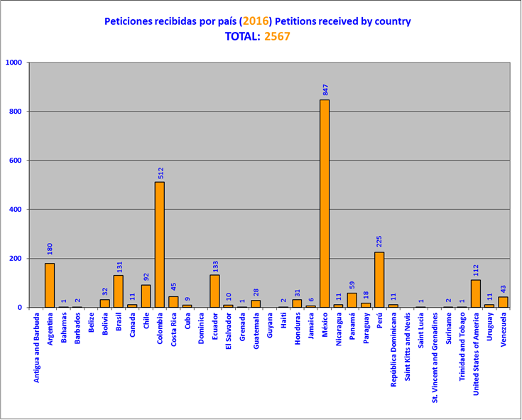

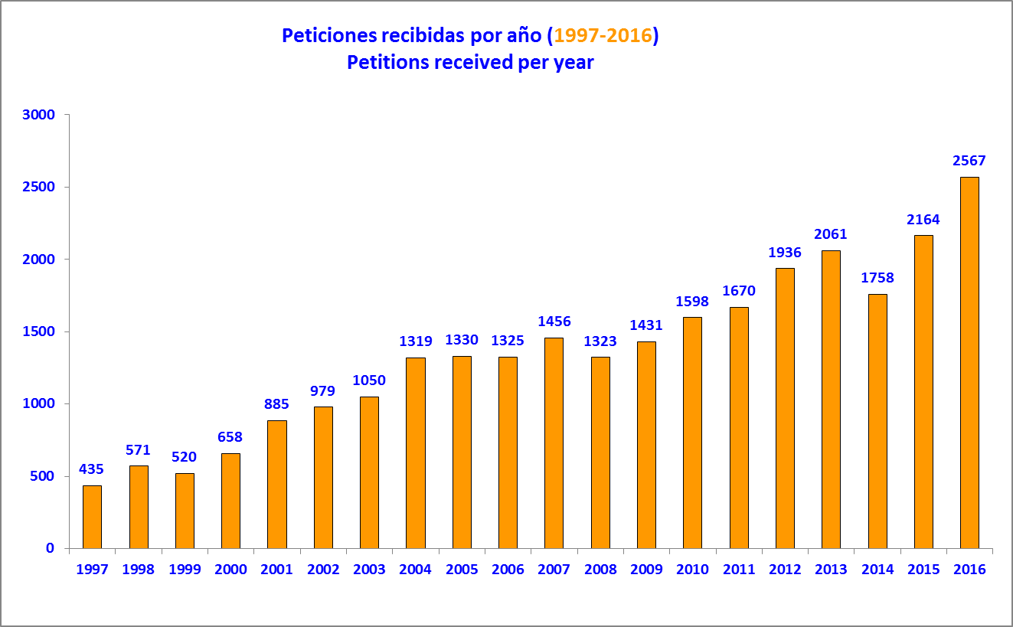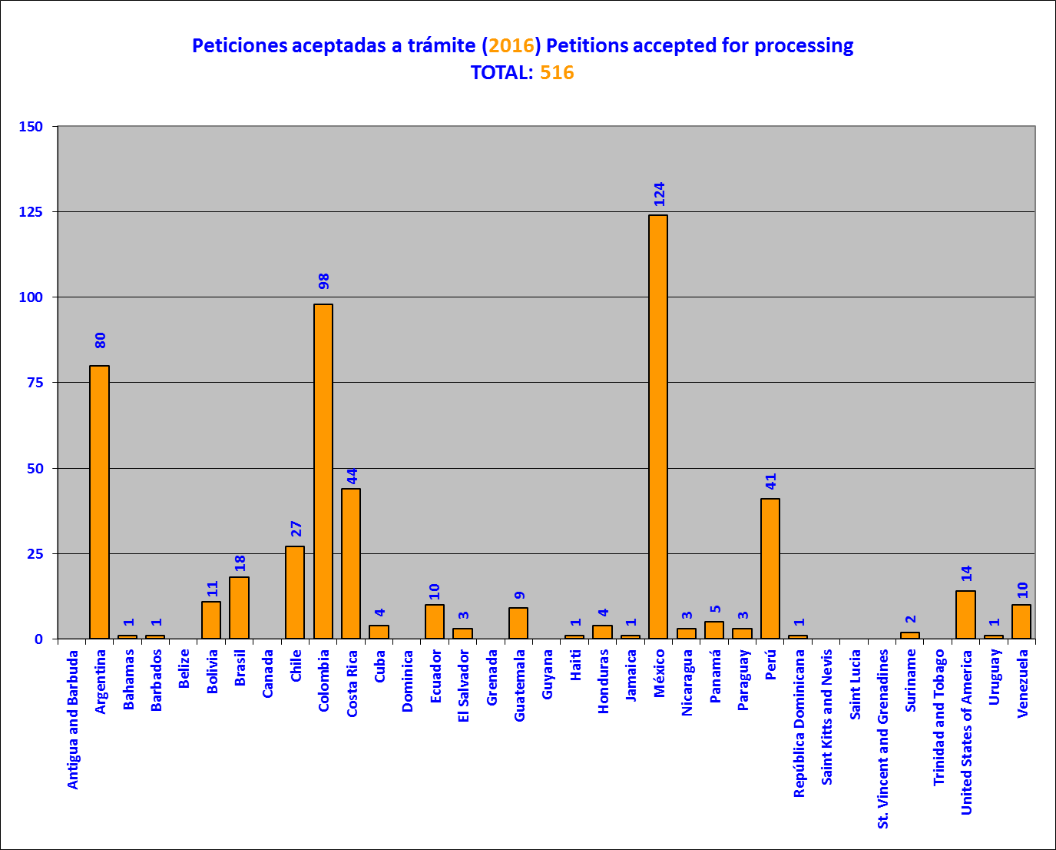
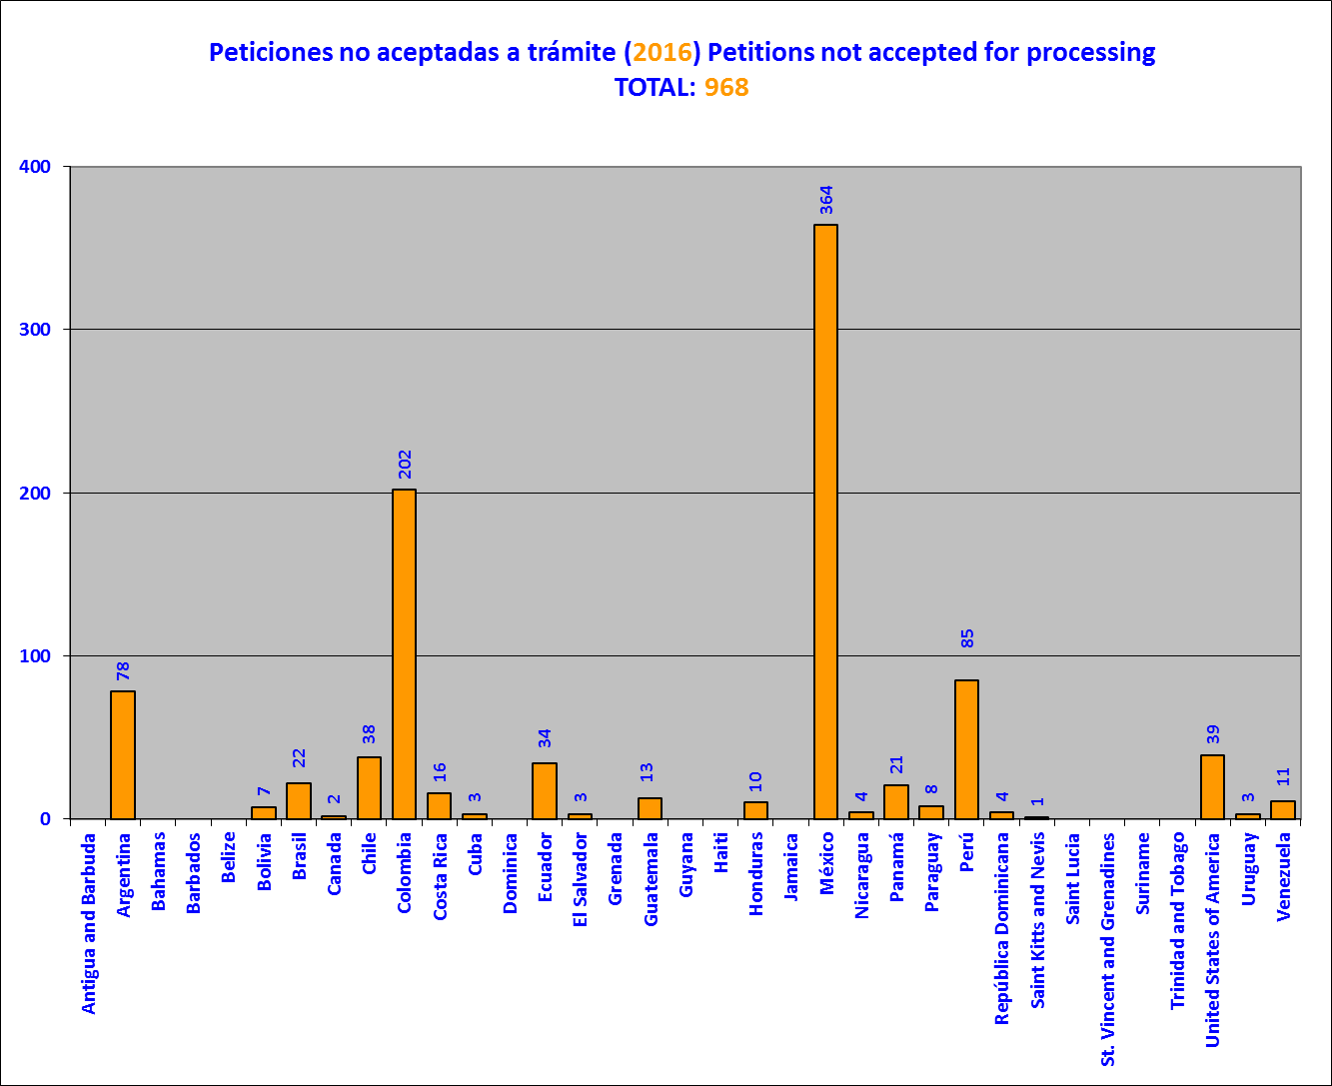
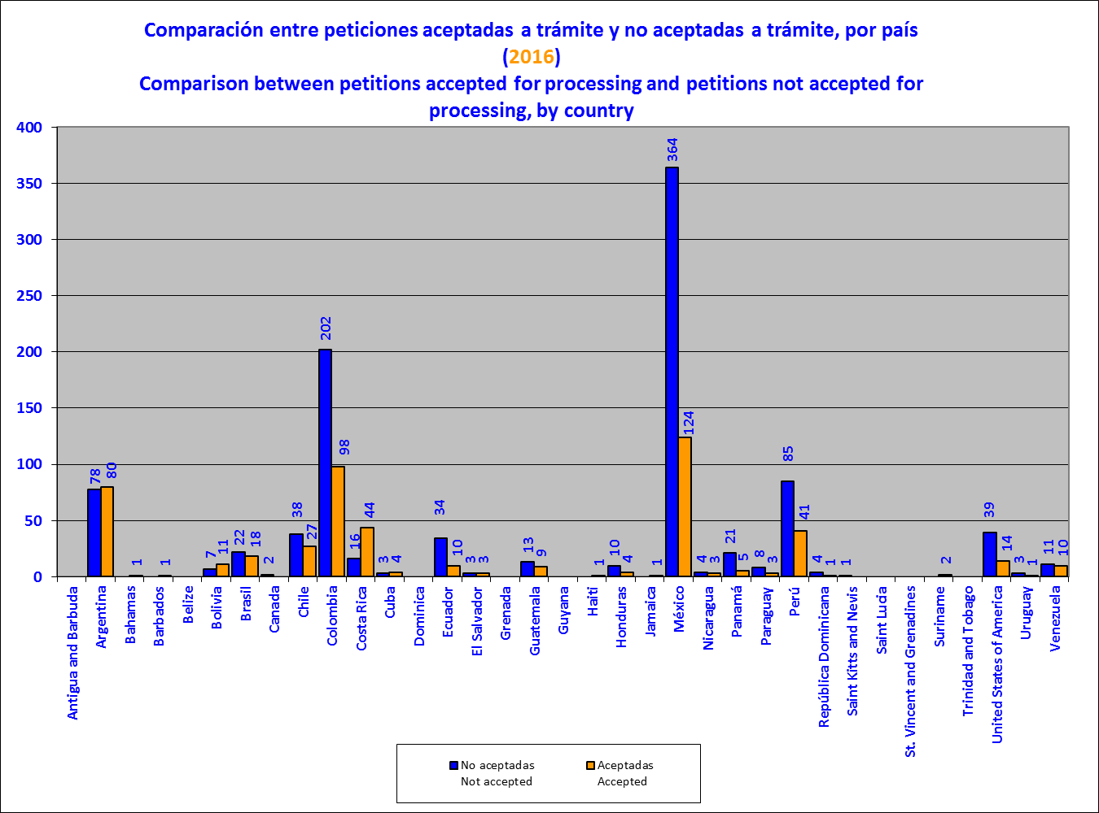
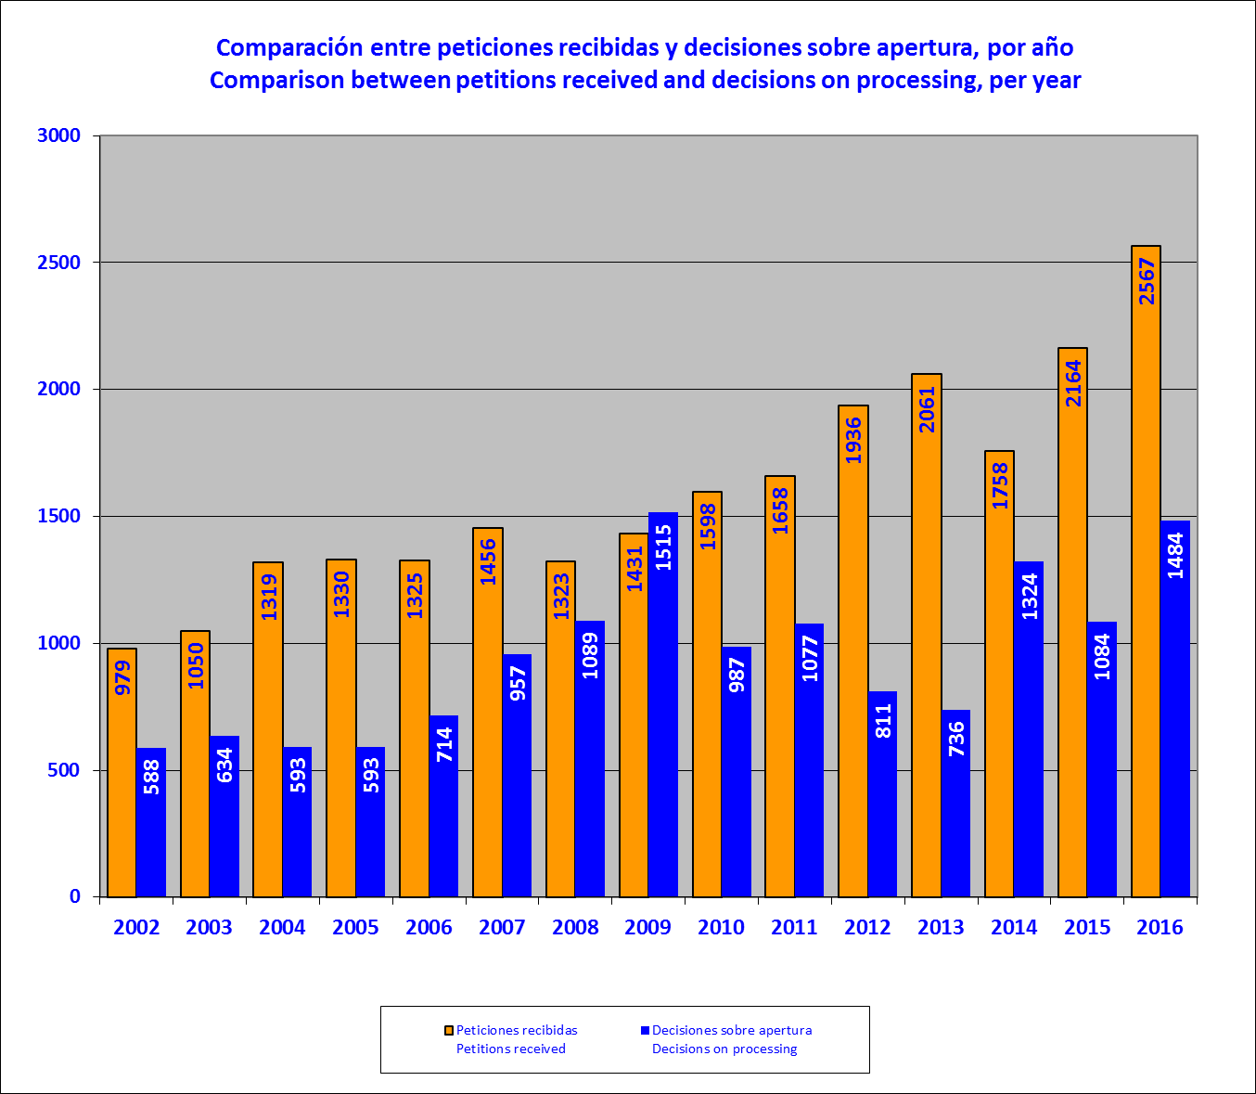
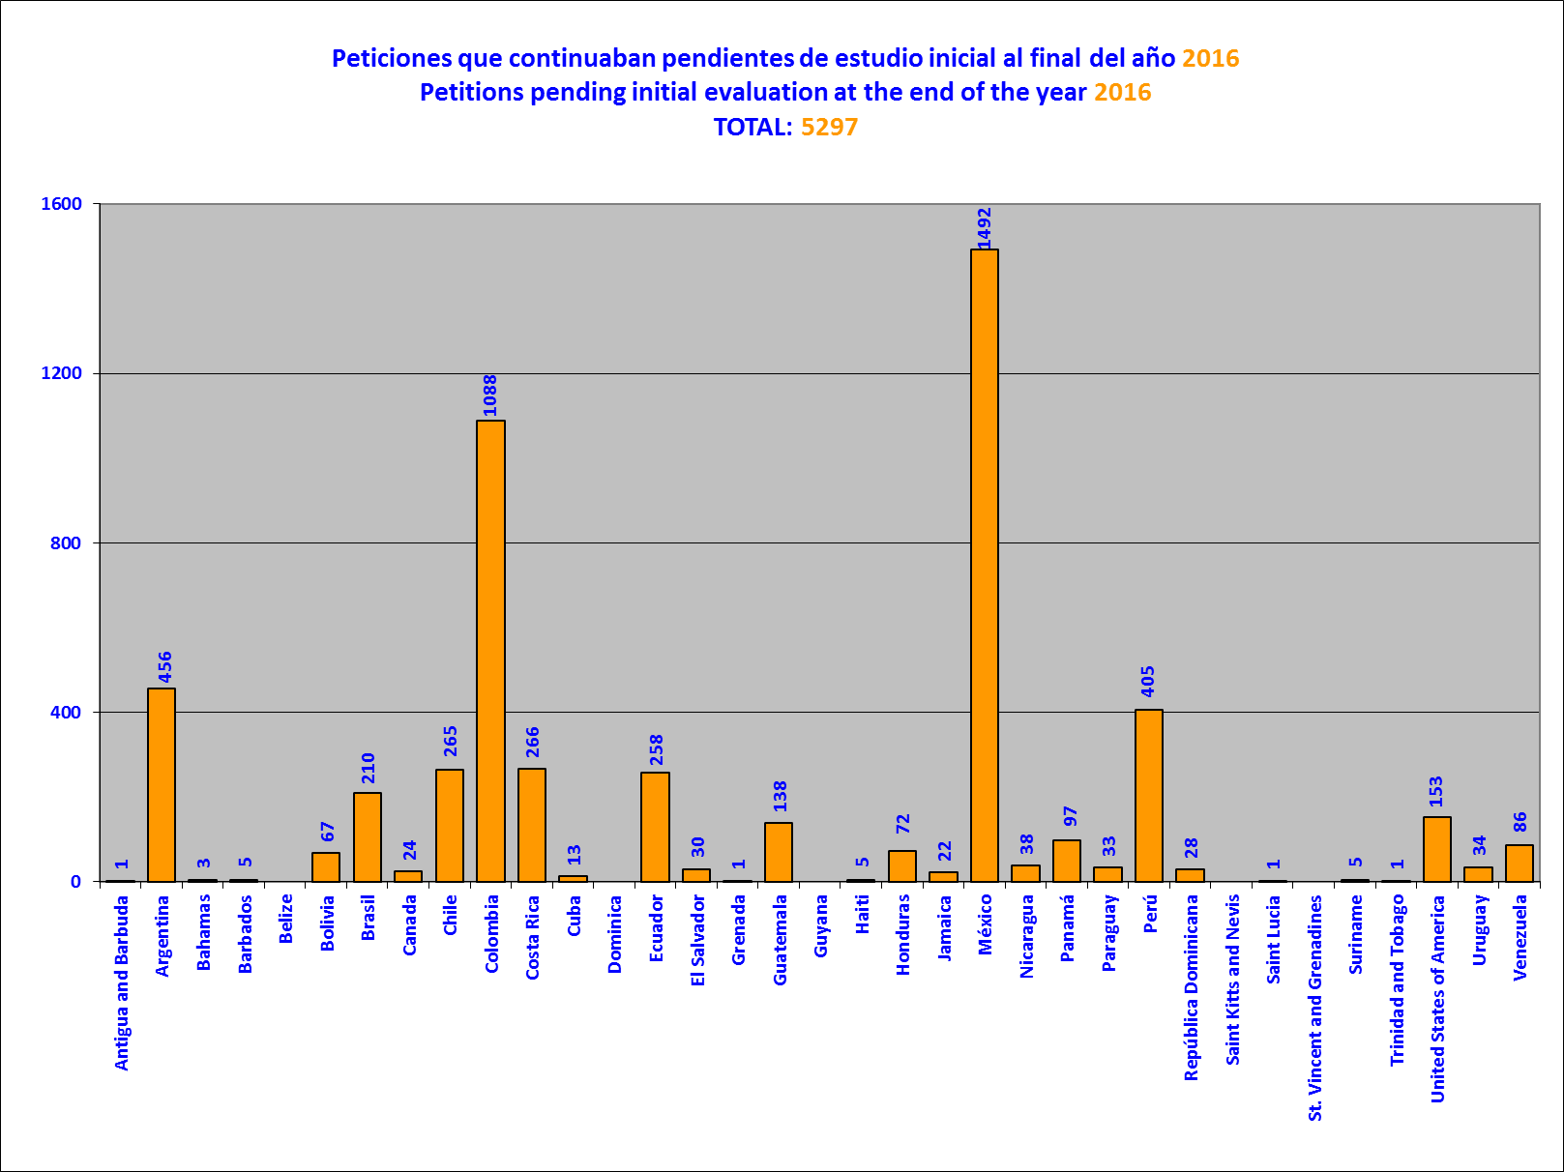
Este número incluye peticiones revisadas por GAP, como parte de la iniciativa contra el atraso procesal, pendientes de una notificación.
This number includes petitions reviewed by GAP, as part of the procedural backlog initiative, which are pending notification..
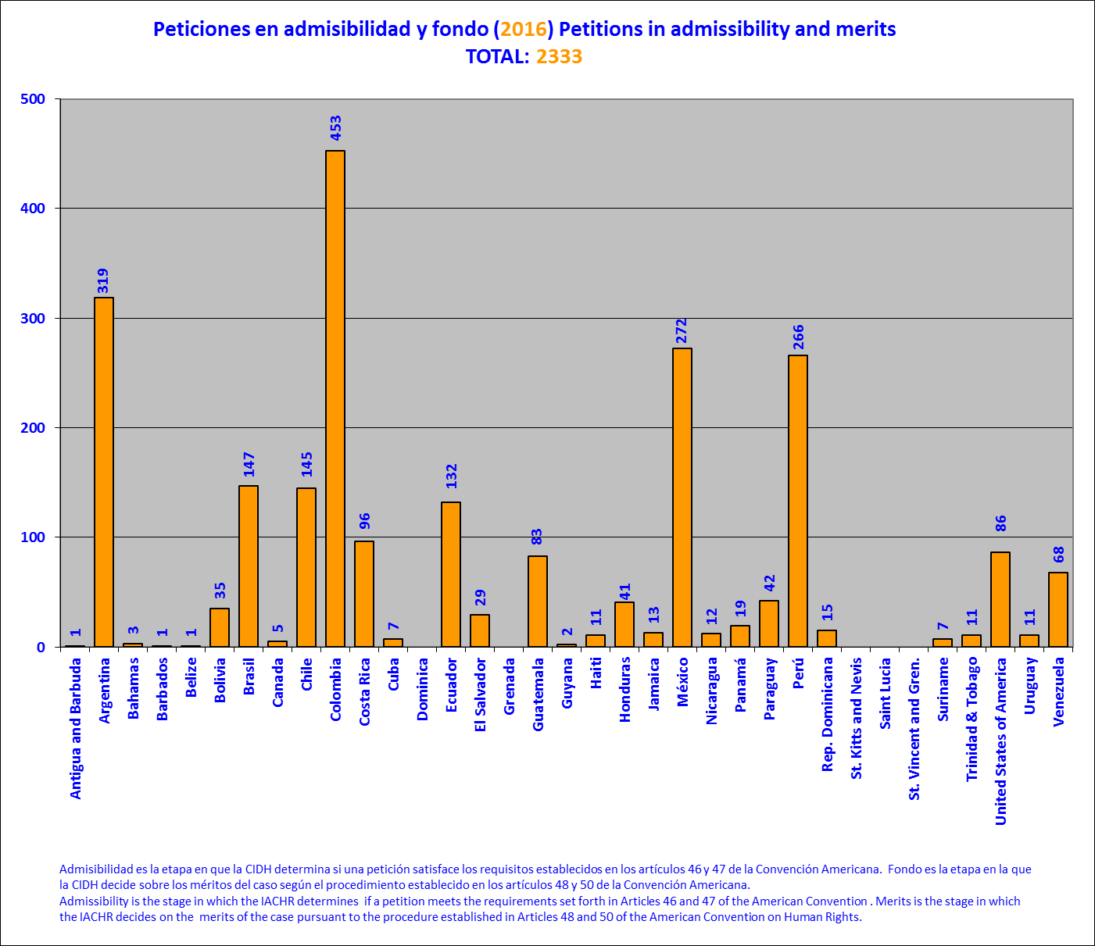
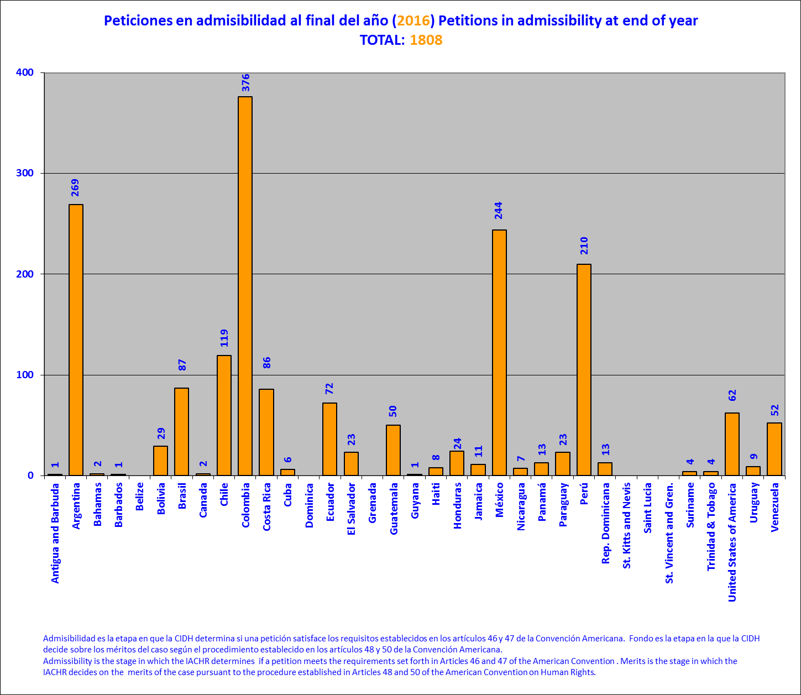
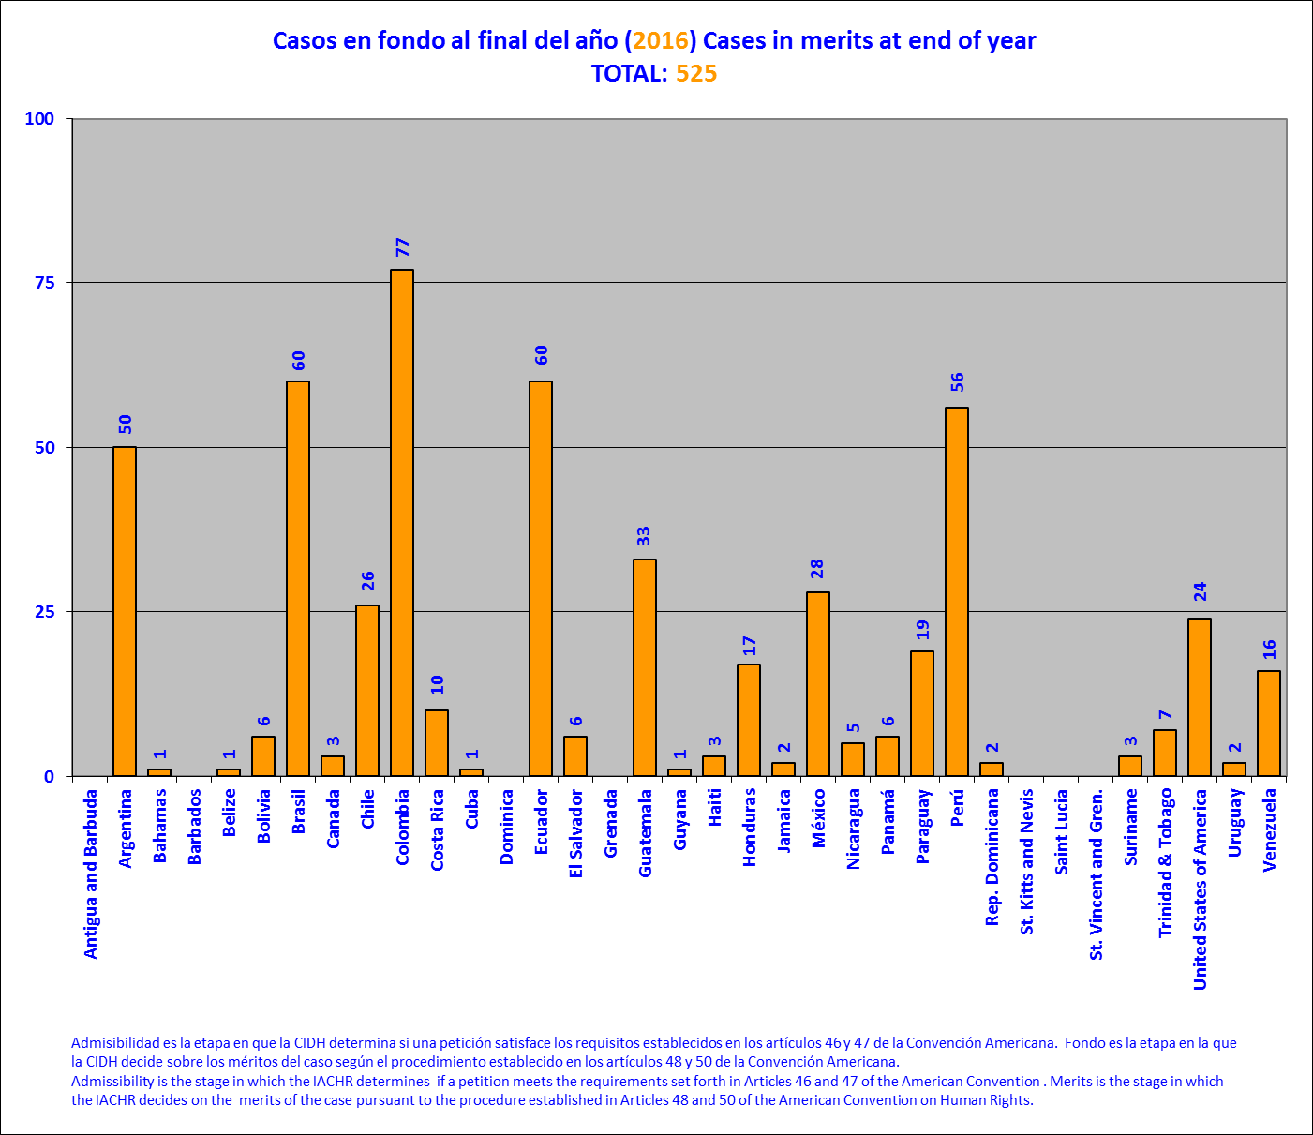
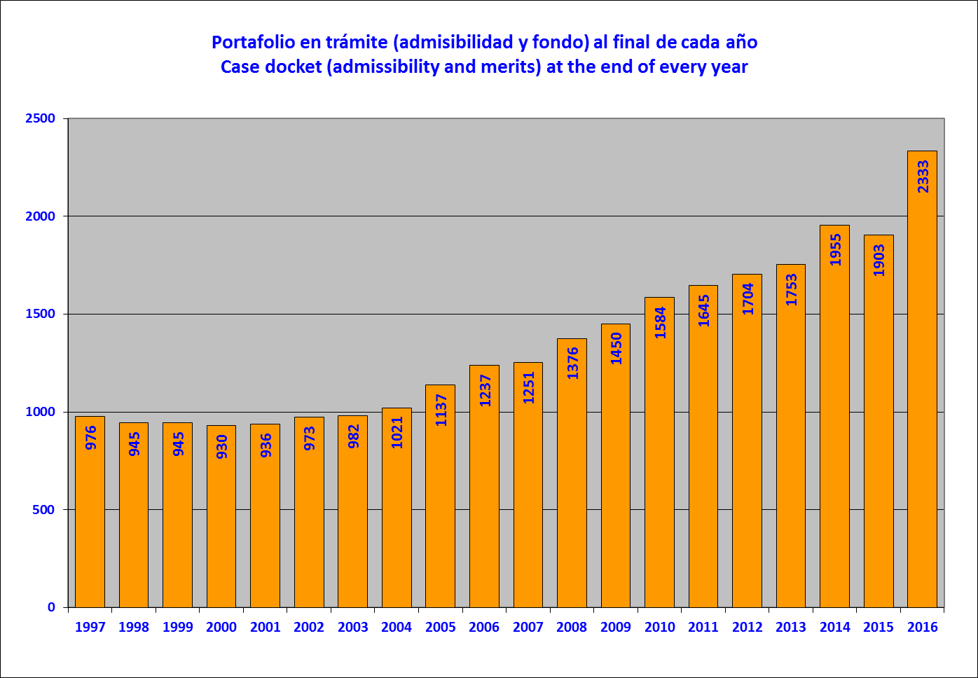

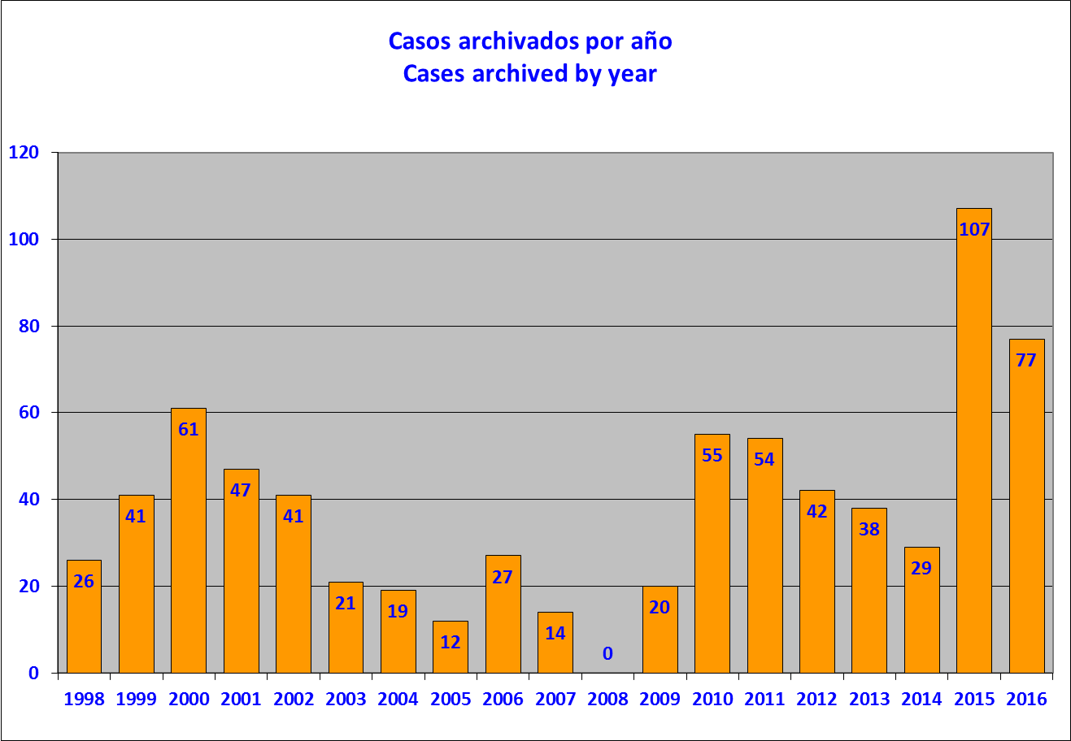
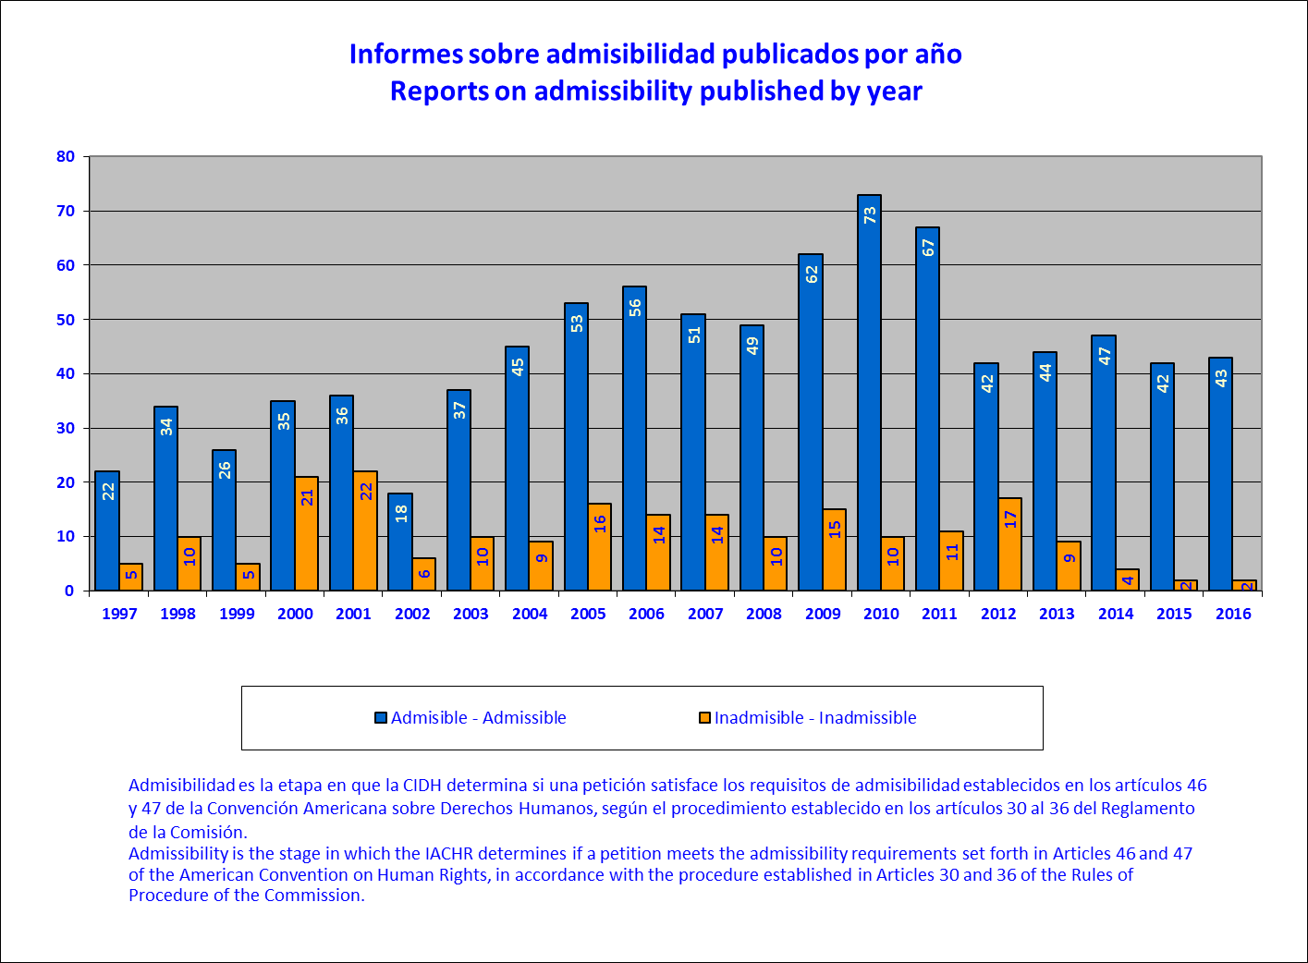

Durante el 2016 se aprobaron 43 informes de admisibilidad que representan un total de 53 peticiones.
In 2016, 43 admissibility reports were approved; they represent 53 petitions.

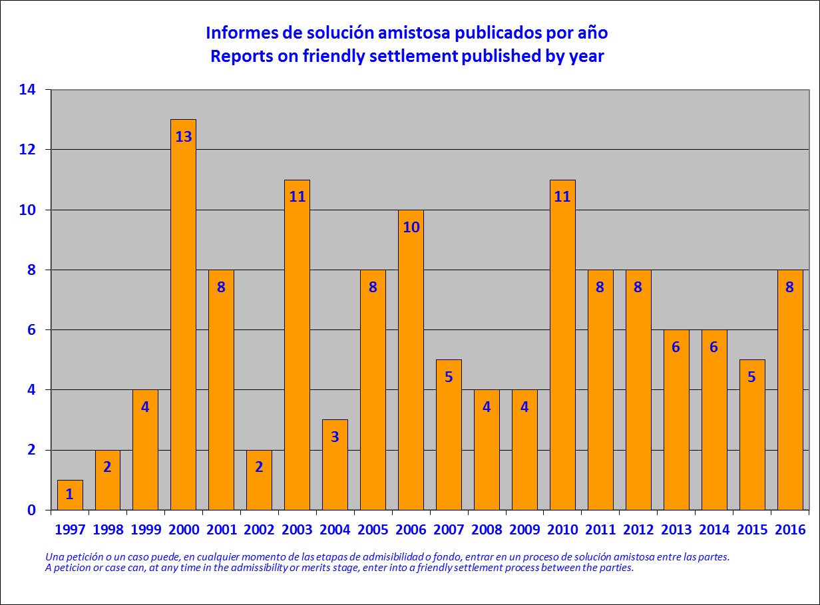

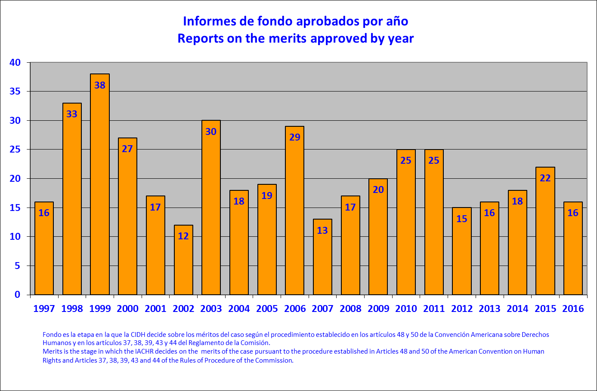
Durante el 2016 se aprobaron 16 informes de fondo que representan un total de 20 casos ya que en un informe se acumularon 5 casos.
In 2016, 16 merits reports were approved; they represent 20 cases, because one report accumulates 5 cases.
