NINTH REGULAR MEETING OF THE OEA/Ser.W/XIII.6.9
INTER-AMERICAN COMMITTEE ON EDUCATION CIDI/CIE/doc. 12/21
November 18-19, 2021 11 November 2021
Washington, D.C., United States of America Original: Spanish
VIRTUAL

EXECUTIVE SUMMARY

Towards a Culture of Digital Accessibility: Experiences and Educational Challenges for Persons with Disabilities during the Pandemic

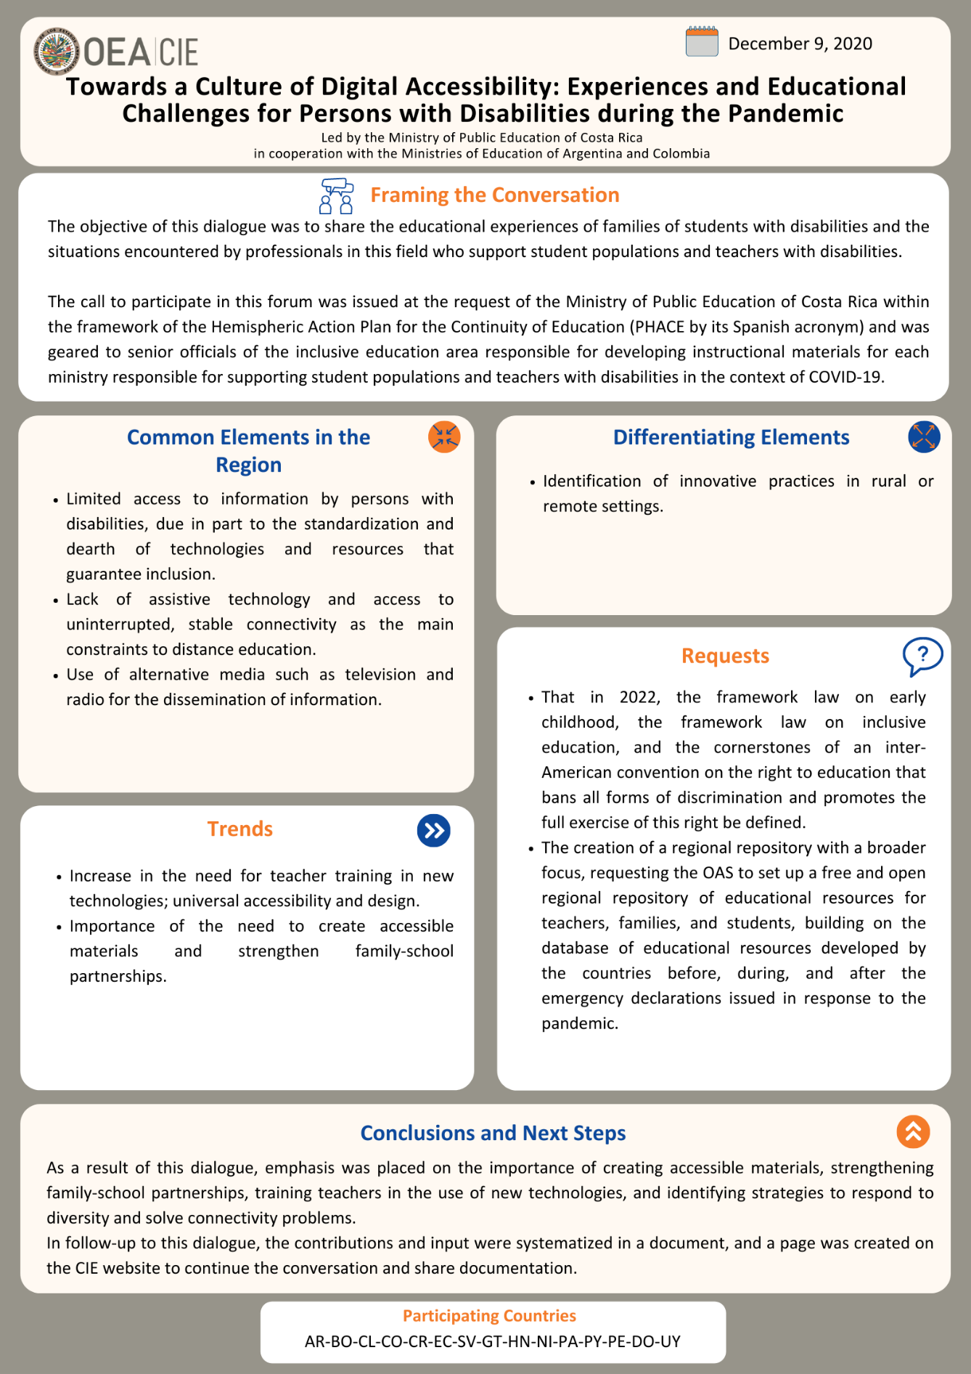
Access to the full document:
Spanish
English
CIDED00229E01

