NINTH REGULAR MEETING OF THE OEA/Ser.W/XIII.6.9
INTER-AMERICAN COMMITTEE ON EDUCATION CIDI/CIE/doc. 6/21
November 18–19, 2021 9 November 2021 Washington, D.C., United States of America Original: Spanish
VIRTUAL

PROGRESS REPORT ON COMPLIANCE WITH THE WORK PLAN OF THE
INTER-AMERICAN COMMITTEE ON EDUCATION (PTCIE) 2019-2022 AND RESOLUTION AG/RES. 2955 (L-O/20) – OPERATIVE PARAGRAPHS 21-23/26

SYSTEMATIZATION OF DIALOGUE
“Roundtable: Exchange and Thoughts on the Return to In-person Education”

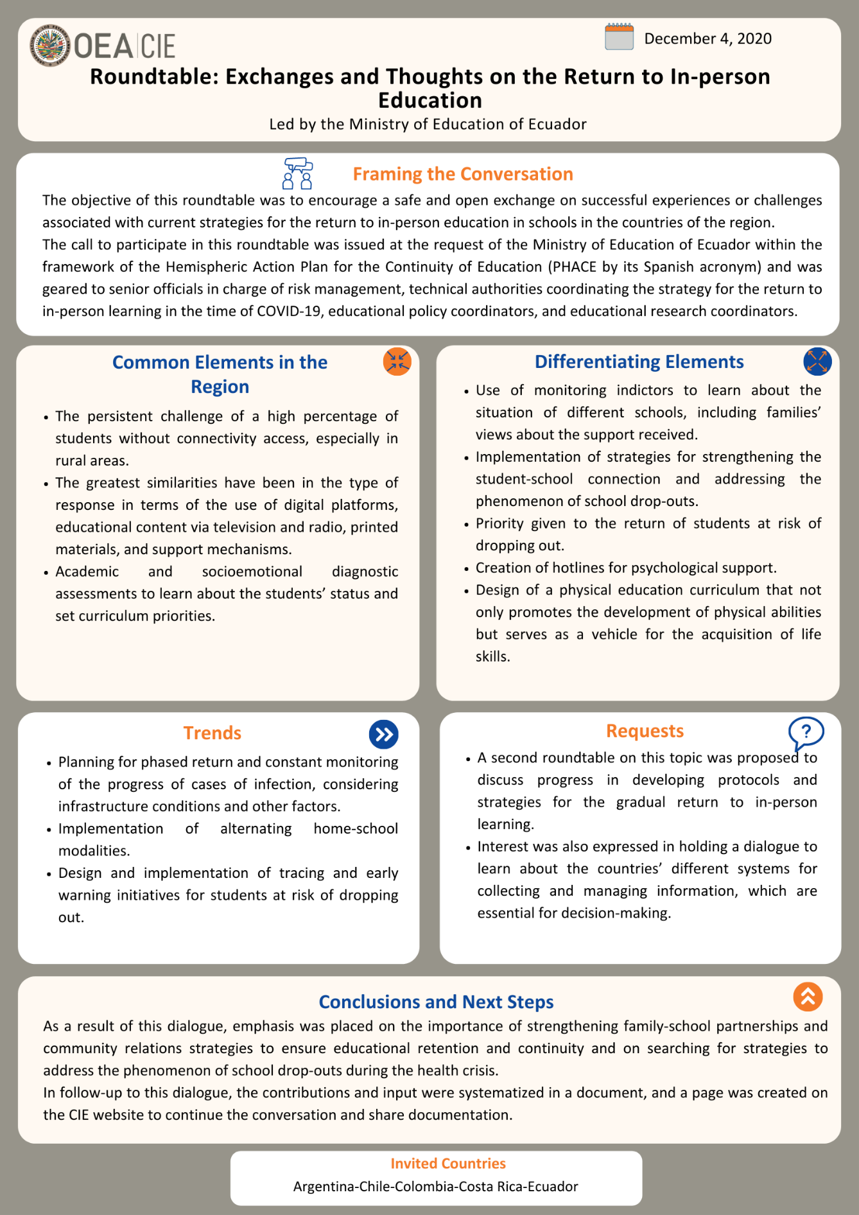

Systematization of Dialogue
Exchange and Thoughts on the Return to In-person Education

Event: Roundtable: Exchange and Thoughts on the Return to In-person Education | Date: December 4, 2020
Objective: Foster dialogue and a safe, open exchange of successful experiences or challenges regarding (ongoing) strategies for the return to onsite learning at school in our countries.
Guest Countries: Argentina-Chile-Colombia-Costa Rica-Ecuador
Under the leadership of: Ecuador

The partners’ roundtable “Exchange and Thoughts on the Return to In-person Education,” under the leadership of the Ministry of Education of Ecuador, took place on December 4, 2020 with the virtual participation of representatives from the Ministries of Education of four guest countries. The exchange was held within the framework of the Hemispheric Action Plan for the Continuity of Education (PHACE).
The call was targeted at high-ranking officials in charge of the risk management area, technical authorities coordinating the onsite learning return strategy in the context of COVID-19, teaching policy coordinators, and educational research teams’ coordinators. The objective was to foster a virtual space to favor a constructive, safe, and open exchange of successful experiences or persistent challenges regarding (ongoing) strategies for the return to classroom learning at educational institutions in the region.
This space for dialogue on public policies and the resulting management of programs that put them into practice provided a starting point to identify aspects that still represent a challenge for strategies being developed. Thus, a space for the exchange of innovative ideas was built collectively, in order to strengthen institutional capacities, empower work teams, and serve as an innovation lab in response to challenges.
The roundtable had two important stages: first, the Ministry of Education of Ecuador’s team presented their proposal to receive the other countries’ feedback, suggestions and perspectives that could enrich the ideas developed so far by the work team regarding measures taken and ongoing progress in relation to the phased return to onsite learning. During the second stage, officials from guest Ministries of Education made comments about Ecuador’s proposals, underlining similarities and differences with the actions taken in their respective countries.
This document is a compilation of the exchanges and contributions made in the virtual meeting. Experiences shared in said event were organized into four sections: Challenges, Contributions to Discussion, Conclusions, and Next Steps and Requests. It should be noted that countries’ contributions appear in alphabetical order.
- Challenges
The COVID-19 pandemic has disrupted education systems in an unprecedented way. These changes have caused – or, in some cases, made more evident – countless challenges for Ministries of Education in the region. In this context, the Ministry of Education of Ecuador started the exchange by sharing the following challenges identified:
- Continuous, stable Internet connection in rural areas.
- Access to technological devices.
- High percentage of students without Internet access.
- Percentage of vulnerable students at risk of dropping out.
- Information and monitoring to identify progress in the process of returning to onsite learning, adapting it to specific needs and updating it.
- Health infrastructure and access to water in certain communities, especially rural areas.
- Management of effective communication channels in case of emergency.
Regarding challenges, participating countries’ officials also highlighted aspects related to ensuring quality education in every modality – distance, blended and onsite learning –, adequate care in rural areas, available time to devise plans and protocols for a timely response to changes in the health crisis, and difficulties of the administrative staff, teachers and students to adapt to remote methodology and to the use of ICT tools.
The switch to distance learning has disrupted the process of establishing relationships and providing guidance to students. In this sense, the greatest challenge identified is ensuring continuation in education and avoiding the risk of school dropout according to the particular reality of each community and school, while conditions to monitor the necessary biosafety and biosecurity protocols are being created.
- Contributions to Discussion
There was an exchange of experiences related to measures taken to ensure education continuation through the implementation of various innovative programs and strategies, taking into account difficulties with Internet access and the risk of school dropout. Greatest similarities are focused on the type of response regarding digital platform use, educational content on television and radio, print materials, and guidance mechanisms.
Another point in common in relation to measures taken throughout 2020 has been planning a phased return and constant monitoring of progress regarding cases of infection, considering infrastructure conditions and other factors in the different communities.
Contributions made by countries during the dialogue are detailed below (in alphabetical order):
- Argentina
Important contributions: Community and school monitoring indicators. Data on precautionary monitoring of the learning process to prevent dropout. Acompañar support program.

The Ministry of Education of Argentina’s team referred to the evaluation of the education continuation process from the policies implemented through monitoring indicators that help identify schools’ status, including families’ perspectives on the support they received. In addition, the process provided information from principals and teachers on the frequency and type of contact they had with students. These indicators also enabled the identification of the monitoring level of students in the learning process, and a combination of indicators is also possible to recognize vulnerable groups and at risk of dropping out.
With the results obtained through these indicators, the Acompañar support program was implemented to track and connect with disengaged or barely engaged students. Moreover, students have been monitored to identify those with difficulties in the learning process, in order to provide adequate teaching solutions and additional activities during the summer.
Argentina emphasized that, initially, few educational centers returned to classroom learning in August 2020. Other educational institutions returned to face-to-face lessons, but had to suspend them again and go back to distance learning due to the health crisis. That is why the return has been progressive, and constant monitoring of indicators has been the basis for the return to onsite learning.

- Chile
Important contributions: Voluntary, gradual reopening in 2020. Personalized advisory sessions by the Ministry of Education to create return plans to classroom learning at each center. Strengthening the student-school relationship. Non-voluntary return by 2021.

In the case of Chile, August/September 2020 saw the beginning of gradual, voluntary and safe reopening processes, especially for priority groups, such as students with reading disorders or at greater risk of dropping out, senior high-school students moving to higher education, and preschoolers. The percentage of open schools was estimated to be about 12-13% of all schools in the country. Monitoring indicators and protocols established by the Ministry of Health were also taken into account. Personalized advisory sessions were carried out with school authorities for the reopening process, in order to help them solve various issues.
The Ministry of Education stated that they used different strategies to face the risk of exclusion from the school system by strengthening the student-school relationship through home visits, work with school community life teams, and reports from educational centers describing how they are working with students at risk of dropping out. Moreover, an additional curriculum program was implemented to bring back students that were falling behind due to disengagement, thus reducing the risk of retention before the end of the academic year.
Regarding return to onsite learning protocols by 2021, a State policy was established for a non-voluntary return in March 2021, except for risk groups. Therefore, in order to prepare for return and open school buildings, school authorities must devise an operation plan for the new academic year including cleaning measures, different timetables, hygiene protocols, nutrition process, among others. The reopening was planned following a series of guidelines based on the center’s conditions to set the number of students that can be present simultaneously and arrange mixed systems. For the beginning of the school year in March 2021, an academic and socio-emotional diagnostic assessment was planned to learn about students’ status and establish curriculum priorities.

- Colombia
Important contributions: Strengthening access to Internet connection and technology resources. Regional guidance from the Ministry. Credit line for private schools.

Officials from the Ministry of Education of Colombia highlighted efforts made to ensure education continuation by implementing various strategies and programs. Moreover, they underlined the improvement and strengthening of existing initiatives in technology, Internet connection and innovation.
They mentioned that one of the initiatives that caused the greatest impact was providing guidance to particular regional entities during the process of planning the blended learning model following location indicators. This has allowed schools to receive a more personalized guidance by a team. In addition, pilot projects were carried out in several schools in order to ensure success in the implementation of blended learning plans. Colombia placed emphasis on the use of information systems to identify student withdrawal or absenteeism from the education system and make decisions on this basis.
Due to the economic impact of the pandemic, another important initiative was supporting families through a credit line to finance private schools for a period of time. The nutrition plan was also mentioned as a strategy to face and ensure the continuation of students. Other initiatives were giving vouchers to parents, increasing the flexibility of academic offerings, and strengthening the family-school partnership to achieve the gradual, progressive return of students to classrooms.

- Costa Rica
Important contributions: Administrative and teaching staff training in the use of ICT tools. Mental health helpline for students and families. Emphasis on collaborative work. Consolidation of information systems to prevent school dropout.

Participating officials from the Ministry of Public Education of Costa Rica referred to the similarities with the other countries and highlighted the innovative initiatives they implemented to face challenges such as self-learning guides, toolboxes, and lessons on television. There was appreciation of efforts made to consolidate the educational community’s support in the processes of distributing print materials and meal packs.
One of the strategies that had the greatest impact was attending to social and emotional health aspects of students and families. For this purpose, a mental health helpline was created to offer support from specialists and first aid to families. This first helpline connects families with specific professional assistance in case they need it. This initiative has had a significant impact, since a great deal of the demand has been related to emotional support.
Another initiative implemented was providing free Microsoft Teams and e-mail accounts for students and teachers. In addition, administrative and teaching staff training sessions in the use of ICT tools were carried out. For the gradual return to onsite learning, protocols were developed based on indicators, also taking into account aspects related to recess and common areas.
Costa Rica also underscored the importance of collaborative work both at the macro level, from the Ministry, and the micro level, from individuals at each educational center. This constant exchange and relationship among the different staff members contributed to making decisions that include various perspectives and ensure inclusion of the most vulnerable groups. Also highly beneficial was the consolidation of information systems for monitoring and creating work teams with members of different departments within the Ministry, focused on identifying early warning signs in students at risk of dropping out.

- Ecuador
Important contributions: Gradual return in communities with lower infection rates. Development of onsite learning return plans at the local level. Use of monitoring systems based on indicators.

Measures taken include television and radio broadcasting of educational content on different schedules for students with no Internet access. Educational processes and students’ progress have been monitored through communication mainly via WhatsApp. Moreover, in order to ensure a gradual return to onsite learning, and within the education continuation program’s second phase, a blended learning modality was implemented to combine home and classroom education in areas with lower infection rates.
Ecuador’s team referred to the development of mandatory institutional plans at the national level to return to onsite learning. An automatic monitoring tool has been used to help devise this plan, which includes regularly evaluated indicators that issue useful warnings for decision-making. These plans must be approved by health and education authorities in each jurisdiction to proceed with the progressive use of facilities and students’ return. Ecuador’s team also referred to the role of monitoring rooms to manage updated information. Another important initiative was performing an initial diagnostic assessment of students regarding socio-emotional aspects, reading comprehension and mathematics.
Furthermore, it was possible to find similarities in participating countries’ initiatives to establish contact with students. For instance, tracking and early detection initiatives through indicators for students at risk of dropping out were highlighted in Argentina, Chile and Costa Rica, as was strengthening nutrition plans and distribution of meal kits and baskets in Chile, Colombia and Costa Rica, as a strategy to connect with students and families in person when attending the educational institution. In addition to information systems with educational centers’ infrastructure indicators, this kind of strategies have been considered at the beginning of the organization and planning process of return to onsite learning protocols, in order to identify the most vulnerable groups of students.

- Conclusions
As a result of this first roundtable, there was a productive exchange of experiences and recommendations in relation to the (ongoing) strategies for the return to onsite learning at guest countries’ schools. Among topics discussed, it was confirmed that the context of the pandemic has created challenges to ensure a safe return to classroom education. Emphasis was placed on the importance of strengthening family-school partnerships and community outreach strategies to ensure continuation in education and on finding strategies to face school dropout in the context of the health crisis. In this sense, countries agreed on the significance of early detection of disengaged and more vulnerable students, and efforts made by Ministries to address this matter were recognized.
Other highly relevant aspects include considering a progressive (and not massive) return to classrooms in 2021, information collection and monitoring educational centers to analyze the viability of a safe return, adequate administrative and teaching staff training in the use of ICT tools and information management, strengthening collaborative work, and providing mental health care for students and families.

- Next Steps and Requests
As part of the ministerial process, the Technical Secretariat of the CIE has provided support to member states in the systematization of strategies, actions and programs implemented to ensure continuation of education in the context of the pandemic. Considering that the Hemispheric Action Plan for the Continuity of Education (PHACE) was introduced when the CIE’s 2019-2022 Work Plan was approved, a summary of the steps discussed is presented herein, in order to promote the strengthening of public policies in the region.
As a result of this first roundtable focused on return to onsite learning, the value of this type of exchange was appreciated. Therefore, with the support of the Technical Secretariat of the CIE, a virtual space was established to keep the conversation and documentation exchange going. Moreover, there was a proposal for a second space for dialogue on the topic to discuss progress in protocols and strategies for a gradual return to onsite learning. The second meeting will be held under the leadership of the Ministry of Education of Chile’s team.
Lastly, Colombia’s team expressed their interest in organizing an exchange to learn about different information management and collection systems in the countries, which are essential to decision-making processes.

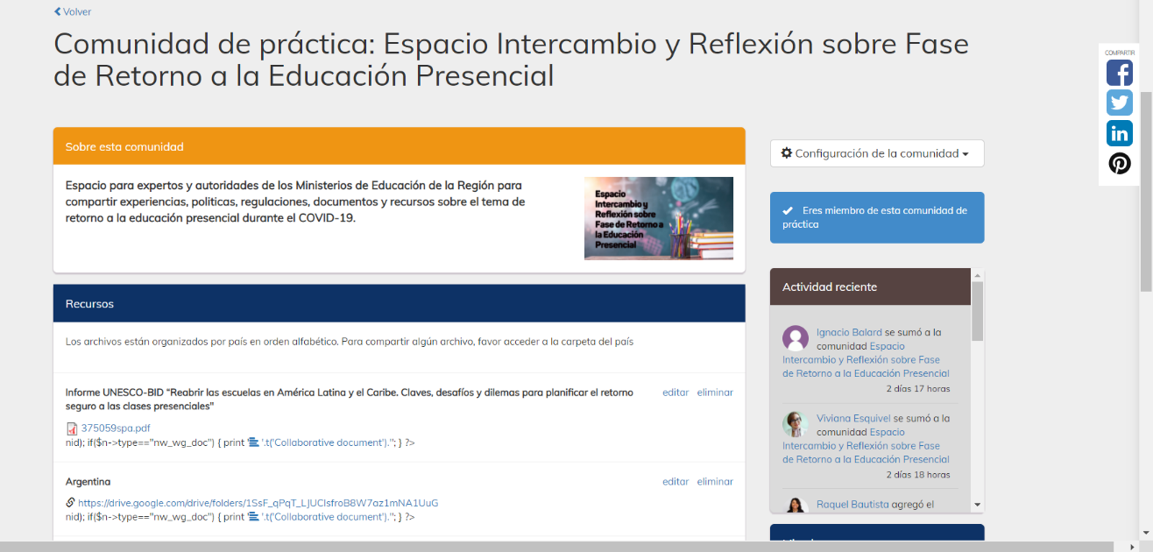

Participants
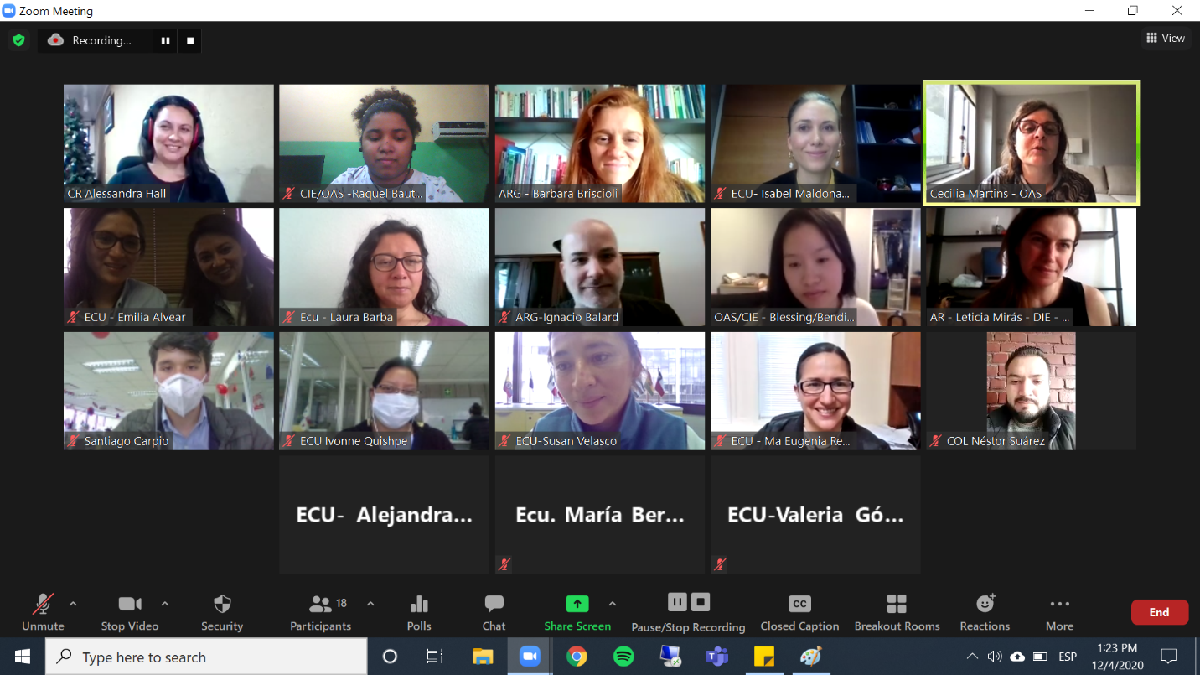
Country | Name | Position
Argentina | Dr. Barbara Briscioli  Leticia Mirás | Director of Educational Evaluation  Director of Educational Information and Statistics
Chile | Raimundo Larraín Hurtado  Enrique Guillermo Laval Zaldívar  Claudia Paz Téllez Marín | Head of the General Education Division  Cooperation
Colombia | Juan Guillermo Alba | Advisor to the Vice Minister of Pre-school, Primary and Secondary Education
Costa Rica | Alessandra Hall Fernández  Gabriela González Salgado | Advisors to the Directorate of Student Life
Ecuador | Isabel Maldonado  Andrea Campos  Emilia Alvear  María Eugenia Naranjo  Patricia Carrillo  Mariana Rivera  Isabel Bermeo  Esteban Moreno  Valeria Gómez  Alejandra Rosero  Ivón Quispe  Samantha Gilbert  Susan Velasco  Laura Barba  María Eugenia Reyes Baquerizo | Vice-Ministry of Education  Organizing Team  Support Team  Directorate of Cooperation
Roundtable facilitator | Cecilia Martins. Education Specialist. DHDEE-CIE
OAS. DHDEE  Education Section.  Technical Secretariat of the CIE | Jesus Schucry Giacoman Zapata. Director  Cecilia Martins. Education Specialist  Raquel Bautista  Verónica Cabrera
CIDED00221E01

